# 人工智能行业大师访谈

## 吴恩达采访Geoffrey Hinton

## 吴恩达采访Pieter Abbeel

## 吴恩达采访Ian Goodfellow

## 吴恩达采访Yoshua Bengio

## 吴恩达采访林元庆

## 吴恩达采访Andrej Karpathy

## 吴恩达采访Ruslan Salakhutdinov

# 课程1——神经网络与深度学习

## 第一周 深度学习概论

### 欢迎来到深度学习工程师微专业

AI是新“电力”（AI将会促进社会变革）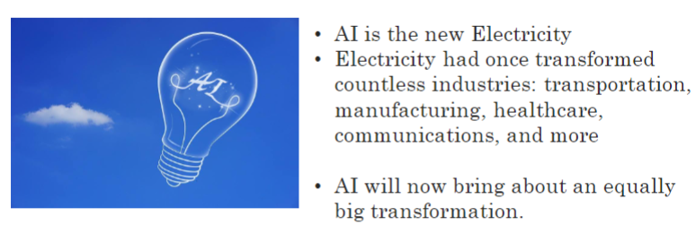

深度学习工程师微专业课程内容（课程体系，C1-C5，Course 1 – Course 5）：

* 1. 神经网络与深度学习
  2. 神经网络调优（超参数、正规化、优化）
  3. 机器学习项目的结构
  4. 卷积神经网络
  5. 自然语言处理：序列模型的构建

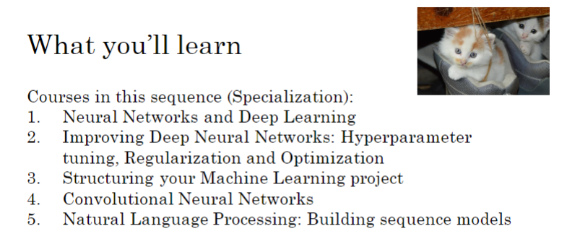

### 什么是神经网络？

下图所示房价预测问题（线性回归）可看做一个非常简单的神经网络（单层神经网络（Single Neural Network），单神经元，无隐层，只有输入、输出层）。

注：一般而言，神经网络至少为2层（至少一个隐藏层+输出层）

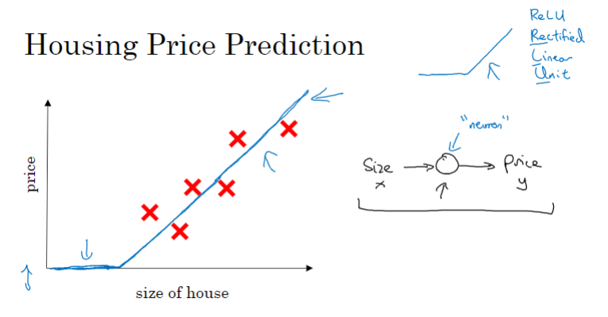

下图所示房价预测问题（线性回归）也可看做一个较简单的多层神经网络（Multiple Neural Network）（2层网络，1个隐藏层）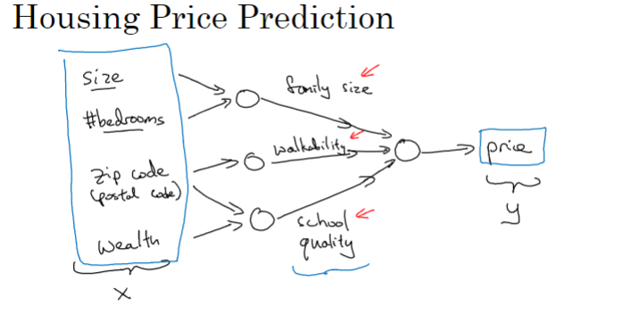

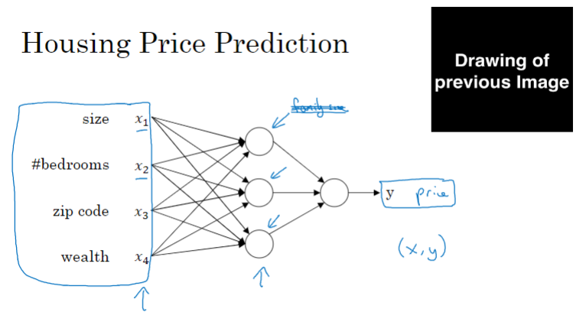

### 用神经网络进行监督学习

目前机器学习中应用最多的还是监督学习（CNN、RNN、hybrid等）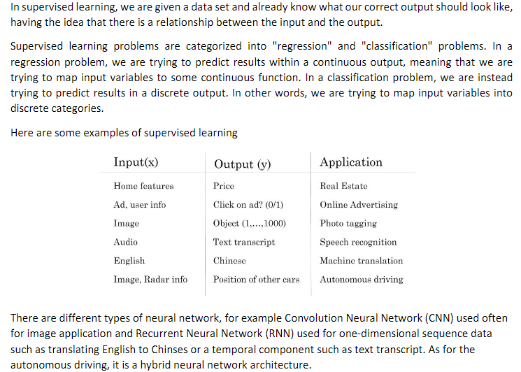

结构化数据与非结构化数据

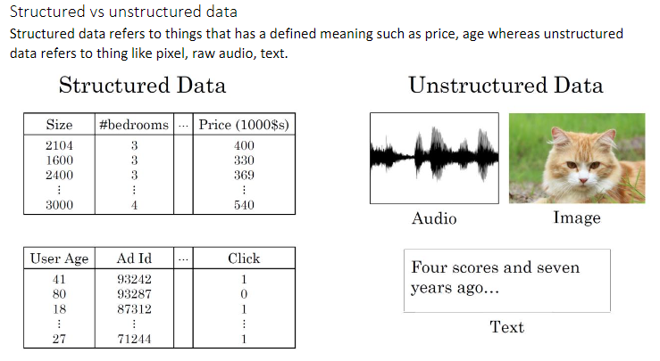

### 为什么深度学习会兴起？

近年来，深度学习在图像、视频、语音等众多应用领域相比其他机器学习方法取得了领先地位，引起了各界的重视。

有利于深度学习发展的两个条件：大数据、高算力

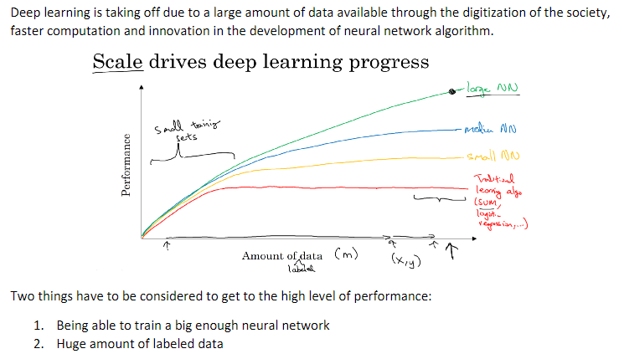

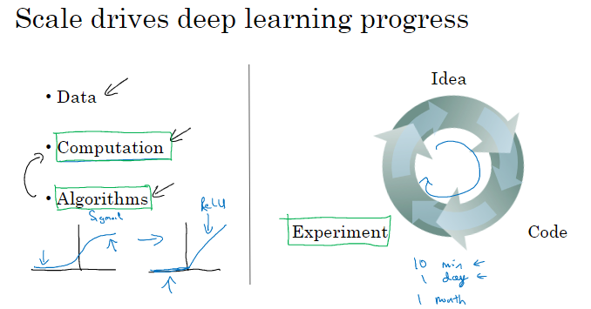

### 关于这门课

课程体系

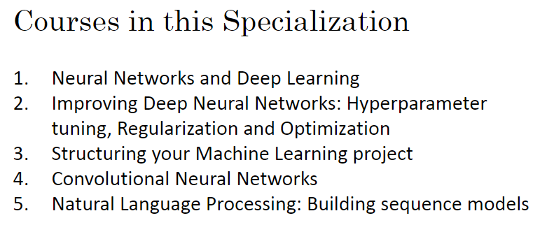

### 1.6 课程资源

### C1W1 Quiz - Introduction to deep learning

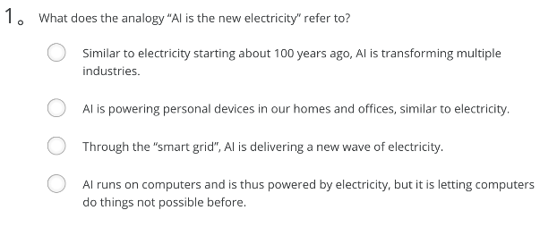

Ans: A

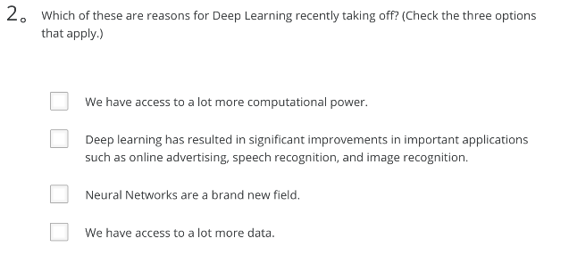

Ans: A、B

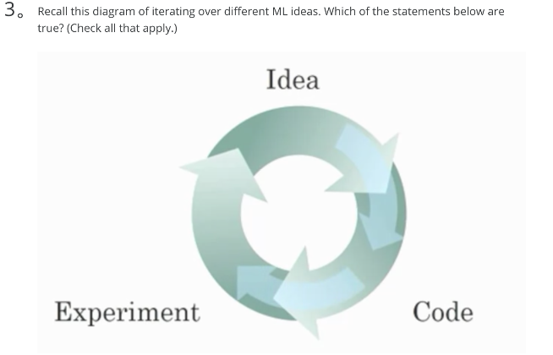

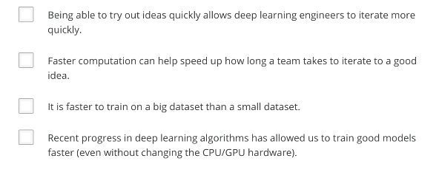

Ans: A、C、D

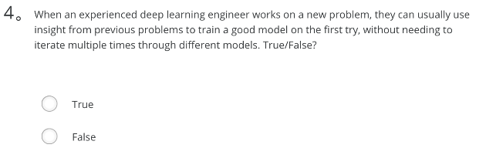

Ans: False

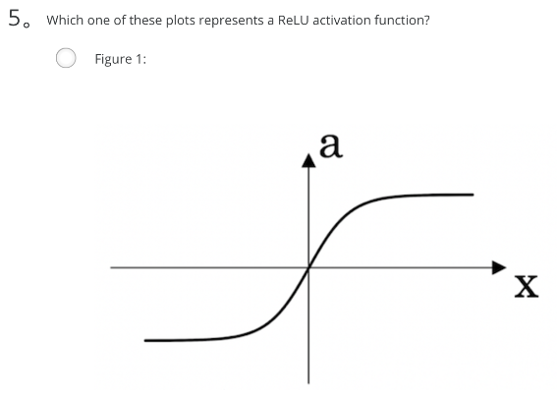

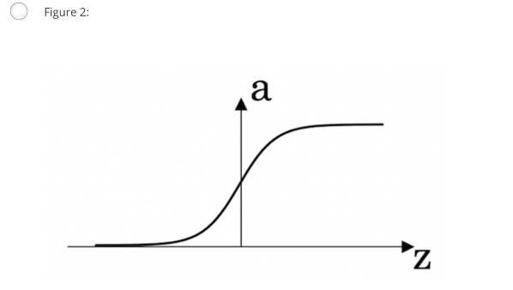

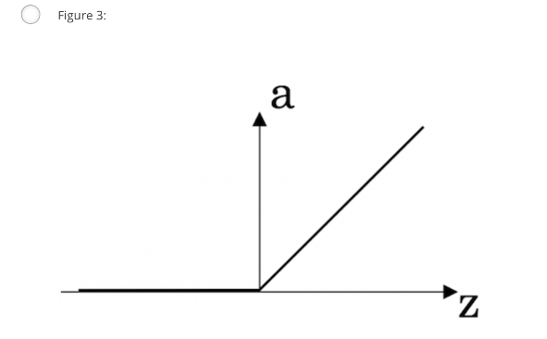

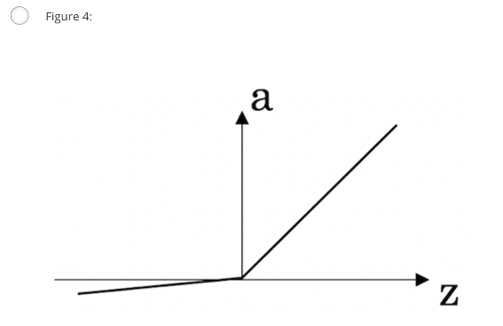

Ans: C

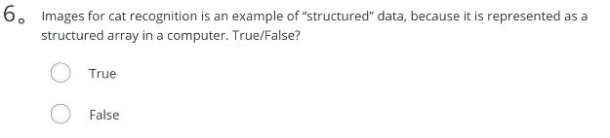

Ans: False

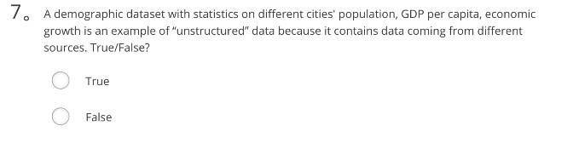

Ans: False

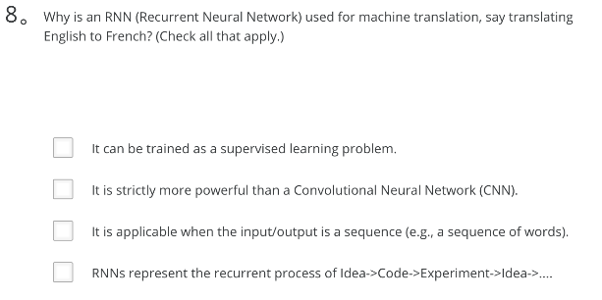

Ans: A、C

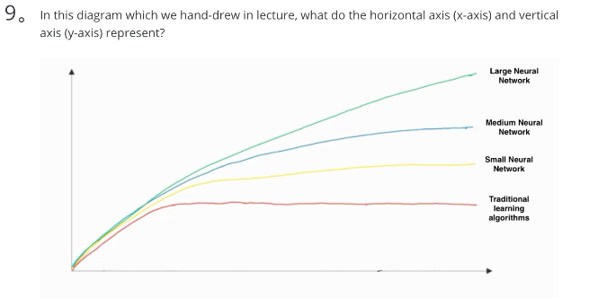

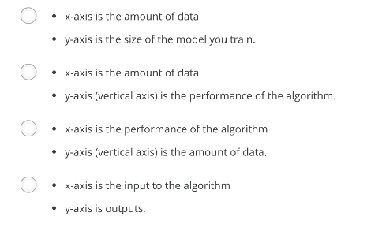

Ans: B

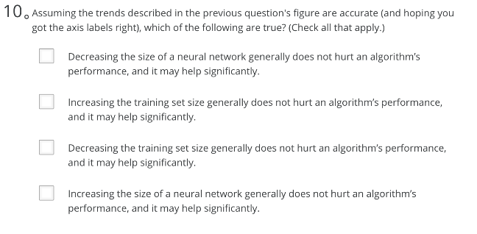

Ans: B、D

1. What does the analogy “AI is the new electricity” refer to?
   *  AI is powering personal devices in our homes and offices, similar to electricity.
   *  Through the “smart grid”, AI is delivering a new wave of electricity.
   *  AI runs on computers and is thus powered by electricity, but it is letting computers do things not possible before.
   *  Similar to electricity starting about 100 years ago, AI is transforming multiple industries.

Note: Andrew illustrated the same idea in the lecture.

1. Which of these are reasons for Deep Learning recently taking off? (Check the two options that apply.)
   *  We have access to a lot more computational power.
   *  Neural Networks are a brand new field.
   *  We have access to a lot more data.
   *  Deep learning has resulted in significant improvements in important applications such as online advertising, speech recognition, and image recognition.
2. Recall this diagram of iterating over different ML ideas. Which of the statements below are true? (Check all that apply.)
   *  Being able to try out ideas quickly allows deep learning engineers to iterate more quickly.
   *  Faster computation can help speed up how long a team takes to iterate to a good idea.
   *  It is faster to train on a big dataset than a small dataset.
   *  Recent progress in deep learning algorithms has allowed us to train good models faster (even without changing the CPU/GPU hardware).

Note: A bigger dataset generally requires more time to train on a same model.

1. When an experienced deep learning engineer works on a new problem, they can usually use insight from previous problems to train a good model on the first try, without needing to iterate multiple times through different models. True/False?
   *  True
   *  False

Note: Maybe some experience may help, but nobody can always find the best model or hyperparameters without iterations.

1. Which one of these plots represents a ReLU activation function?
   * Check [here](https://en.wikipedia.org/wiki/Rectifier_(neural_networks)).

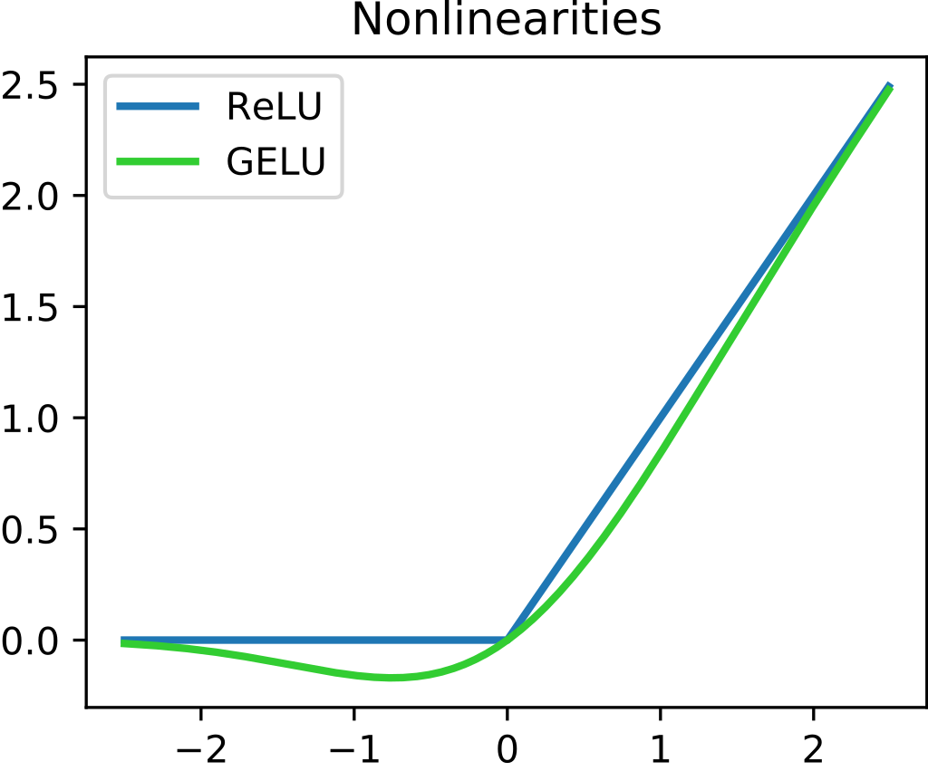

1. Images for cat recognition is an example of “structured” data, because it is represented as a structured array in a computer. True/False?
   *  True
   *  False
2. A demographic dataset with statistics on different cities' population, GDP per capita, economic growth is an example of “unstructured” data because it contains data coming from different sources. True/False?
   *  True
   *  False
3. Why is an RNN (Recurrent Neural Network) used for machine translation, say translating English to French? (Check all that apply.)
   *  It can be trained as a supervised learning problem.
   *  It is strictly more powerful than a Convolutional Neural Network (CNN).
   *  It is applicable when the input/output is a sequence (e.g., a sequence of words).
   *  RNNs represent the recurrent process of Idea->Code->Experiment->Idea->....
4. In this diagram which we hand-drew in lecture, what do the horizontal axis (x-axis) and vertical axis (y-axis) represent?

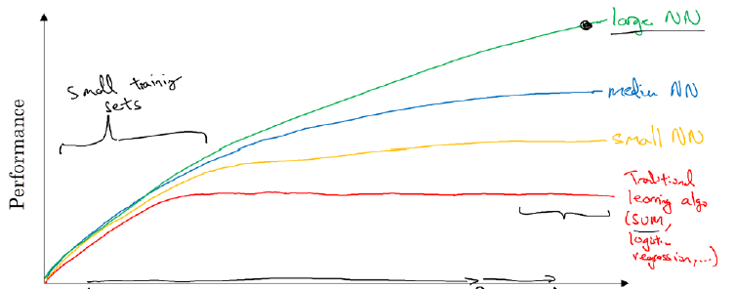

* + x-axis is the amount of data
  + y-axis (vertical axis) is the performance of the algorithm.

1. Assuming the trends described in the previous question's figure are accurate (and hoping you got the axis labels right), which of the following are true? (Check all that apply.)
   *  Increasing the training set size generally does not hurt an algorithm’s performance, and it may help significantly.
   *  Increasing the size of a neural network generally does not hurt an algorithm’s performance, and it may help significantly.
   *  Decreasing the training set size generally does not hurt an algorithm’s performance, and it may help significantly.
   *  Decreasing the size of a neural network generally does not hurt an algorithm’s performance, and it may help significantly.

## 第二周 神经网络基础

### 2.1 二分分类

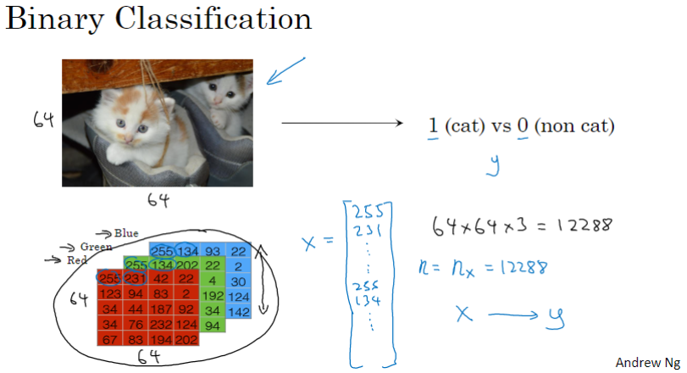

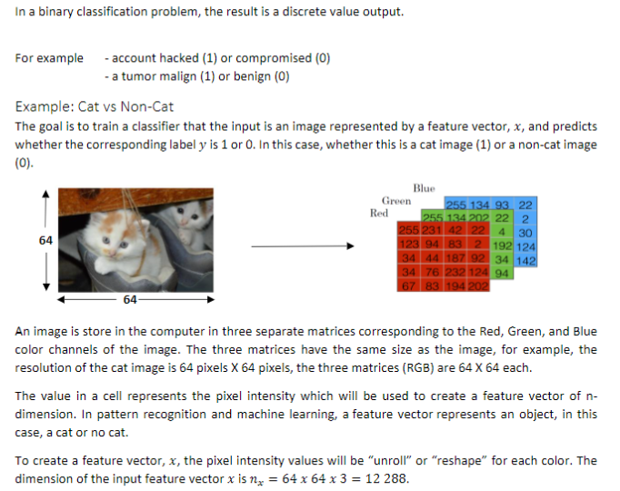

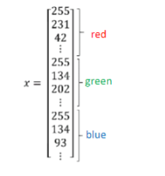

符号表示

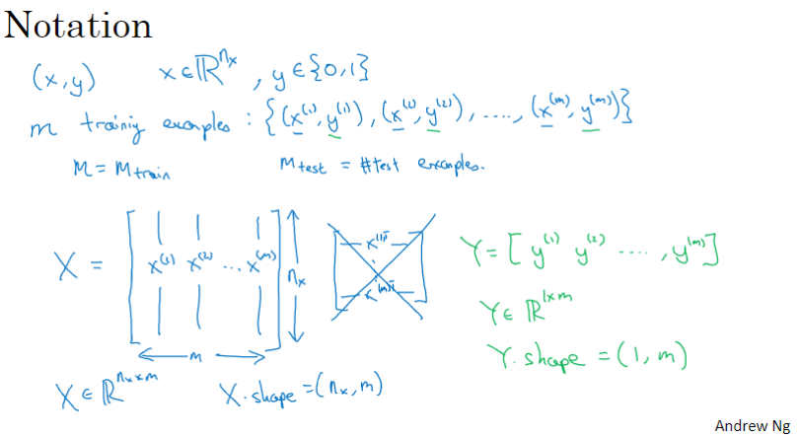

### 2.2 logistic 回归

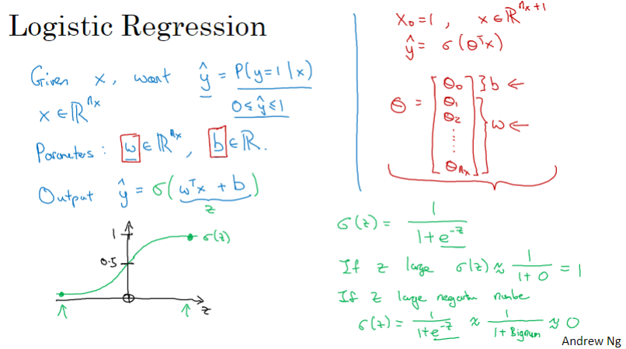

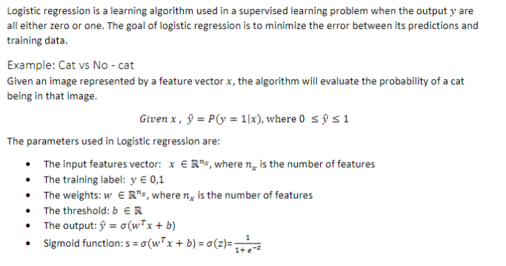

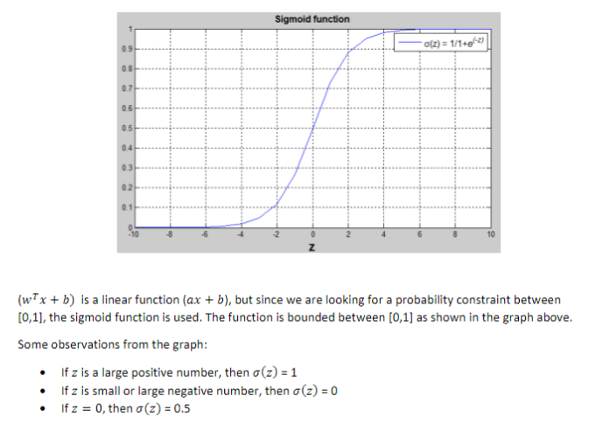

### 2.3 logistic 回归损失函数

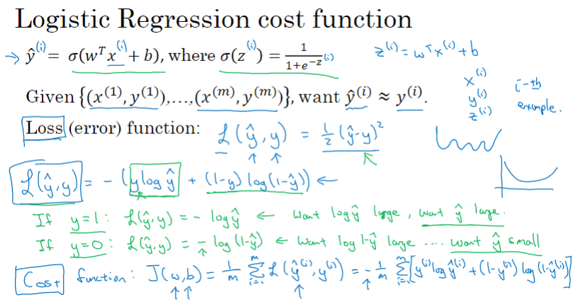

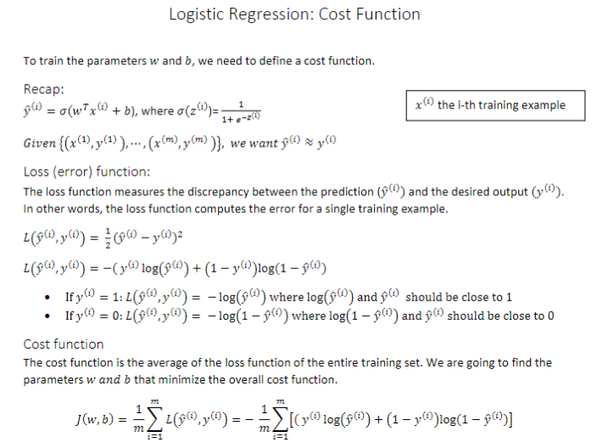

### 2.4 梯度下降法

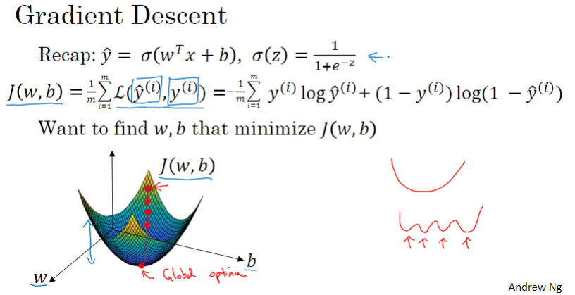

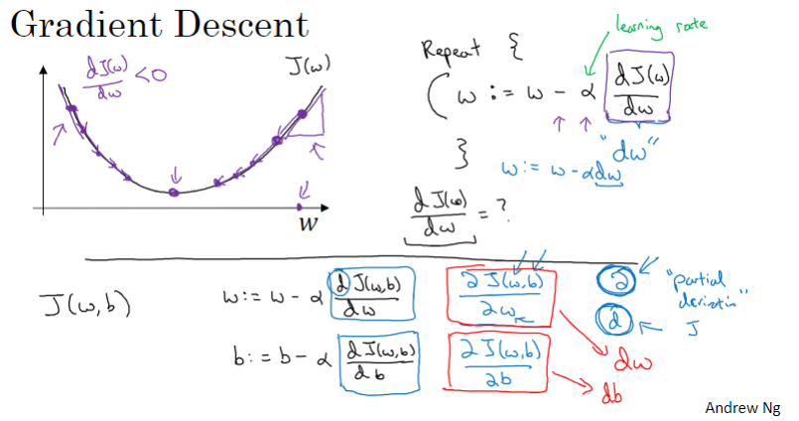

### 2.5 导数

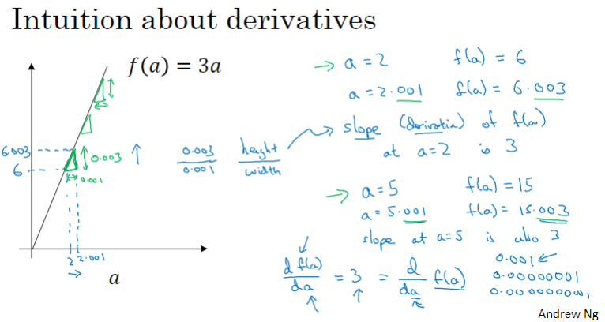

### 2.6 更多导数的例子

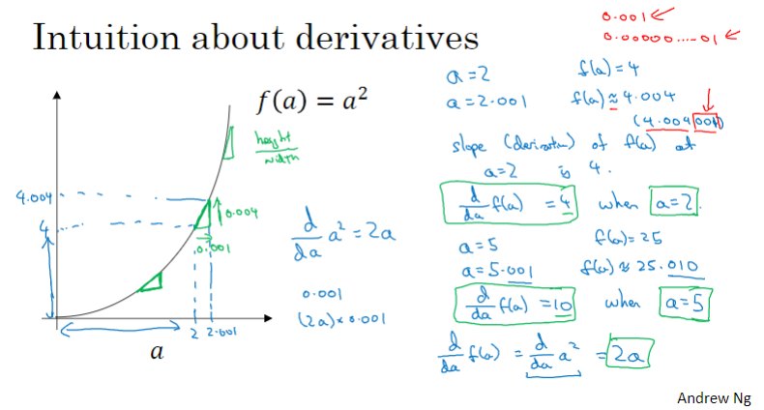

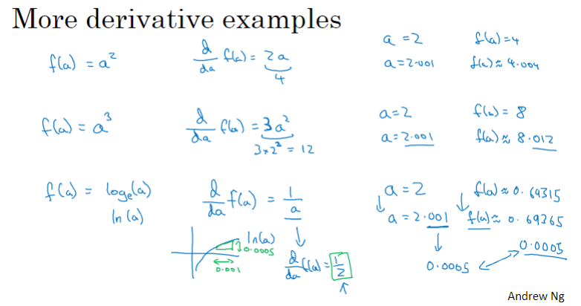

### 2.7 计算图

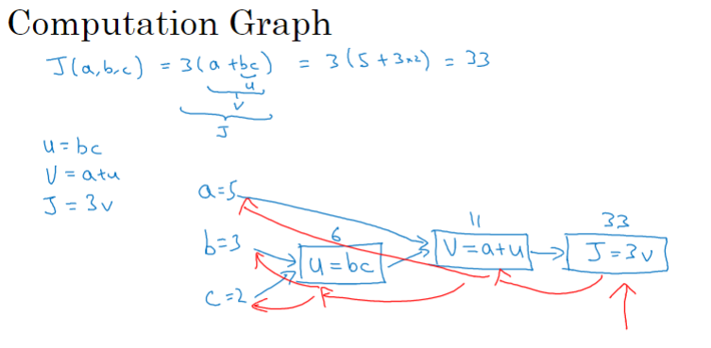

### 2.8 计算图的导数计算

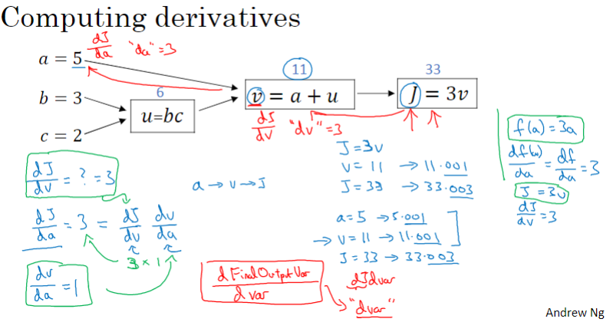

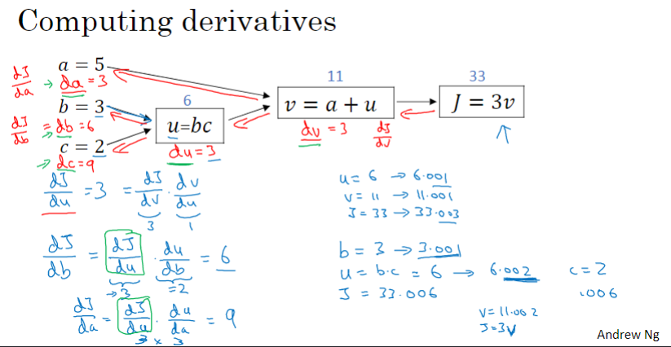

### 2.9 logistic 回归中的梯度下降法

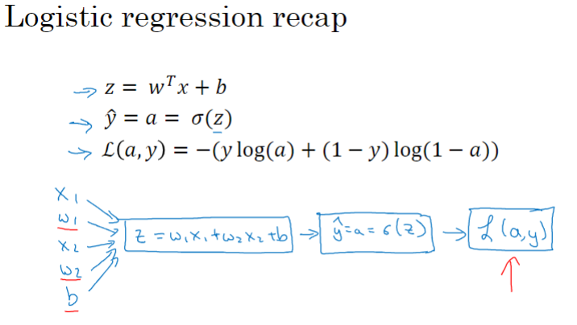

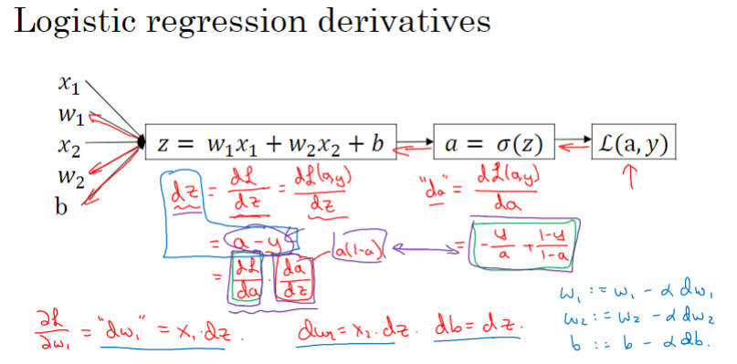

### 2.10 m个样本的梯度下降

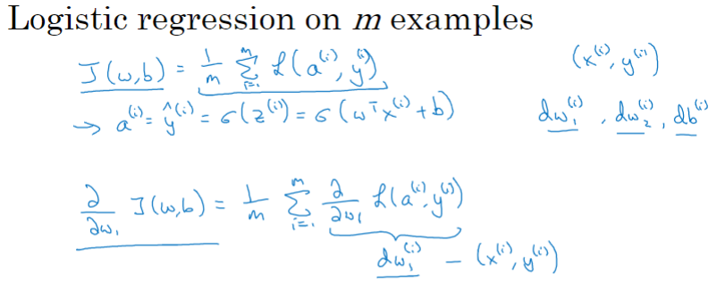

### 2.11 向量化

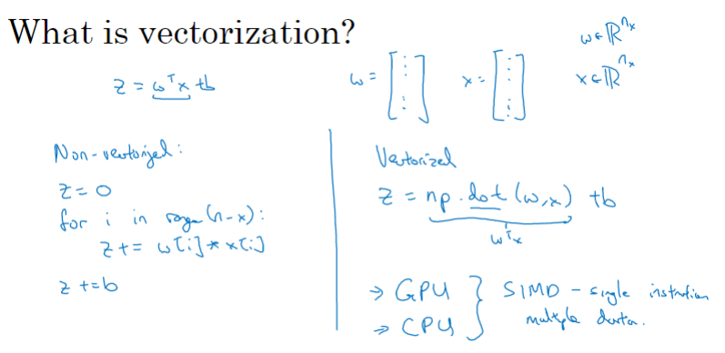

### 2.12 向量化的更多例子

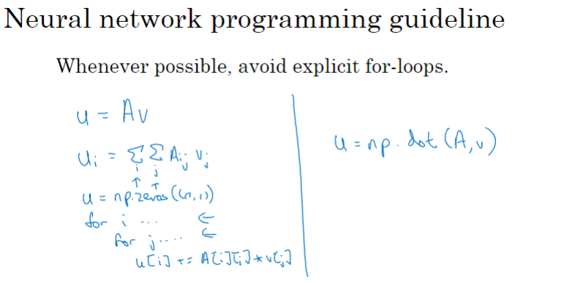

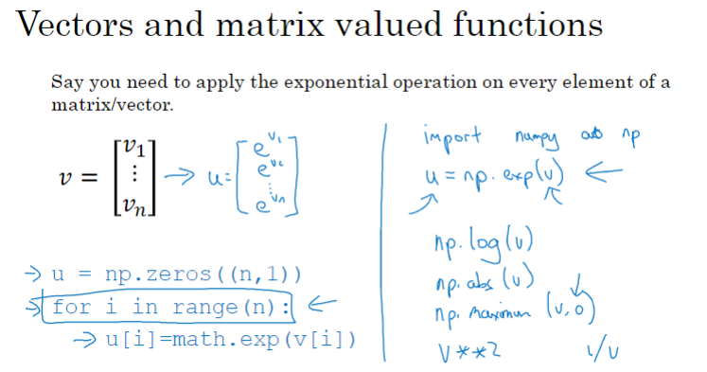

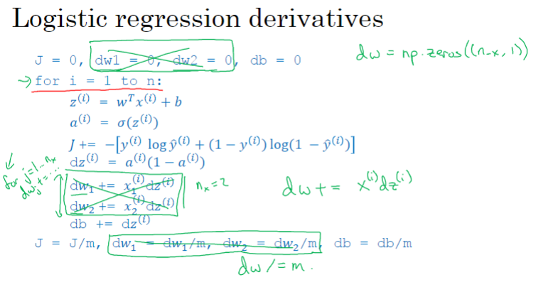

### 2.13 logistic 回归的向量化实现

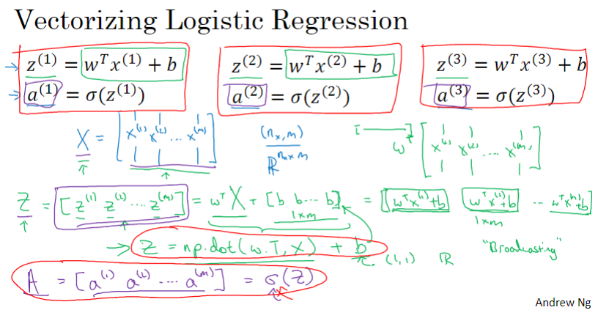

### 2.14 logistic 回归的梯度输出的向量化实现

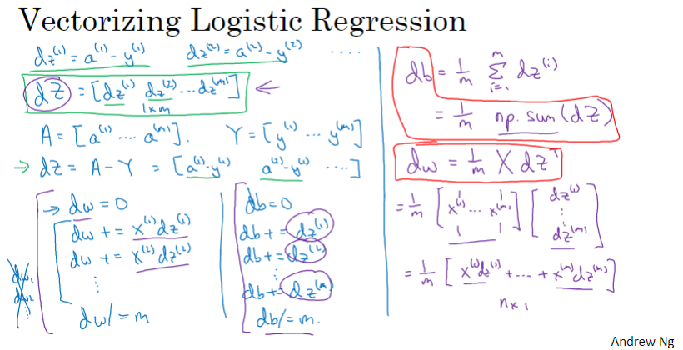

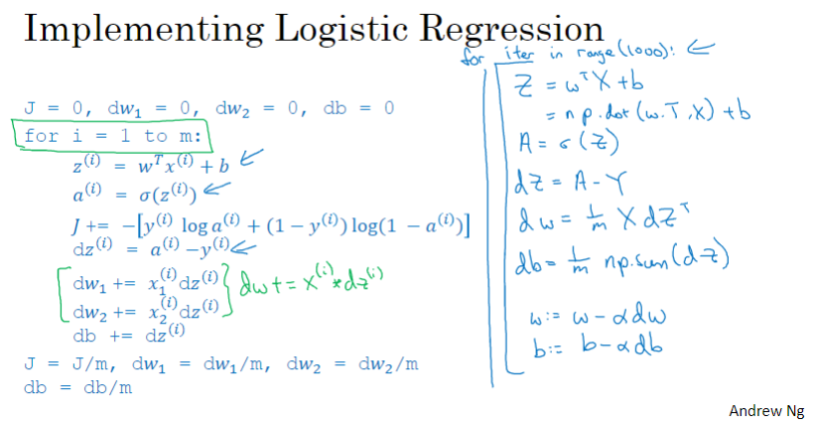

### 2.15 Python 中的广播

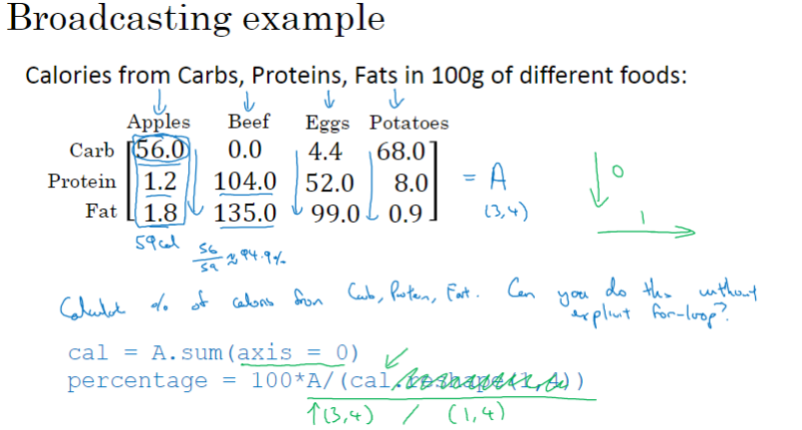

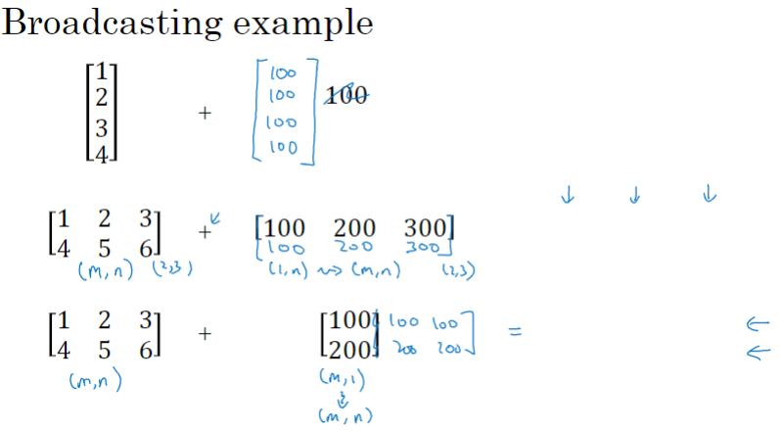

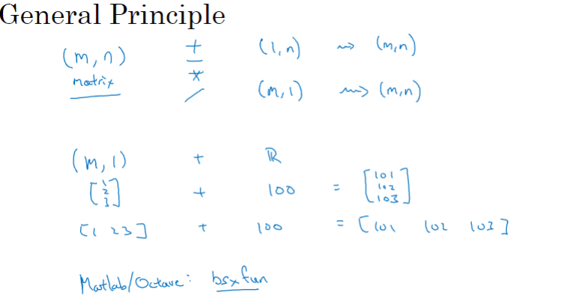

### 2.16 关于 python / numpy 向量的说明

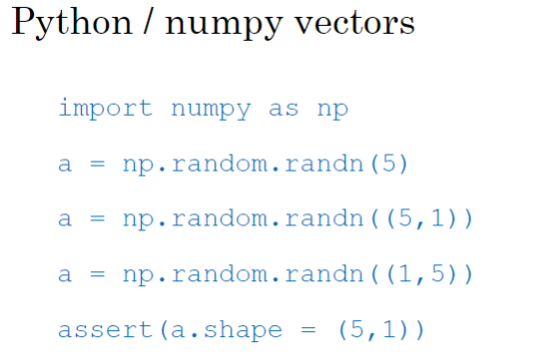

### 2.17 Jupyter / IPython 笔记本的快速指南

### 2.18 （选修）logistic 损失函数的解释

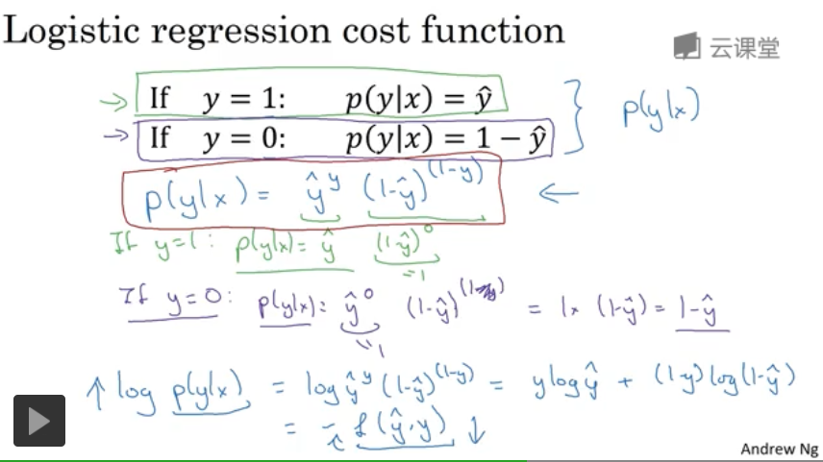

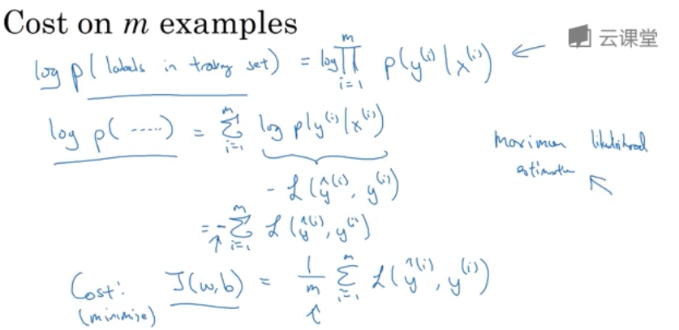

### C1W2 Quiz - Neural Network Basics

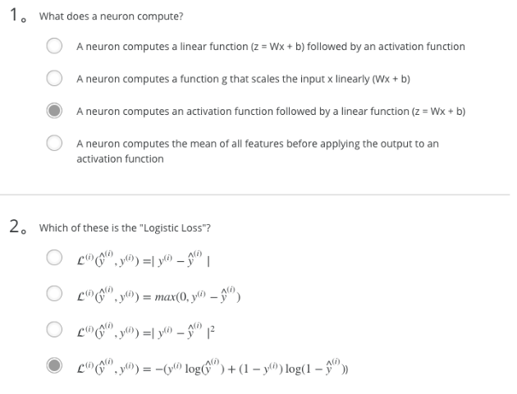

Note: The output of a neuron is a = g(Wx + b) where g is the activation function (sigmoid, tanh, ReLU, ...).

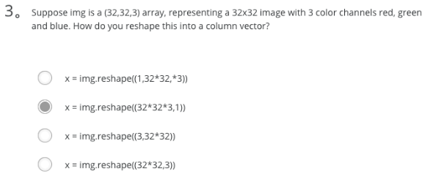

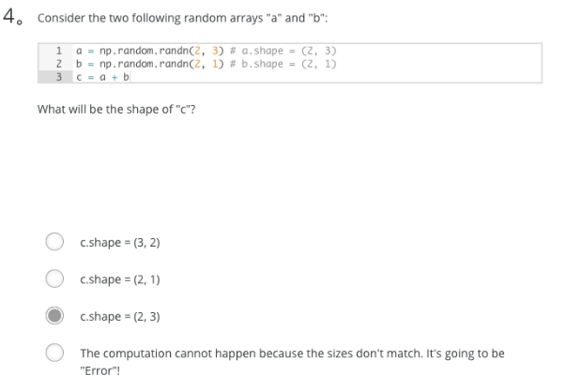

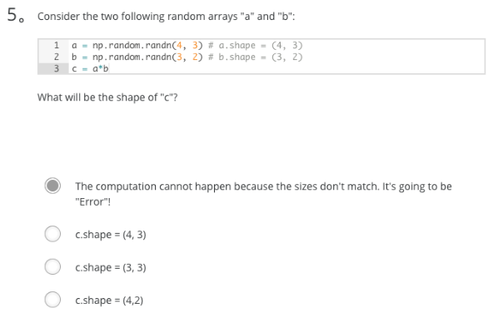

Note: "*" operator indicates element-wise multiplication. Element-wise multiplication requires same dimension between two matrices. It's going to be an error.

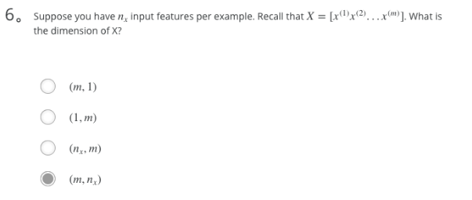

Note: A stupid way to validate this is use the formula Z^(l) = W^(l)A^(l) when l = 1, then we have

- A^(1) = X

- X.shape = (n_x, m)

- Z^(1).shape = (n^(1), m)

- W^(1).shape = (n^(1), n_x)

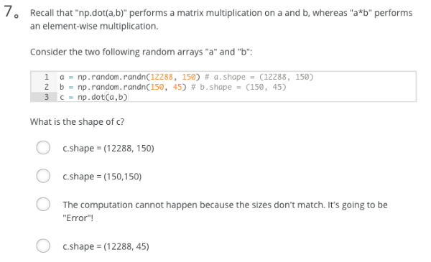

Ans: D

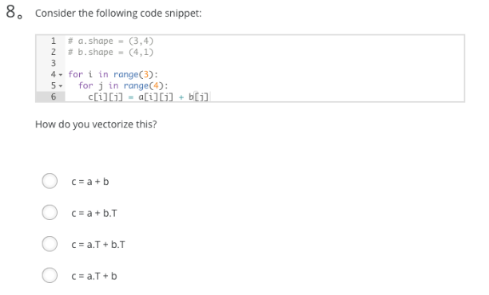

Ans: B

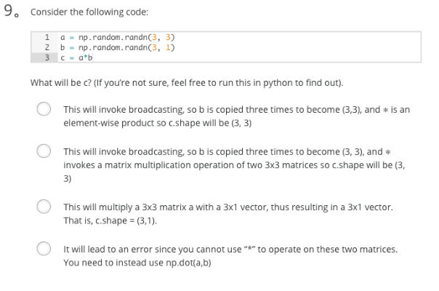

Ans: A

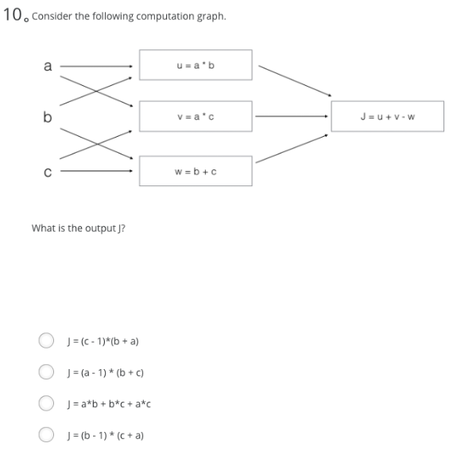

Ans: B

1. What does a neuron compute?
   *  A neuron computes an activation function followed by a linear function (z = Wx + b)
   *  A neuron computes a linear function (z = Wx + b) followed by an activation function
   *  A neuron computes a function g that scales the input x linearly (Wx + b)
   *  A neuron computes the mean of all features before applying the output to an activation function

Note: The output of a neuron is a = g(Wx + b) where g is the activation function (sigmoid, tanh, ReLU, ...).

1. Which of these is the "Logistic Loss"?

L(i)(y^(i),y(i))=y(i)log(y^(i))+(1−y(i))log(1−y^(i))

* + Check [here](https://en.wikipedia.org/wiki/Cross_entropy#Cross-entropy_error_function_and_logistic_regression).

Note: We are using a cross-entropy loss function.

1. Suppose img is a (32,32,3) array, representing a 32x32 image with 3 color channels red, green and blue. How do you reshape this into a column vector?
   * x = img.reshape((32 * 32 * 3, 1))
2. Consider the two following random arrays "a" and "b":

a = np.random.randn(2, 3) # a.shape = (2, 3)

b = np.random.randn(2, 1) # b.shape = (2, 1)

c = a + b

What will be the shape of "c"?

b (column vector) is copied 3 times so that it can be summed to each column of a. Therefore, c.shape = (2, 3).

1. Consider the two following random arrays "a" and "b":

a = np.random.randn(4, 3) # a.shape = (4, 3)

b = np.random.randn(3, 2) # b.shape = (3, 2)

c = a * b

What will be the shape of "c"?

"*" operator indicates element-wise multiplication. Element-wise multiplication requires same dimension between two matrices. It's going to be an error.

1. Suppose you have n_x input features per example. Recall that X=[x^(1), x^(2)...x^(m)]. What is the dimension of X?

(n_x, m)

Note: A stupid way to validate this is use the formula Z^(l) = W^(l)A^(l) when l = 1, then we have

* + A^(1) = X
  + X.shape = (n_x, m)
  + Z^(1).shape = (n^(1), m)
  + W^(1).shape = (n^(1), n_x)

1. Recall that np.dot(a,b) performs a matrix multiplication on a and b, whereas a*b performs an element-wise multiplication.

Consider the two following random arrays "a" and "b":

a = np.random.randn(12288, 150) # a.shape = (12288, 150)

b = np.random.randn(150, 45) # b.shape = (150, 45)

c = np.dot(a, b)

What is the shape of c?

c.shape = (12288, 45), this is a simple matrix multiplication example.

1. Consider the following code snippet:

# a.shape = (3,4)

# b.shape = (4,1)

for i in range(3):

for j in range(4):

c[i][j] = a[i][j] + b[j]

How do you vectorize this?

c = a + b.T

1. Consider the following code:

a = np.random.randn(3, 3)

b = np.random.randn(3, 1)

c = a * b

What will be c?

This will invoke broadcasting, so b is copied three times to become (3,3), and ∗ is an element-wise product so c.shape = (3, 3).

1. Consider the following computation graph.

What is the output J?

J = u + v - w

= a * b + a * c - (b + c)

= a * (b + c) - (b + c)

= (a - 1) * (b + c)

Answer: (a - 1) * (b + c)

## 第三周 浅层神经网络

### 3.1 神经网络概览

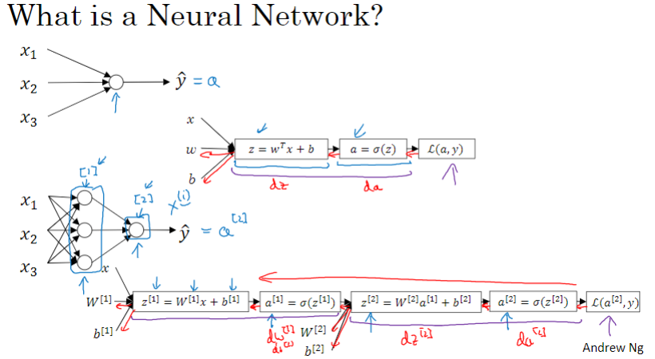

### 3.2 神经网络表示

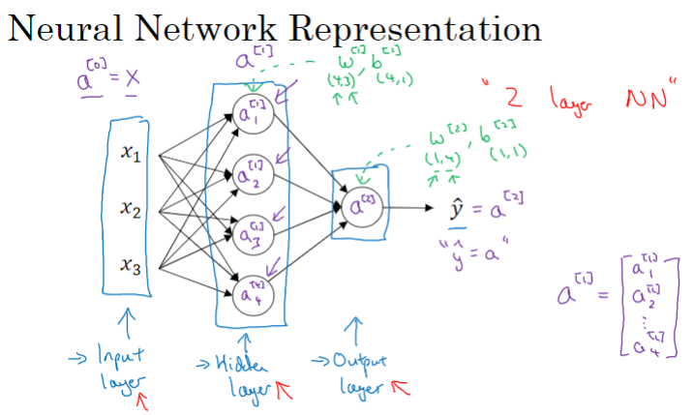

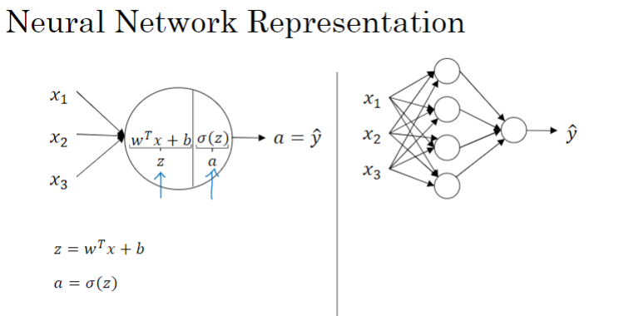

### 3.3 计算神经网络的输出

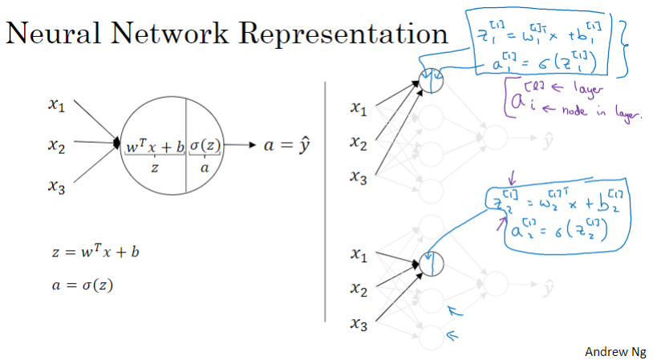

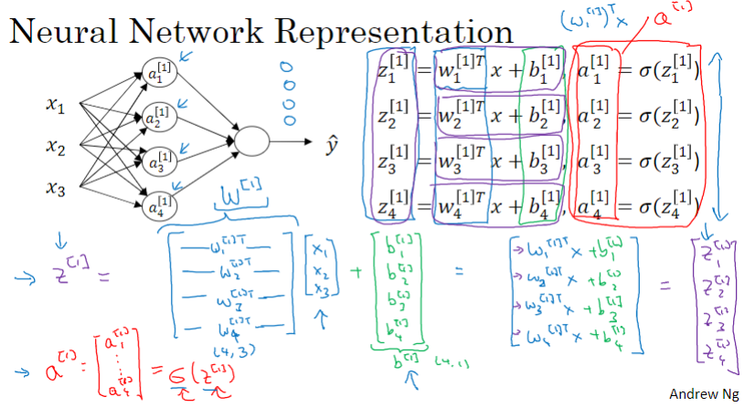

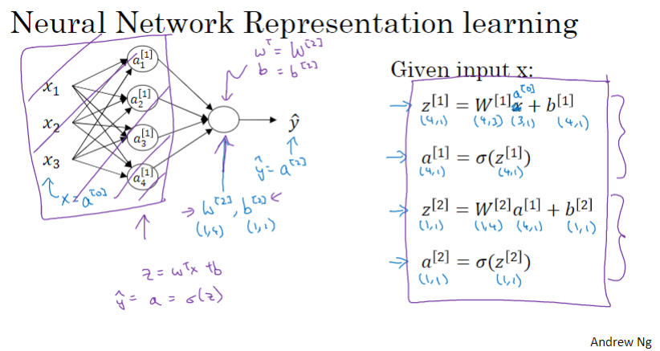

### 3.4 向量化示例

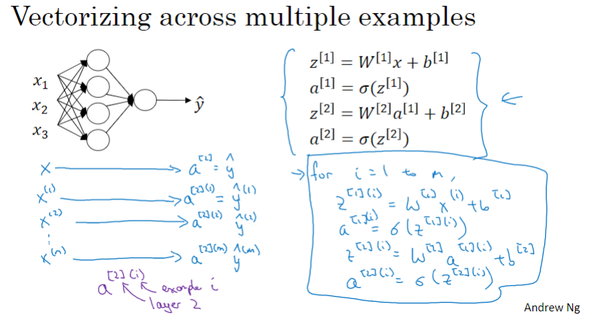

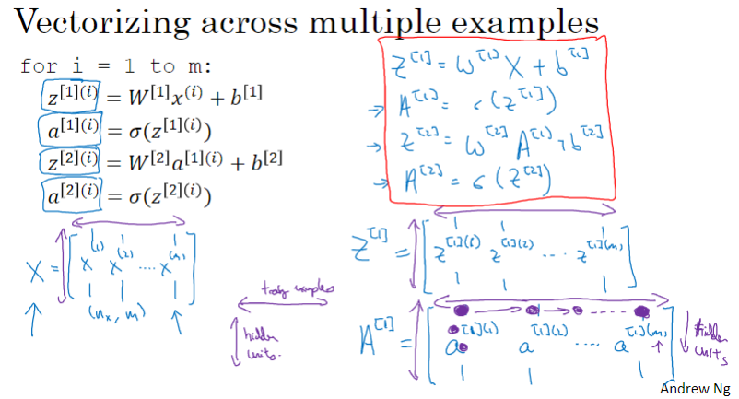

### 3.5 向量化实现的解释

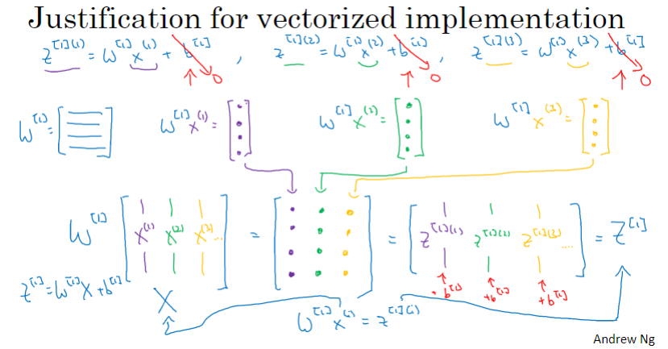

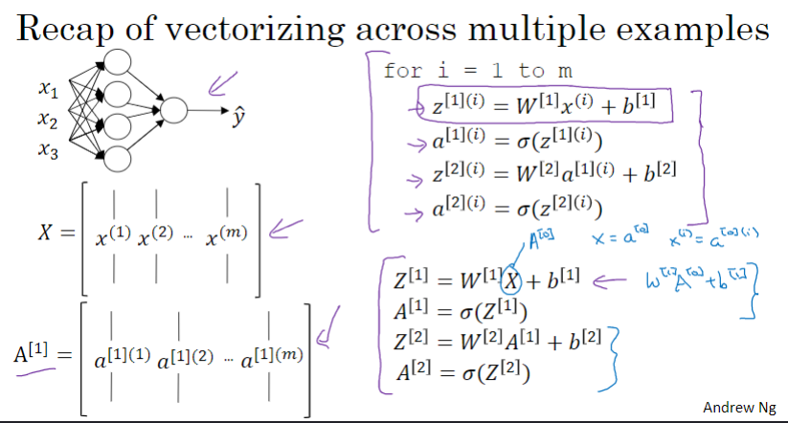

### 3.6 激活函数

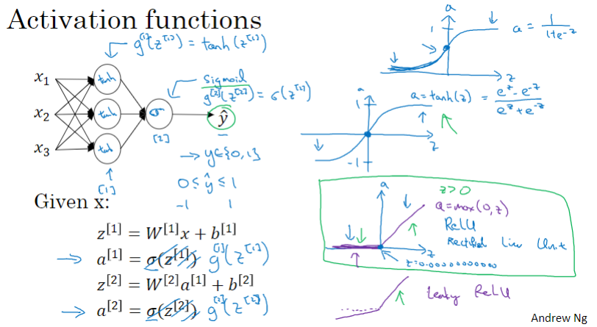

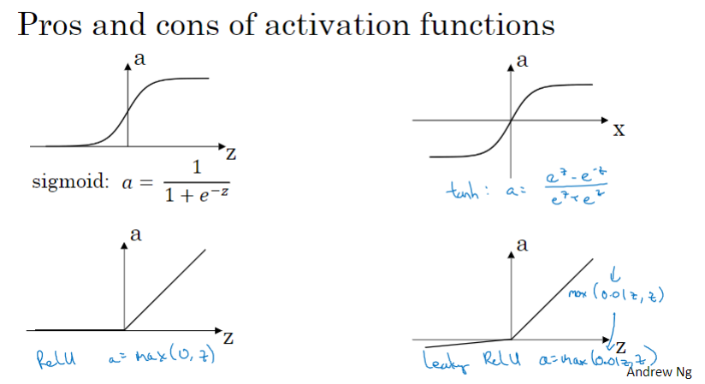

### 3.7 为什么需要非线性激活函数？

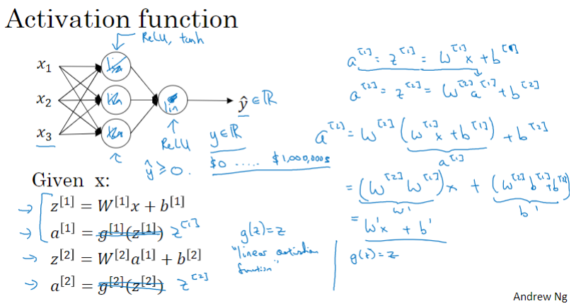

### 3.8 激活函数的导数

参考文章：

1. sigmoid函数求导过程

<https://blog.csdn.net/zhangyingjie09/article/details/82180199>

1. Tanh激活函数及求导过程

<https://blog.csdn.net/qq_35200479/article/details/84502844>

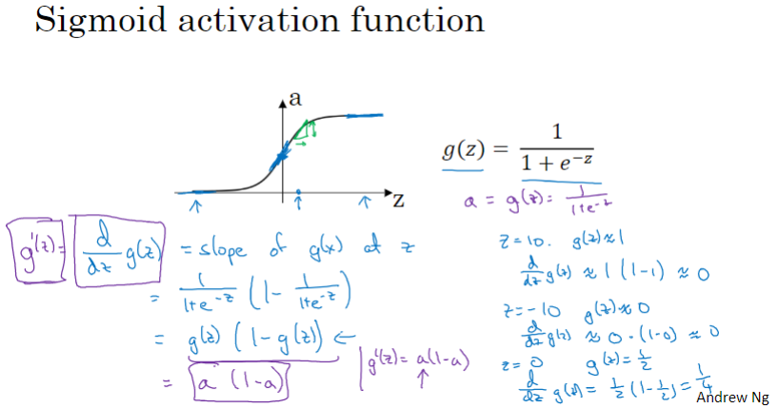

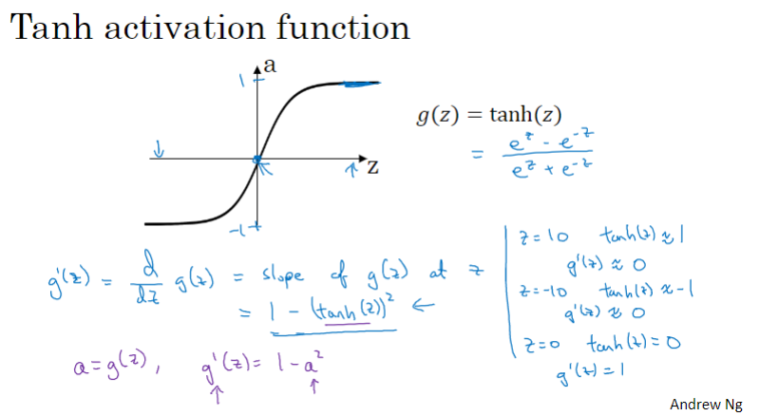

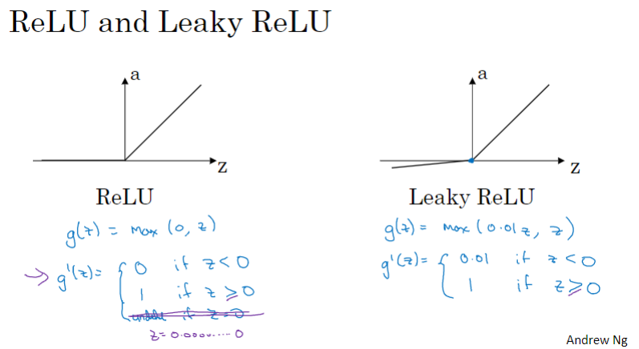

### 3.9 神经网络的梯度下降法

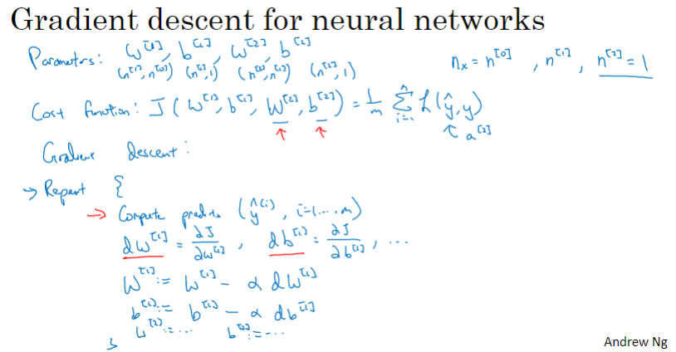

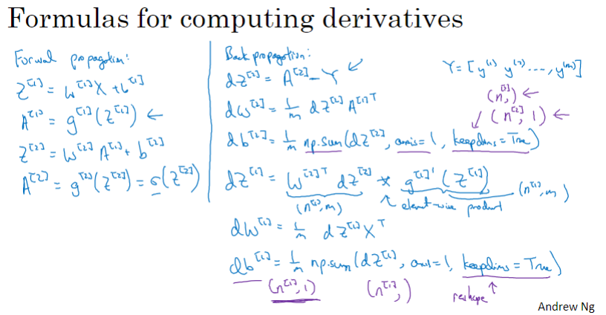

### 3.10 （选修）直观理解反向传播

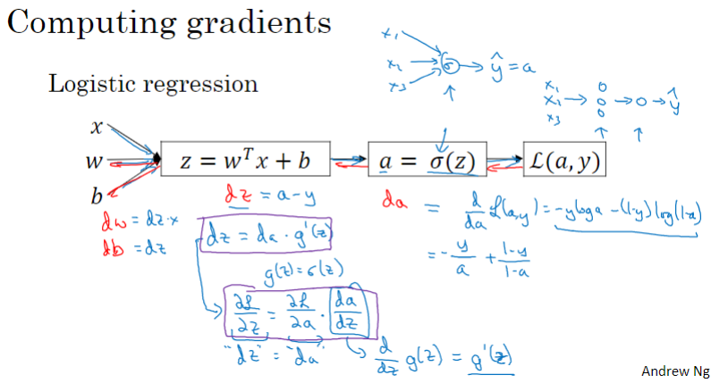

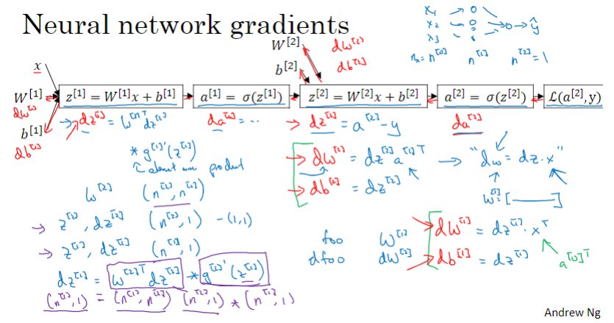

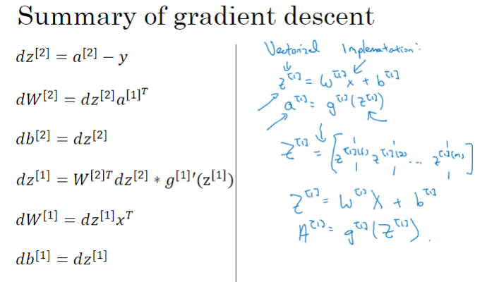

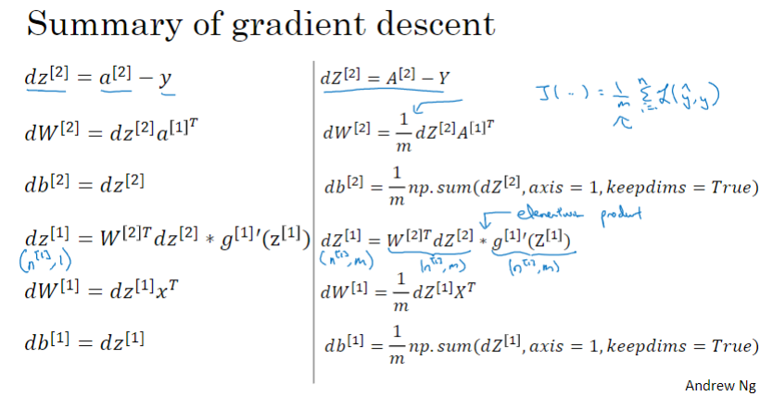

### 3.11 随机初始化

为什么不能将权重W初始化为零？因为这样做的话，同一隐层的每个节点的值将始终保持相同，失去了使用多个节点的意义（模型将过于简单，而难以有所作为）

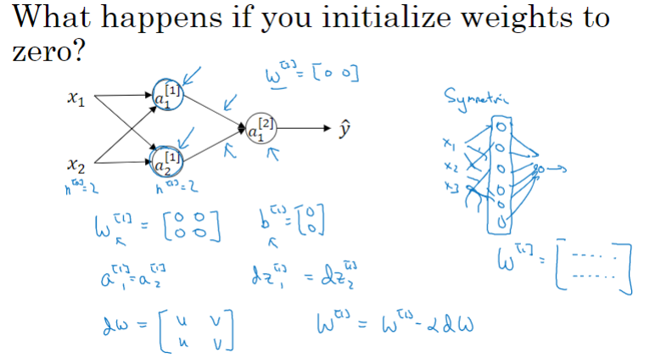

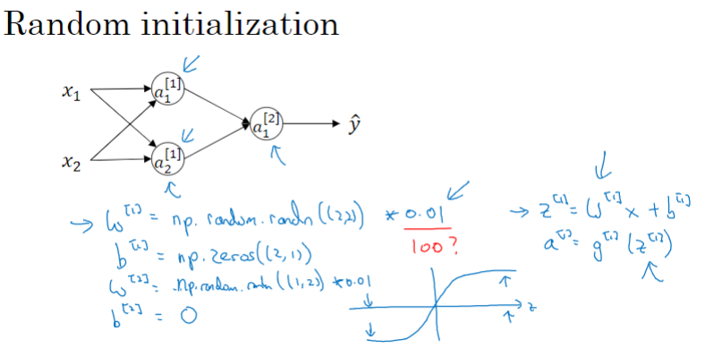

### C1W3 Quiz - Shallow Neural Networks

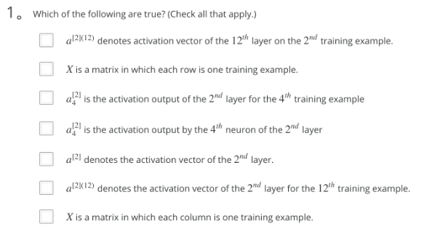

Ans: D、E、F、G

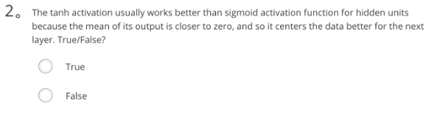

Ans: True

Note: As seen in lecture the output of the tanh is between -1 and 1, it thus centers the data which makes the learning simpler for the next layer.

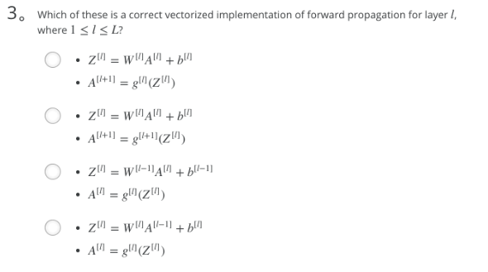  
 Ans: D

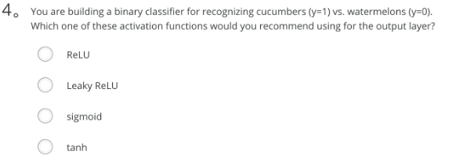

Ans: C

Note: The output value from a sigmoid function can be easily understood as a probability.

Sigmoid outputs a value between 0 and 1 which makes it a very good choice for binary classification. You can classify as 0 if the output is less than 0.5 and classify as 1 if the output is more than 0.5. It can be done with tanh as well but it is less convenient as the output is between -1 and 1.

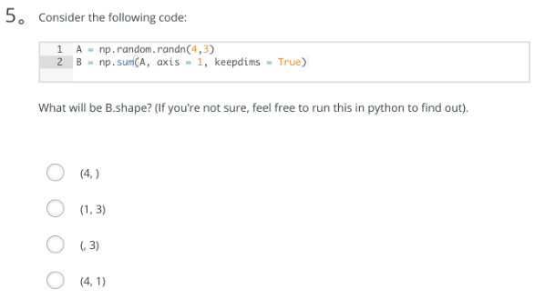

Ans: we use (keepdims = True) to make sure that A.shape is (4,1) and not (4, ). It makes our code more rigorous.

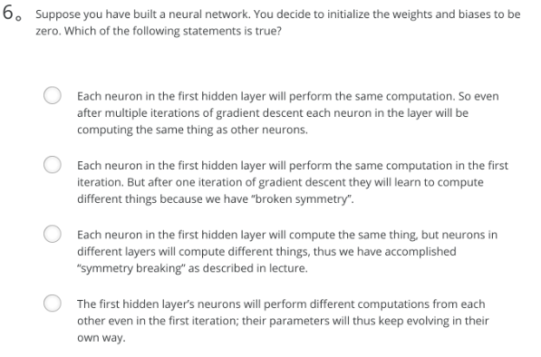

Ans: A

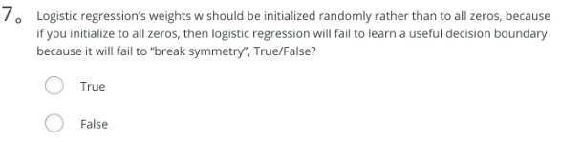

Ans: False

Note: Logistic Regression doesn't have a hidden layer. If you initialize the weights to zeros, the first example x fed in the logistic regression will output zero but the derivatives of the Logistic Regression depend on the input x (because there's no hidden layer) which is not zero. So at the second iteration, the weights values follow x's distribution and are different from each other if x is not a constant vector.

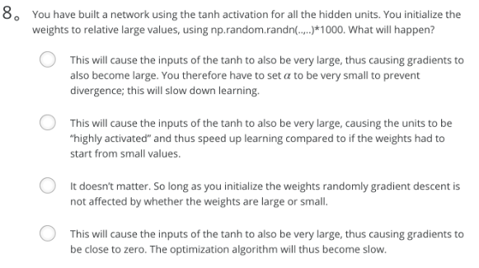

Ans: D

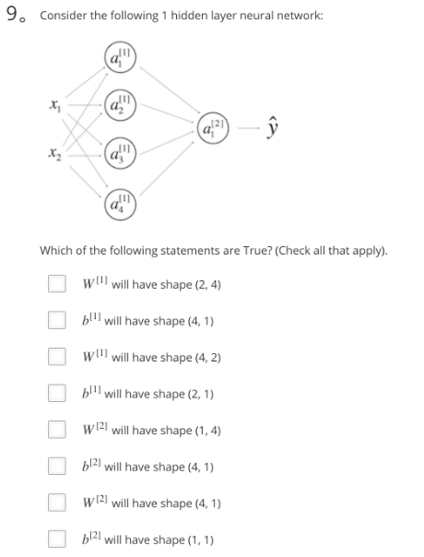

Ans: B、C、E、H

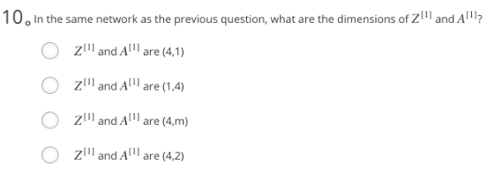

Ans: C

1. Which of the following are true? (Check all that apply.) **Notice that I only list correct options.**
   * X is a matrix in which each column is one training example.
   * a^[2]_4 is the activation output by the 4th neuron of the 2nd layer
   * a^[2](12) denotes the activation vector of the 2nd layer for the 12th training example.
   * a^[2] denotes the activation vector of the 2nd layer.

Note: If you are not familiar with the notation used in this course, check [here](https://www.coursera.org/learn/neural-networks-deep-learning/resources/YsZjP).

1. The tanh activation usually works better than sigmoid activation function for hidden units because the mean of its output is closer to zero, and so it centers the data better for the next layer. True/False?
   *  True
   *  False

Note: You can check [this post](https://stats.stackexchange.com/a/101563/169377)  (<https://stats.stackexchange.com/a/101563/169377>) and (this paper)[<http://yann.lecun.com/exdb/publis/pdf/lecun-98b.pdf>].

As seen in lecture the output of the tanh is between -1 and 1, it thus centers the data which makes the learning simpler for the next layer.

1. Which of these is a correct vectorized implementation of forward propagation for layer l, where 1≤l≤L?
   * Z^[l]=W^[l]A^[l−1]+b^[l]
   * A^[l]=g^[l](Z^[l])
2. You are building a binary classifier for recognizing cucumbers (y=1) vs. watermelons (y=0). Which one of these activation functions would you recommend using for the output layer?
   *  ReLU
   *  Leaky ReLU
   *  sigmoid
   *  tanh

Note: The output value from a sigmoid function can be easily understood as a probability.

Sigmoid outputs a value between 0 and 1 which makes it a very good choice for binary classification. You can classify as 0 if the output is less than 0.5 and classify as 1 if the output is more than 0.5. It can be done with tanh as well but it is less convenient as the output is between -1 and 1.

1. Consider the following code:

A = np.random.randn(4,3)

B = np.sum(A, axis = 1, keepdims = True)

What will be B.shape?

B.shape = (4, 1)

we use (keepdims = True) to make sure that A.shape is (4,1) and not (4, ). It makes our code more rigorous.

1. Suppose you have built a neural network. You decide to initialize the weights and biases to be zero. Which of the following statements are True? (Check all that apply)
   *  Each neuron in the first hidden layer will perform the same computation. So even after multiple iterations of gradient descent each neuron in the layer will be computing the same thing as other neurons.
   *  Each neuron in the first hidden layer will perform the same computation in the first iteration. But after one iteration of gradient descent they will learn to compute different things because we have “broken symmetry”.
   *  Each neuron in the first hidden layer will compute the same thing, but neurons in different layers will compute different things, thus we have accomplished “symmetry breaking” as described in lecture.
   *  The first hidden layer’s neurons will perform different computations from each other even in the first iteration; their parameters will thus keep evolving in their own way.
2. Logistic regression’s weights w should be initialized randomly rather than to all zeros, because if you initialize to all zeros, then logistic regression will fail to learn a useful decision boundary because it will fail to “break symmetry”, True/False?
   *  True
   *  False

Logistic Regression doesn't have a hidden layer. If you initialize the weights to zeros, the first example x fed in the logistic regression will output zero but the derivatives of the Logistic Regression depend on the input x (because there's no hidden layer) which is not zero. So at the second iteration, the weights values follow x's distribution and are different from each other if x is not a constant vector.

1. You have built a network using the tanh activation for all the hidden units. You initialize the weights to relative large values, using np.random.randn(..,..)*1000. What will happen?
   *  It doesn’t matter. So long as you initialize the weights randomly gradient descent is not affected by whether the weights are large or small.
   *  This will cause the inputs of the tanh to also be very large, thus causing gradients to also become large. You therefore have to set α to be very small to prevent divergence; this will slow down learning.
   *  This will cause the inputs of the tanh to also be very large, causing the units to be “highly activated” and thus speed up learning compared to if the weights had to start from small values.
   *  This will cause the inputs of the tanh to also be very large, thus causing gradients to be close to zero. The optimization algorithm will thus become slow.

tanh becomes flat for large values, this leads its gradient to be close to zero. This slows down the optimization algorithm.

1. Consider the following 1 hidden layer neural network:
   * b[1] will have shape (4, 1)
   * W[1] will have shape (4, 2)
   * W[2] will have shape (1, 4)
   * b[2] will have shape (1, 1)

Note: Check [here](https://user-images.githubusercontent.com/14886380/29200515-7fdd1548-7e88-11e7-9d05-0878fe96bcfa.png) for general formulas to do this.

1. In the same network as the previous question, what are the dimensions of Z^[1] and A^[1]?
   * Z[1] and A[1] are (4,m)

Note: Check [here](https://user-images.githubusercontent.com/14886380/29200515-7fdd1548-7e88-11e7-9d05-0878fe96bcfa.png) for general formulas to do this.

## 第四周 深层神经网络

### 4.1 深层神经网络

Logistic 回归：无隐层

2层神经网络：单隐层

3 层神经网络：双隐层

N层神经网络：N-1个隐层

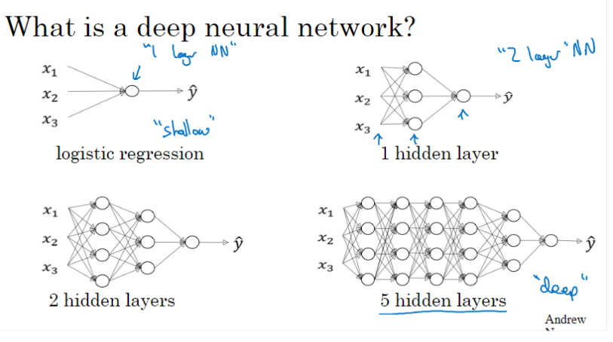

深度神经网络的符号表示方法

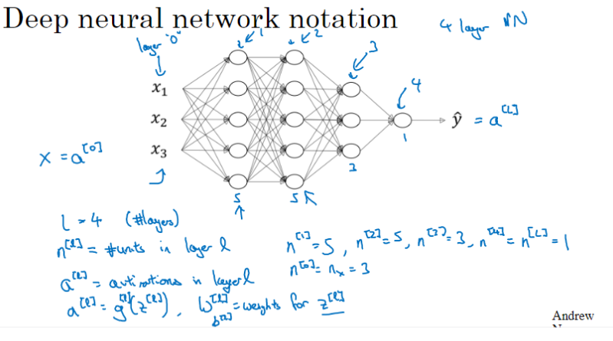

### 4.2 深层网络中的前向传播

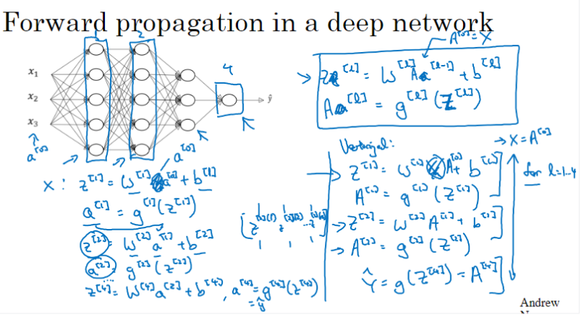

### 4.3 核对矩阵的维数

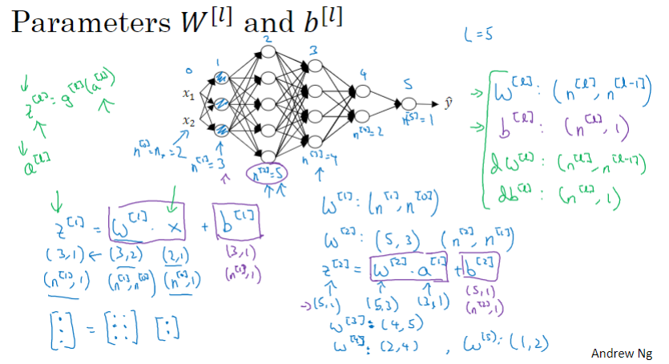

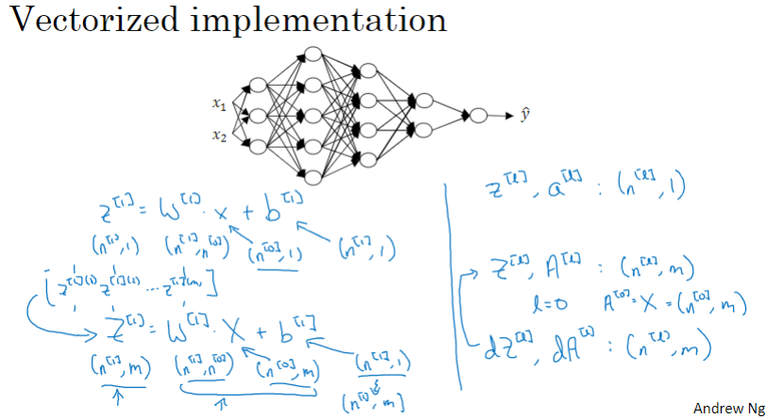

### 4.4 为什么使用深层表示？

深度表示的直观感受：

以人脸识别为例：边缘检测 -> 眼睛、鼻子等人脸要素的识别 -> “人脸”的组装

以音频识别为例：声波识别 -> 音位识别 -> 单词识别 -> 句子、短语的识别

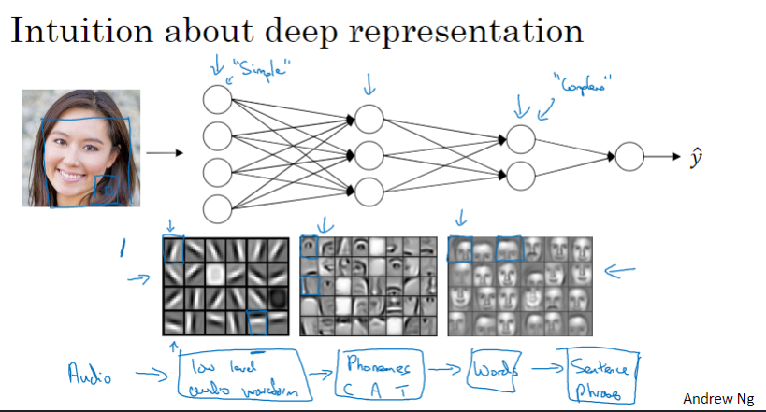

电路理论对深度学习的解释（如果不使用层次结构，输入单元数将会指数级增长）

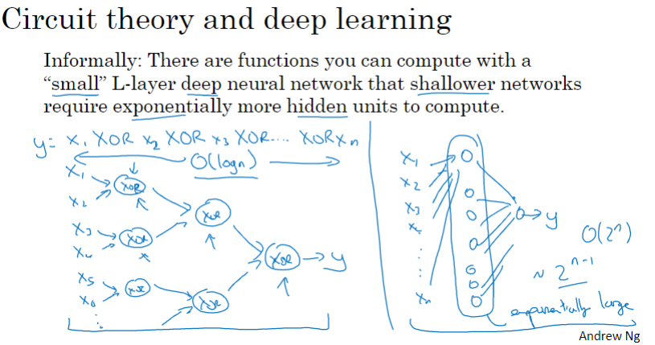

### 4.5 深层神经网络的搭建

前向传播和反向传播

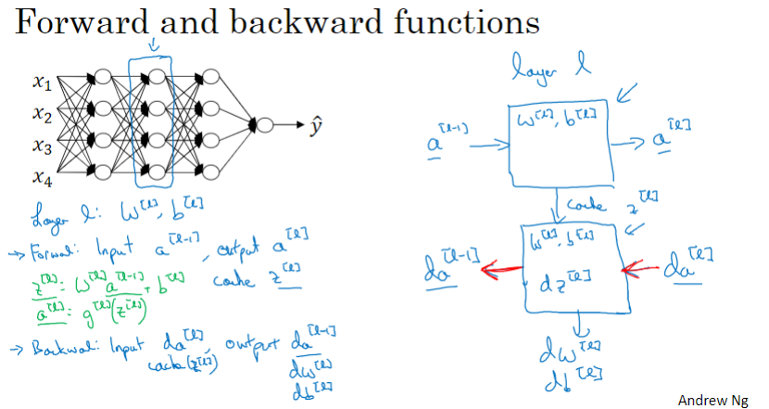

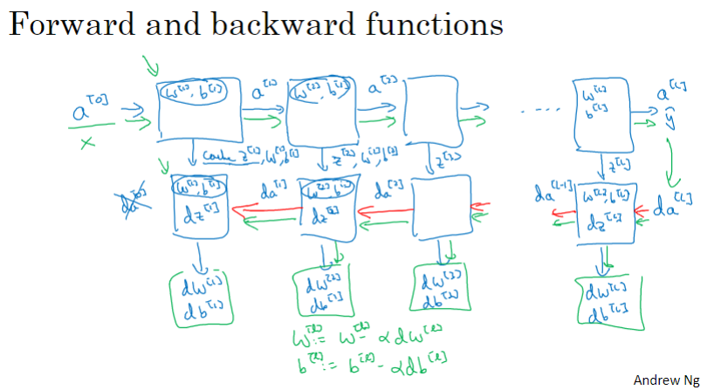

### 4.6 前向和反向传播

前向传播

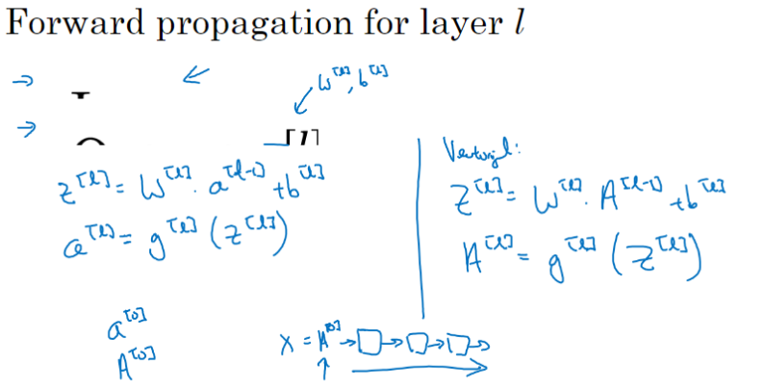

反向传播

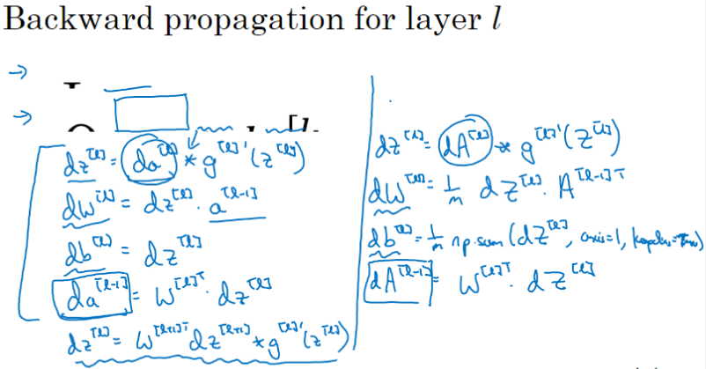

### 4.7 参数 VS 超参数

参数：W、b

超参数：学习率α、循环次数（循环一次表示遍历所有训练数据一遍）、隐层数L、隐层单元数n[l]、所选激活函数、动量momentum、小批量大小(minibatch size)、正则化(regularization)等

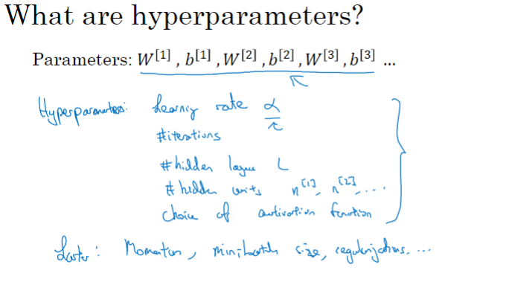

深度学习的应用目前还是相当依赖经验的

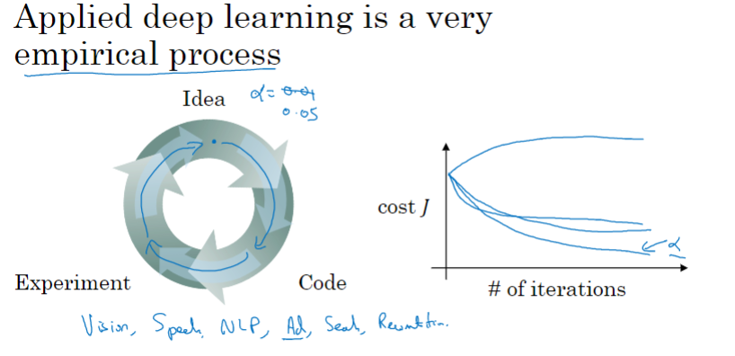

### 4.8 这和大脑有什么关系？

深度学习神经网络虽然使用了“神经”一次，但目前即使神经学家也并不清楚单个神经元（neuro, dendrite（树突）、axon（轴突））的工作机制， “人工神经网络”和大脑神经并没有必然的关系。

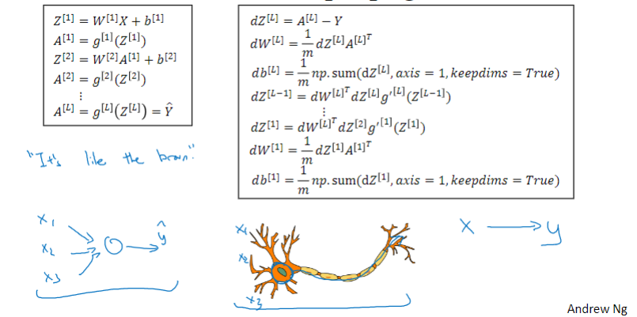

### C1W4 Quiz - Key concepts on Deep Neural Networks

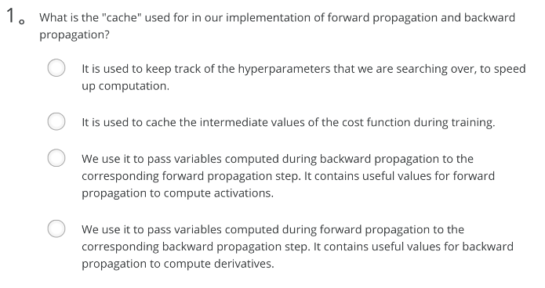

Ans: D

Note: the "cache" records values from the forward propagation units and sends it to the backward propagation units because it is needed to compute the chain rule derivatives.

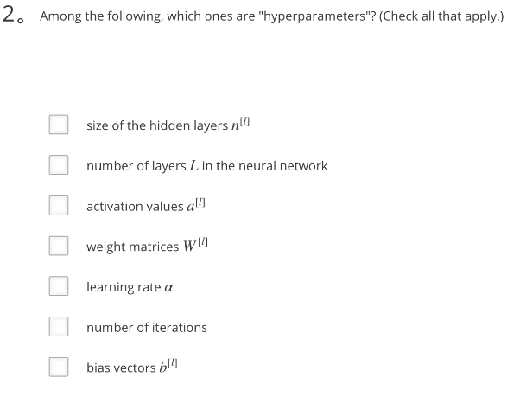

Ans: A、B、E、F

Note: You can check [this Quora post](https://www.quora.com/What-are-hyperparameters-in-machine-learning) （https://www.quora.com/What-are-hyperparameters-in-machine-learning） or [this blog post](http://colinraffel.com/wiki/neural_network_hyperparameters) （http://colinraffel.com/wiki/neural_network_hyperparameters）.

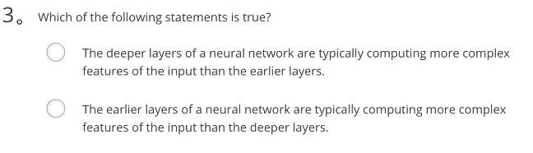

Ans: A

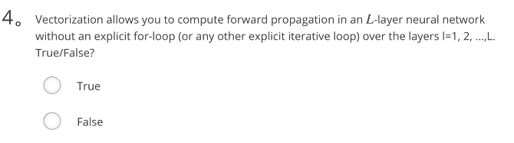

Ans: False

Note: We cannot avoid the for-loop iteration over the computations among layers.

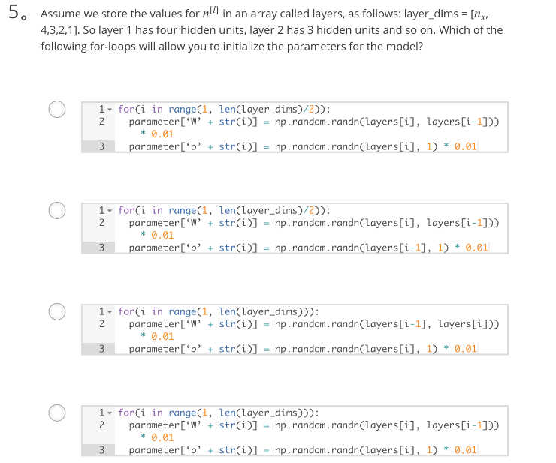

Ans: D

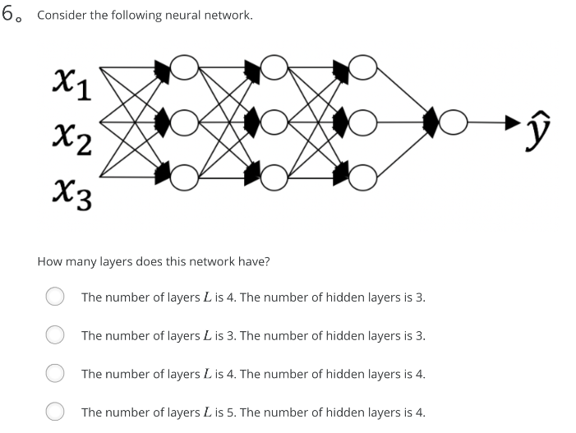

Ans: A

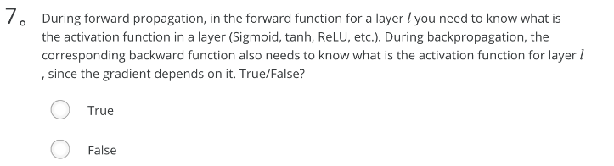

Ans: True

Note: During backpropagation you need to know which activation was used in the forward propagation to be able to compute the correct derivative.

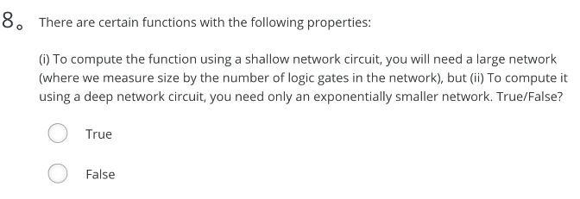

Ans: True

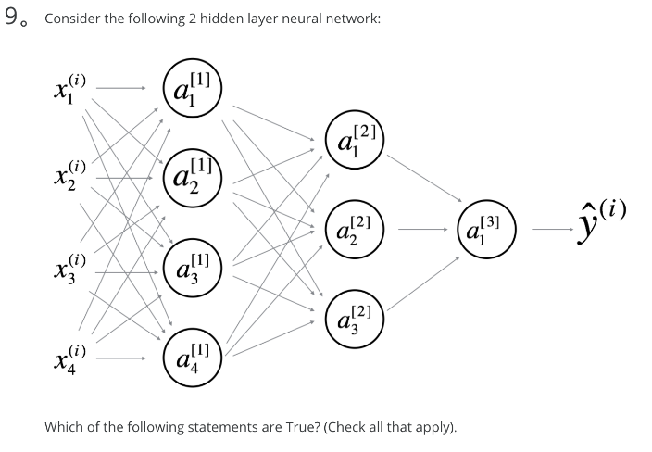

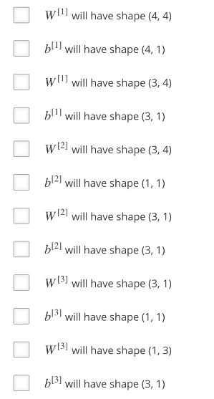

Ans: A、B、E、H、J、K

Note: See [this image](https://user-images.githubusercontent.com/14886380/29200515-7fdd1548-7e88-11e7-9d05-0878fe96bcfa.png) (<https://user-images.githubusercontent.com/14886380/29200515-7fdd1548-7e88-11e7-9d05-0878fe96bcfa.png>) for general formulas.

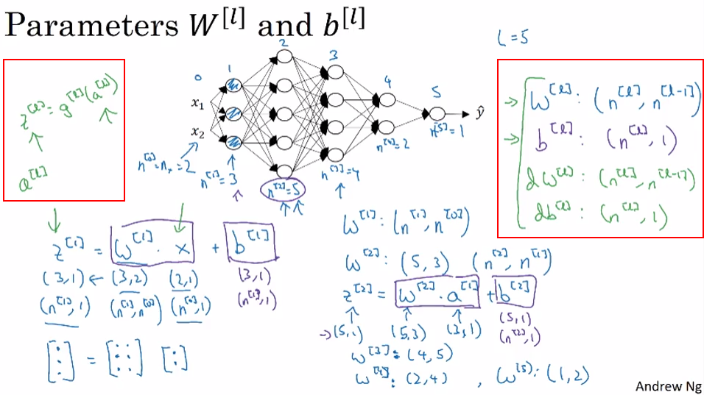

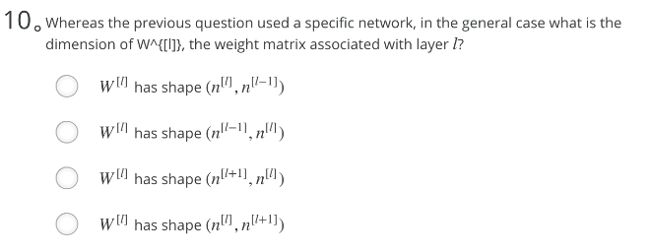

Ans: A

1. What is the "cache" used for in our implementation of forward propagation and backward propagation?
   *  It is used to cache the intermediate values of the cost function during training.
   *  We use it to pass variables computed during forward propagation to the corresponding backward propagation step. It contains useful values for backward propagation to compute derivatives.
   *  It is used to keep track of the hyperparameters that we are searching over, to speed up computation.
   *  We use it to pass variables computed during backward propagation to the corresponding forward propagation step. It contains useful values for forward propagation to compute activations.

the "cache" records values from the forward propagation units and sends it to the backward propagation units because it is needed to compute the chain rule derivatives.

1. Among the following, which ones are "hyperparameters"? (Check all that apply.) **I only list correct options.**
   * size of the hidden layers n[l]
   * learning rate α
   * number of iterations
   * number of layers L in the neural network

Note: You can check [this Quora post](https://www.quora.com/What-are-hyperparameters-in-machine-learning) or [this blog post](http://colinraffel.com/wiki/neural_network_hyperparameters).

1. Which of the following statements is true?
   *  The deeper layers of a neural network are typically computing more complex features of the input than the earlier layers. Correct
   *  The earlier layers of a neural network are typically computing more complex features of the input than the deeper layers.

Note: You can check the lecture videos. I think Andrew used a CNN example to explain this.

1. Vectorization allows you to compute forward propagation in an L-layer neural network without an explicit for-loop (or any other explicit iterative loop) over the layers l=1, 2, …,L. True/False?
   *  True
   *  False

Note: We cannot avoid the for-loop iteration over the computations among layers.

1. Assume we store the values for n^[l] in an array called layers, as follows: layer_dims = [n_x, 4,3,2,1]. So layer 1 has four hidden units, layer 2 has 3 hidden units and so on. Which of the following for-loops will allow you to initialize the parameters for the model?

for(i in range(1, len(layer_dims))):

parameter[‘W’ + str(i)] = np.random.randn(layers[i], layers[i - 1])) * 0.01

parameter[‘b’ + str(i)] = np.random.randn(layers[i], 1) * 0.01

1. Consider the following neural network.
   * The number of layers L is 4. The number of hidden layers is 3.

Note: The input layer (L^[0]) does not count.

As seen in lecture, the number of layers is counted as the number of hidden layers + 1. The input and output layers are not counted as hidden layers.

1. During forward propagation, in the forward function for a layer l you need to know what is the activation function in a layer (Sigmoid, tanh, ReLU, etc.). During backpropagation, the corresponding backward function also needs to know what is the activation function for layer l, since the gradient depends on it. True/False?
   *  True
   *  False

During backpropagation you need to know which activation was used in the forward propagation to be able to compute the correct derivative.

1. There are certain functions with the following properties:

(i) To compute the function using a shallow network circuit, you will need a large network (where we measure size by the number of logic gates in the network), but (ii) To compute it using a deep network circuit, you need only an exponentially smaller network. True/False?

* +  True
  +  False

Note: See lectures, exactly same idea was explained.

1. Consider the following 2 hidden layer neural network:

Which of the following statements are True? (Check all that apply).

* + W^[1] will have shape (4, 4)
  + b^[1] will have shape (4, 1)
  + W^[2] will have shape (3, 4)
  + b^[2] will have shape (3, 1)
  + b^[3] will have shape (1, 1)
  + W^[3] will have shape (1, 3)

Note: See [this image](https://user-images.githubusercontent.com/14886380/29200515-7fdd1548-7e88-11e7-9d05-0878fe96bcfa.png) for general formulas.

1. Whereas the previous question used a specific network, in the general case what is the dimension of W^[l], the weight matrix associated with layer l?
   * W^[l] has shape (n^[l],n^[l−1])

Note: See [this image](https://user-images.githubusercontent.com/14886380/29200515-7fdd1548-7e88-11e7-9d05-0878fe96bcfa.png) for general formulas.

# 课程2——改善深层神经网络：超参数调试、正则化以及优化

## 第一周 深度学习的实用层面

### 训练 / 开发 / 测试集

机器学习的应用是个高度迭代的过程

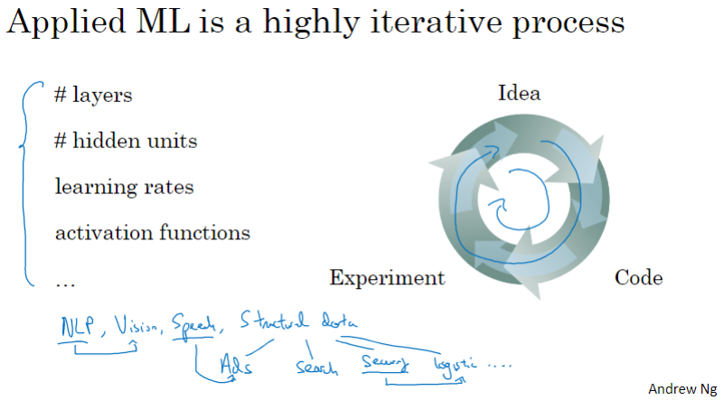

数据集的划分：训练集、开发集及测试集

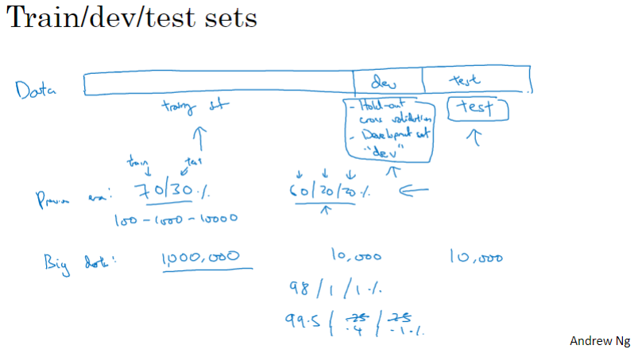

训练集和测试集的分布应该相同（匹配）

例如：在“识猫”应用中，若训练时使用高清图片，而开发、测试时使用低清晰度、较模糊的图片，则模型的可靠性值得怀疑

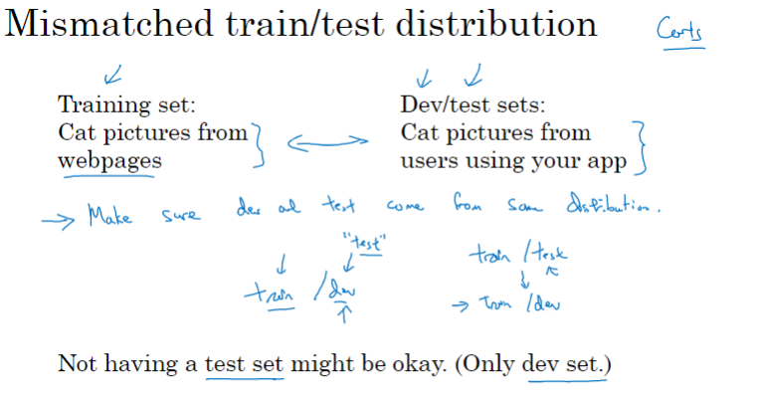

### 偏差 / 方差

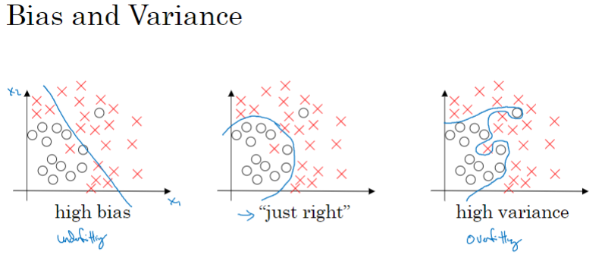

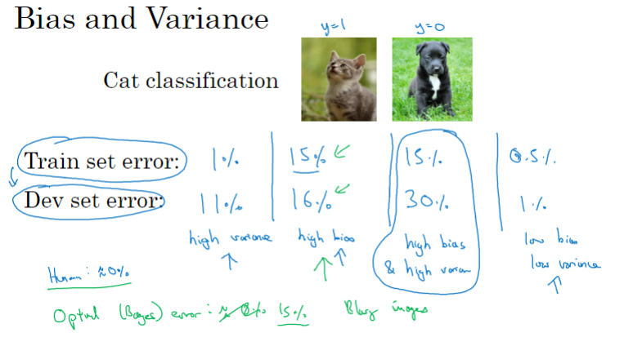

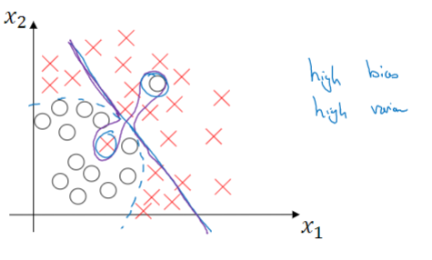

### 机器学习基本流程

注：高偏差（high bias）：训练集错误率高，相当于欠拟合（underfitting）

高方差（high various）：训练集错误率低，但验证集（开发集）错误率高，相当于过拟合（overfitting）

在深度学习中，如果模型中使用更大规模的网络，有利于消除高偏差，但并不用担心会引起高方差的问题。又比如，如果使用更多的数据，有利于消除高方差，但并不用担心会引起高偏差的问题。可以说，在深度学习中，高偏差和高方差的对立相比早期机器学习时期有所缓解，不再需要强调偏差——方差的权衡（bias - various tradeoff）。

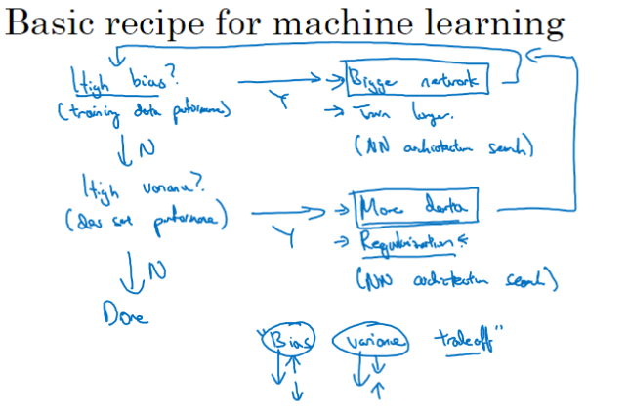

### 正则化

Logistic回归的正则化

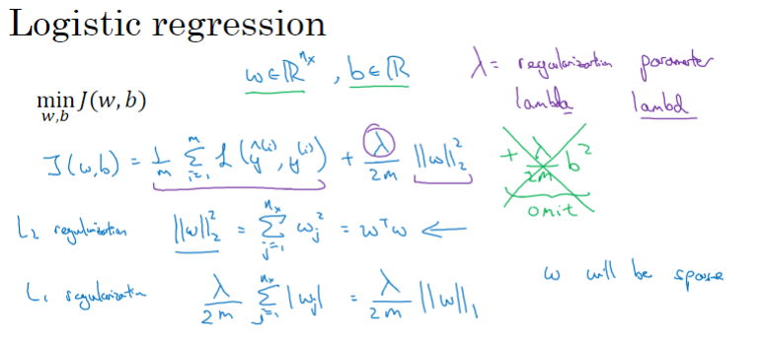

神经网络的正则化

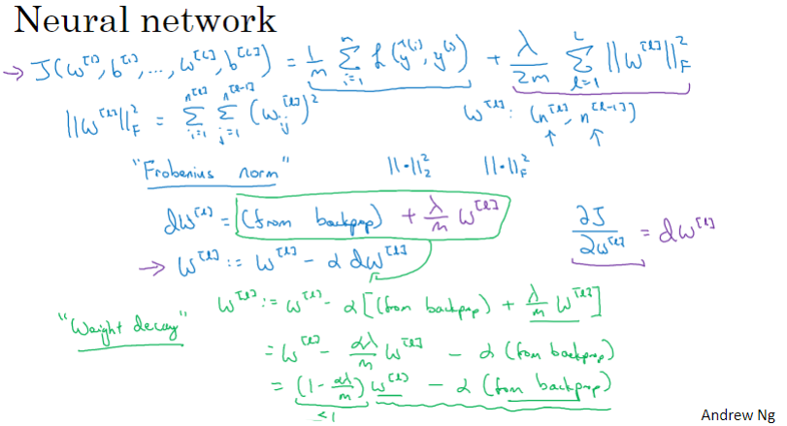

### 为什么正则化可以减少过拟合？

两个直观说明：

1. 假设正则化系数λ很大，则成本函数J中的权重系数可忽略不计，即趋近于零，相当于消除了网络中部分神经元，从而有利于降低过拟合。
2. 若激活函数为tanh，正则化系数λ增加后，权重系数倾向于减少，相当于将线性运算结果z的范围控制在tanh函数中心位置区域。而这块区域是比较“线性”的，从而可以减轻模型过拟合的程度。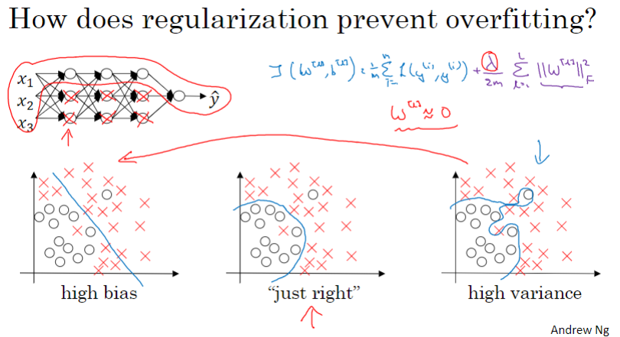

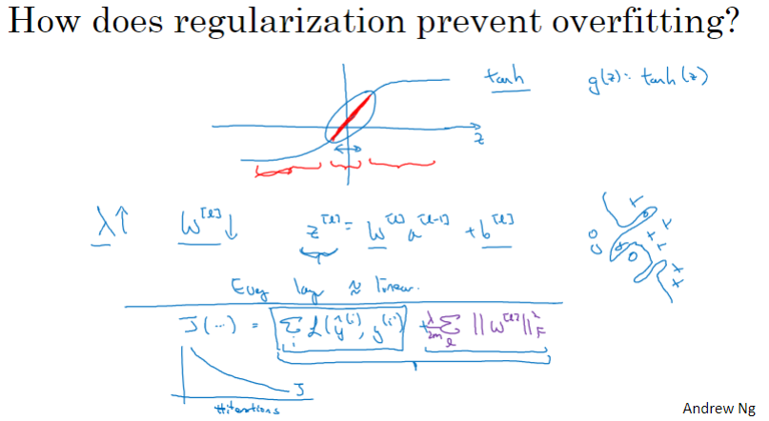

### Dropout 正则化

Dropout（丢弃，失活）正则化：随机选择一些神经元（计算节点），让其值清零（zero out），相当于从网络中随机删除一些神经元，从而降低网络复杂度，降低过拟合

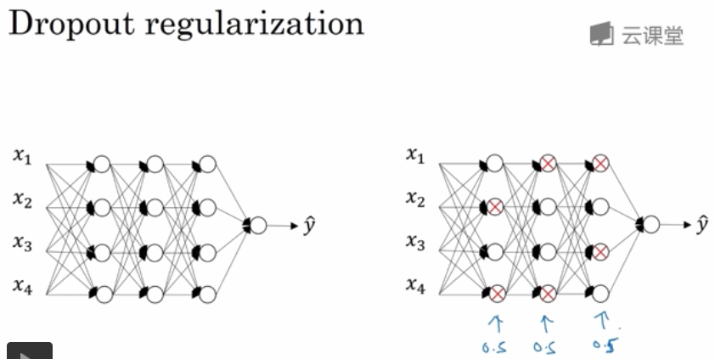

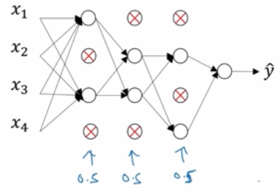

Inverted dropout（反向失活）的实现

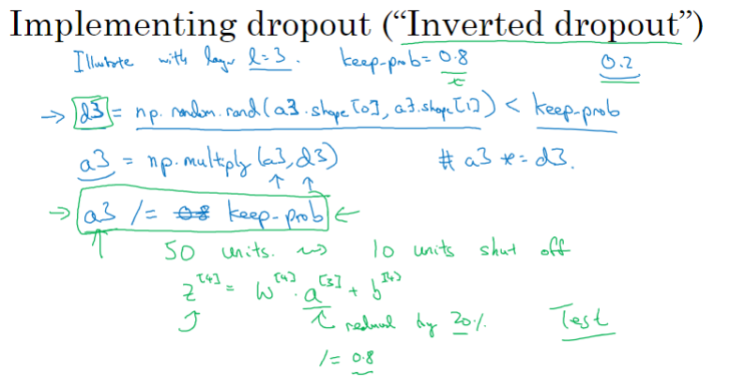

仅需在训练时进行dropout，测试时不需要

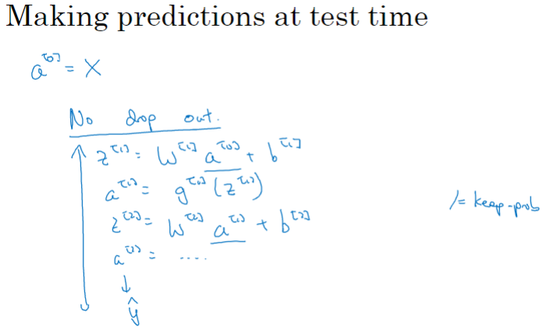

### 理解 Dropout

为什么dropout有用？直观理解：任何一个特征都有可能被随机地“消除”，必须将权重分散到各个神经元，从而起到压缩权重(shrink weights)的作用。（注：这段描述不是很理解）

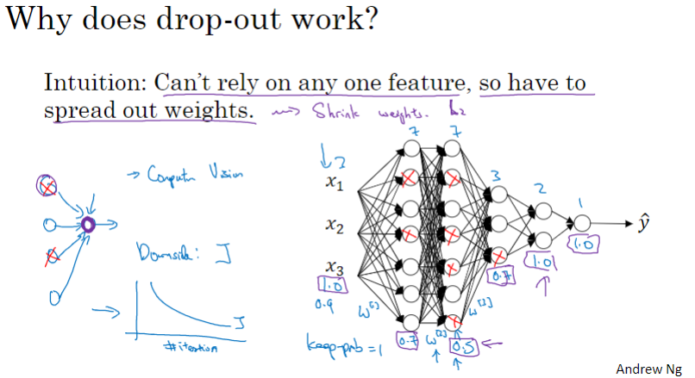

### 其他正则化方法

数据增广（利用现有数据，创建新数据，扩增训练集，防止过拟合）

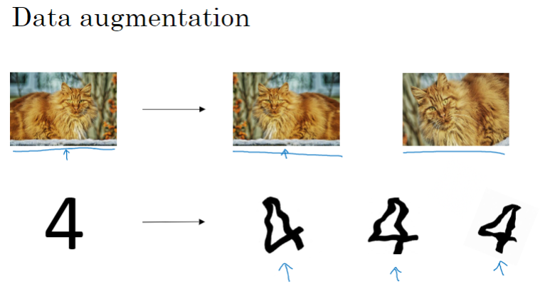

早停（提前停止迭代，训练准确度会下降，但验证集准确度反而会提高，即，防止了过拟合）

早停的不好之处：将成本函数的优化和防止过拟合这两个任务耦合在了一起，并不符合通用的“正交化”方法，即将成本函数优化和过拟合看作两个互不相干的任务，分开执行

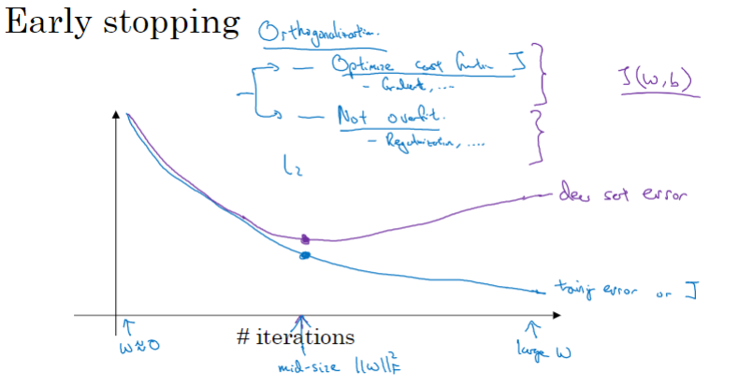

### 数据归一化（规范化）

训练集的归一化示例

1. 零均值化——训练集特征值减去其平均值
2. 求特征值平方均值
3. 零均值化后的特征值除以特征值平方均值

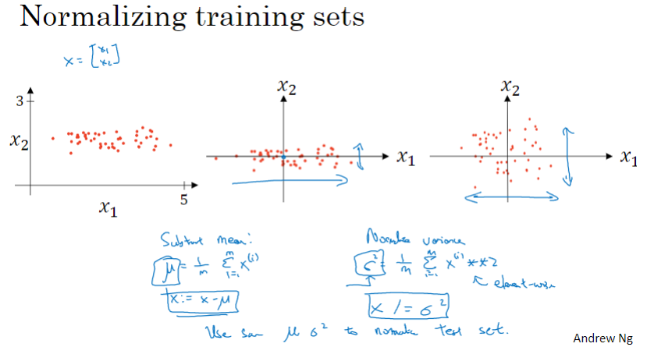

为什么需要归一化输入值（特征值）？

可以提高训练速度

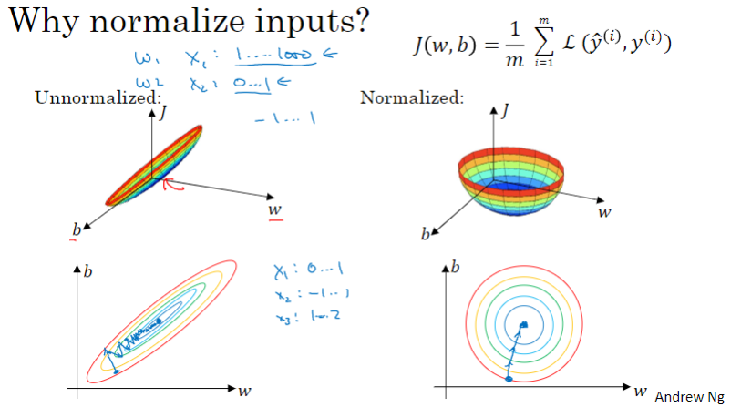

### 梯度消失与梯度爆炸

在深层网络中，对于指数运算，很容易出现数值过大或过小，分别对应梯度爆炸和梯度减小

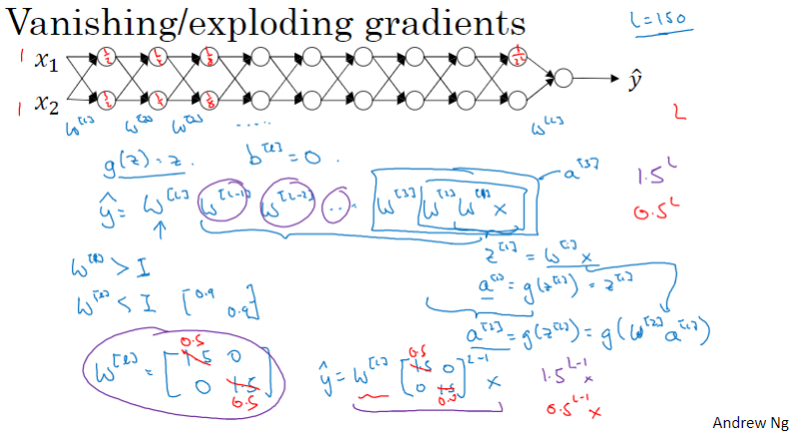

### 深度网络的权重初始化

通过在初始化权重时进行适当调整（如，随机数乘以上层节点数的倒数的平方根），可以减轻梯度爆炸或梯度消失

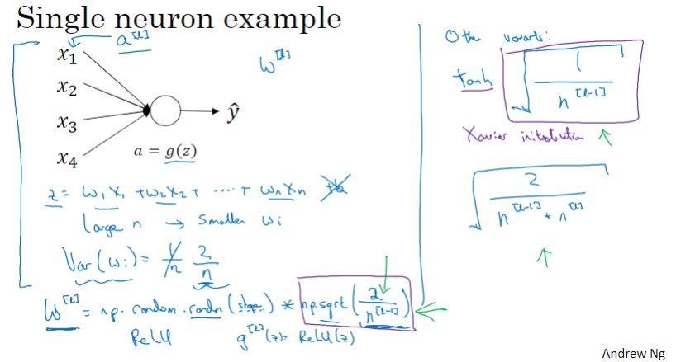

### 梯度的数值逼近

数值逼近（数值解）求导可用于检查梯度计算是否正确

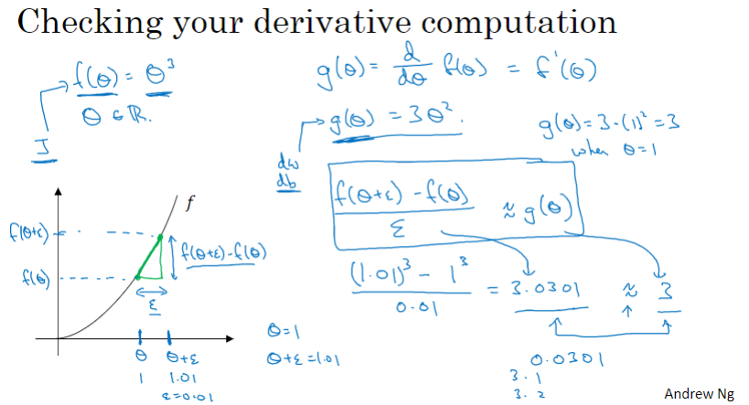

双边数值逼近（two sided numerical approximations）的精度要高于单边逼近

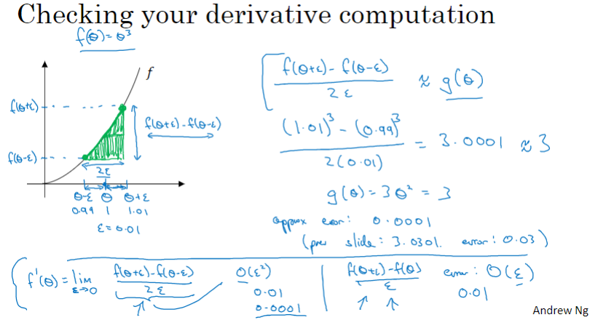

### 梯度检验

将所有参数重排（reshape、拉平）后连接成一个大向量θ

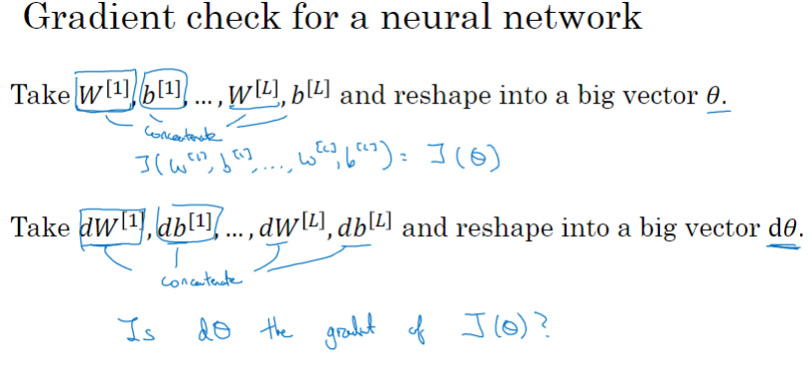

检查J(θ)的数值解导数是否足够接近解析解导数d(θ)（反向传播中的导数），如果不够接近，说明算法可能有bug

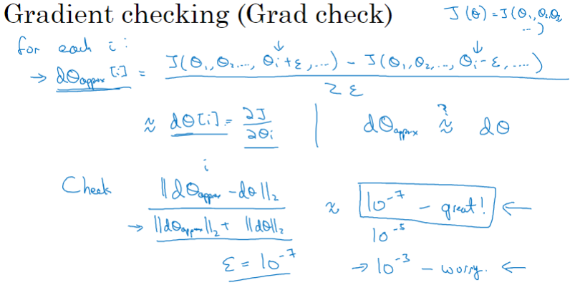

### 梯度检验实践中的注意事项

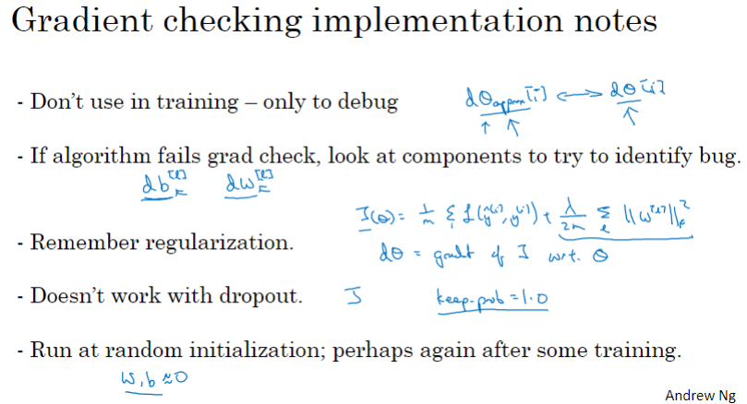

### C2W1 Quiz - Practical aspects of deep learning

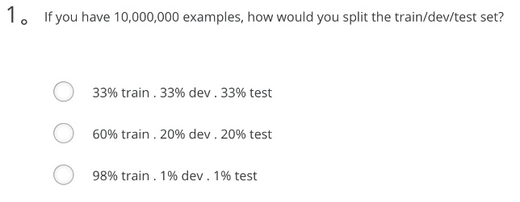

Ans: C

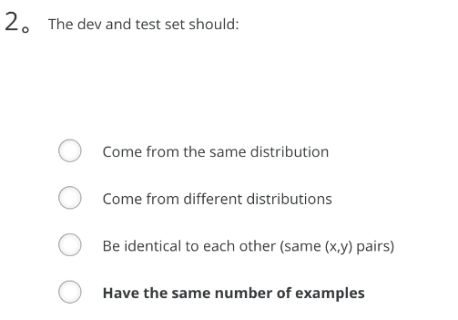

Ans: A (Come from the same distribution)

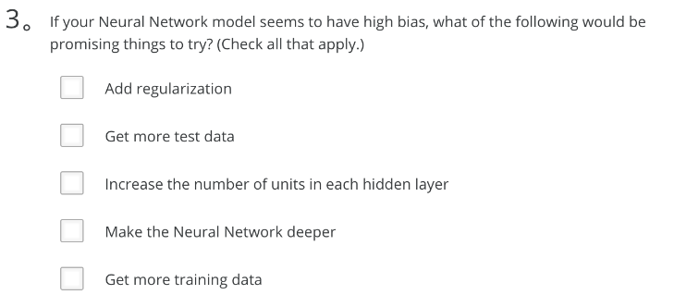

Ans: C、D

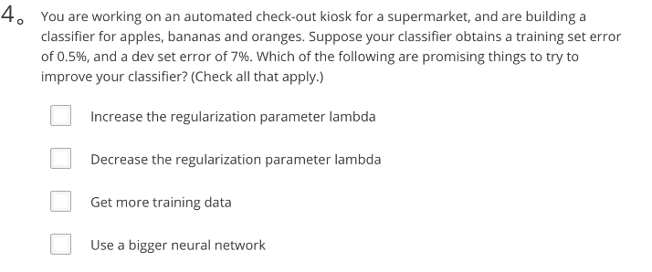Ans: A、C

Note: refer below diagram

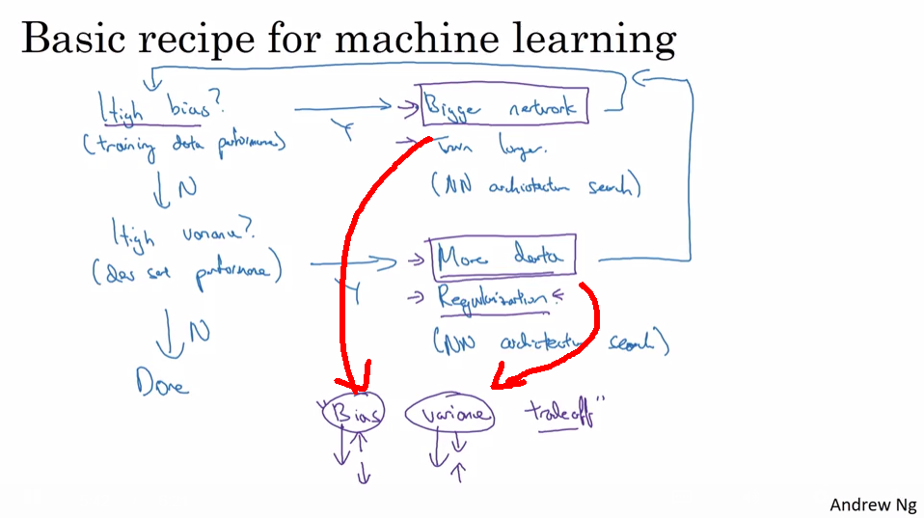

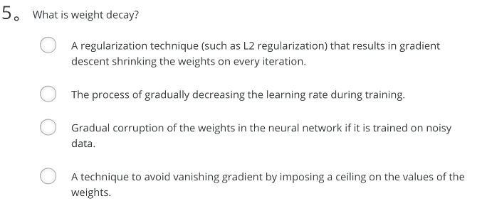

Ans: A

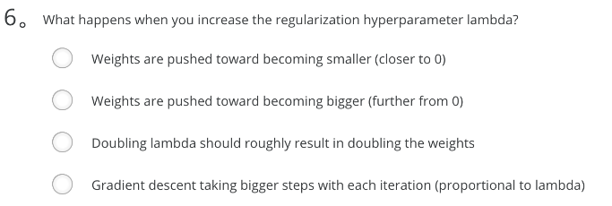

Ans: A

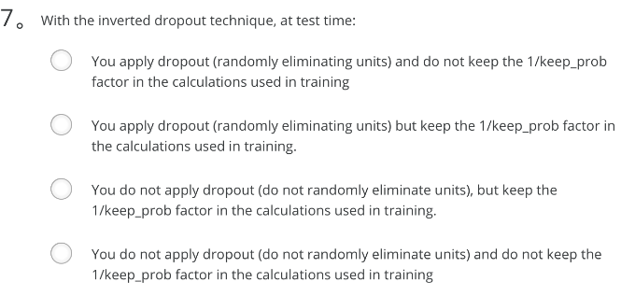

Ans: D

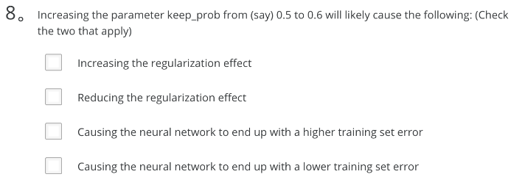

Ans: B、D

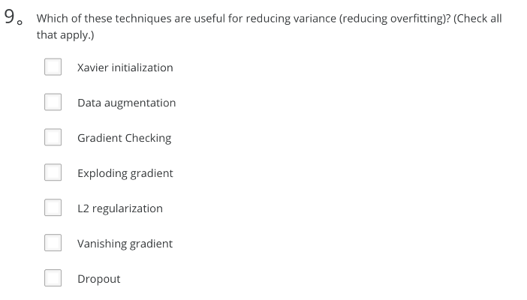

Ans: B、E、G (Data augmentation, L2 regularization, Dropout)

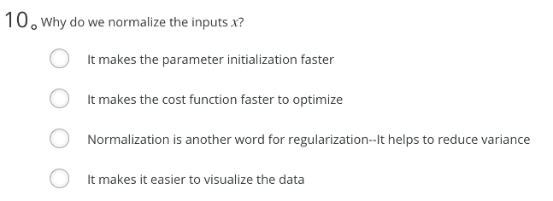

Ans: B

1. If you have 10,000,000 examples, how would you split the train/dev/test set?
   * 98% train . 1% dev . 1% test
2. The dev and test set should:
   * Come from the same distribution
3. If your Neural Network model seems to have high variance, what of the following would be promising things to try?
   * Add regularization
   * Get more training data
4. You are working on an automated check-out kiosk for a supermarket, and are building a classifier for apples, bananas and oranges. Suppose your classifier obtains a training set error of 0.5%, and a dev set error of 7%. Which of the following are promising things to try to improve your classifier? (Check all that apply.)
   * Increase the regularization parameter lambda
   * Get more training data
5. What is weight decay?
   * A regularization technique (such as L2 regularization) that results in gradient descent shrinking the weights on every iteration.
6. What happens when you increase the regularization hyperparameter lambda?
   * Weights are pushed toward becoming smaller (closer to 0)
7. With the inverted dropout technique, at test time:
   * You do not apply dropout (do not randomly eliminate units) and do not keep the 1/keep_prob factor in the calculations used in training
8. Increasing the parameter keep_prob from (say) 0.5 to 0.6 will likely cause the following: (Check the two that apply)
   * Reducing the regularization effect
   * Causing the neural network to end up with a lower training set error
9. Which of these techniques are useful for reducing variance (reducing overfitting)? (Check all that apply.)
   * Dropout
   * L2 regularization
   * Data augmentation
10. Why do we normalize the inputs x?
    * It makes the cost function faster to optimize

## 第二周 优化算法

### Mini-batch 梯度下降法

Mini-batch是指将大的数据集分成更小规模的子集

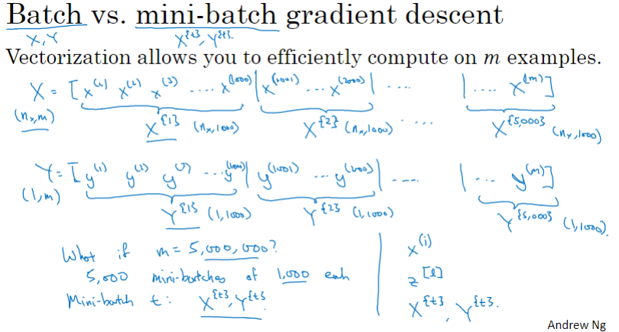

采用mini-batch梯度下降，在每次遍历完一个mini-batch后即可更新参数，而不用等待遍历完全部训练集才更新参数

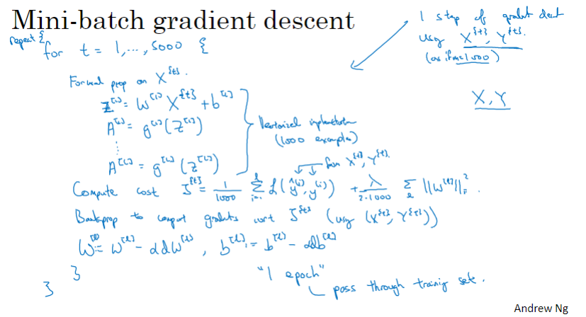

### 理解 mini-batch 梯度下降法

Mini-batch梯度下降不如Batch梯度下降那么平滑，但是整体趋势还是下降的

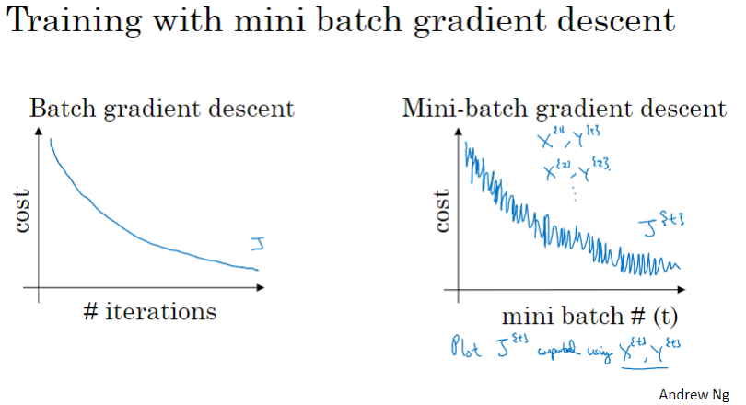

选择mini-batch的大小：

当size = m时，即为普通的batch梯度下降

当size = 1时，即为随机（stochastic）梯度下降

通常，选择折中的大小，mini-batch的大小也可作为一个超参数（hyper-parameter）进行确定

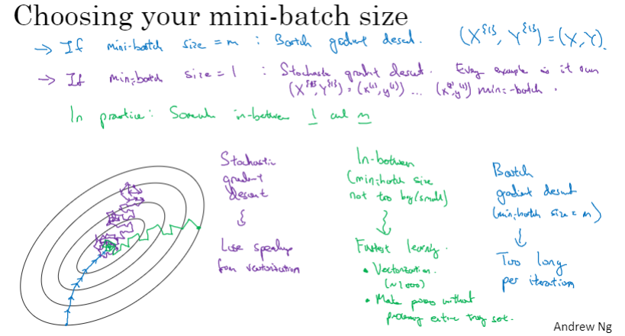

Mini-batch的大小通常选择为2的整数次幂（否则，训练速度可能会断崖式下降）

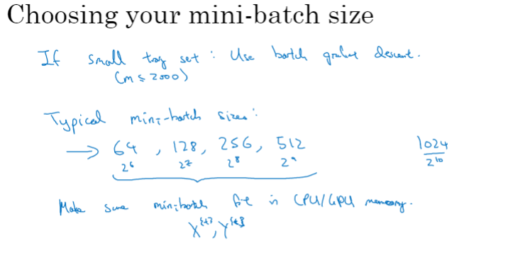

### 指数加权平均

通过加权平均，可以让数据更加“平滑”

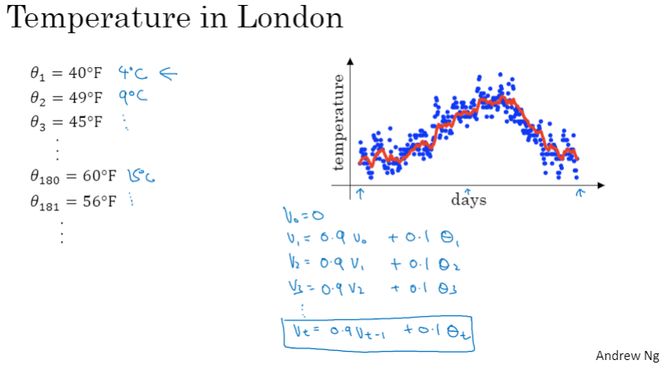

指数加权平均（vt = βvt-1 + (1-β)θt），β值越高，数据曲线更平滑，但同时曲线会更加向右偏移

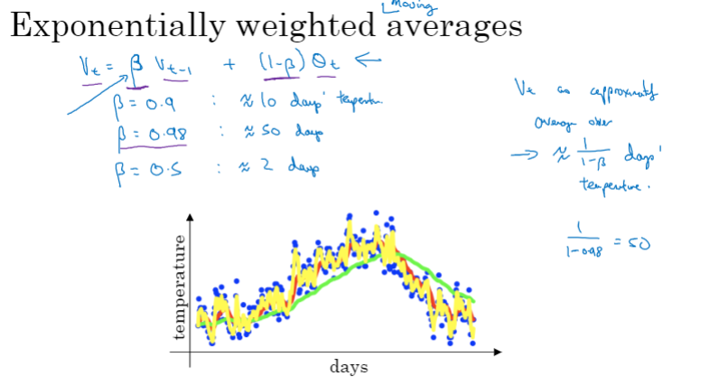

### 理解指数加权平均

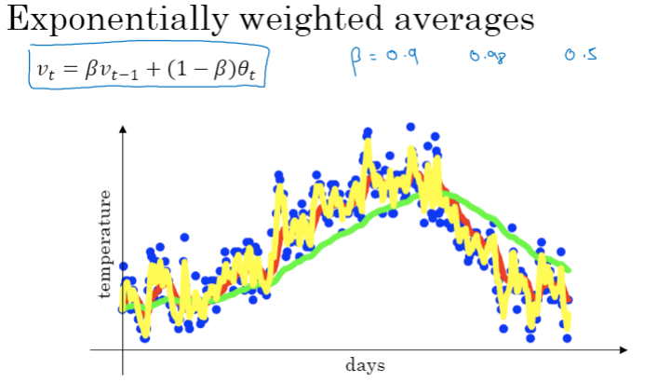

指数加权平均中的β有什么含义？β值越高，相当于在计算新值（当前值）时考虑了更多的历史数据

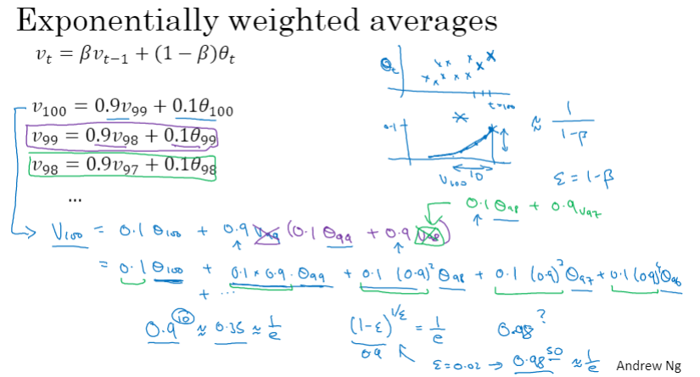

指数加权平均的实现示例，其优点时占用内存小（只用一行代码表示旧值）

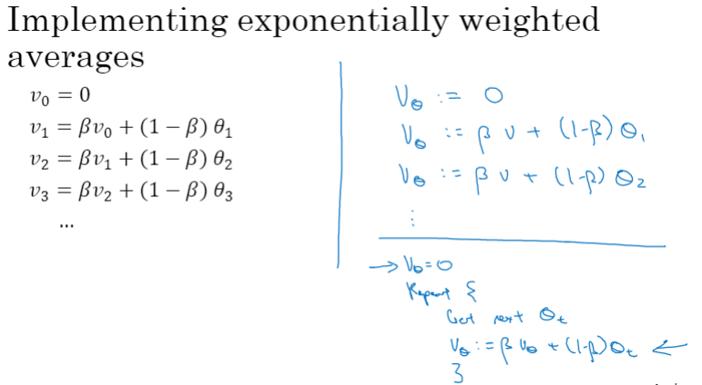

### 指数加权平均的偏差修正

采用指数加权平均后，头部数据值会明显偏低（出现偏差），可对此进行修正

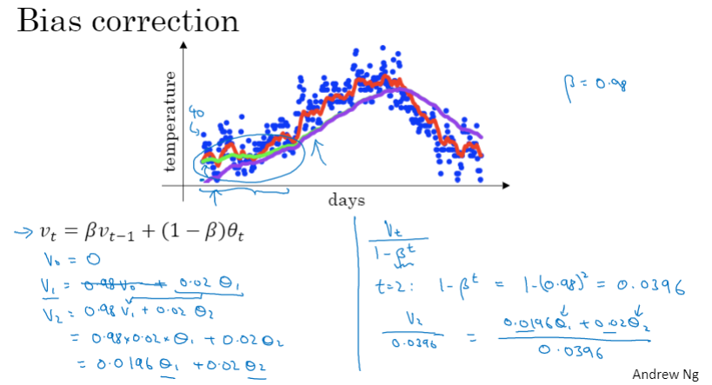

### 动量梯度下降法

动量梯度下降法可加速梯度下降过程

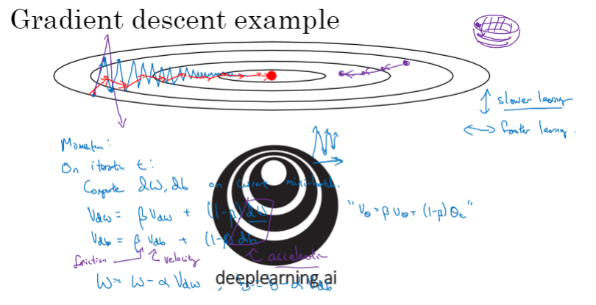

动量梯度下降法的实现方法

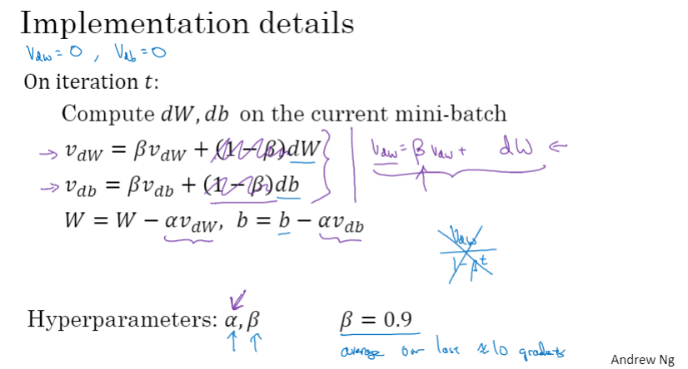

### RMSprop

RMSprop（Root Mean Square Prop）算法

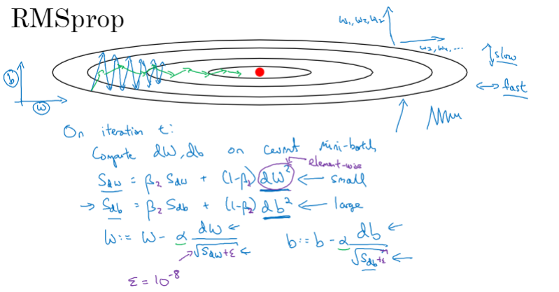

### Adam 优化算法

Adam（Adaptive Moment Estimation）优化算法

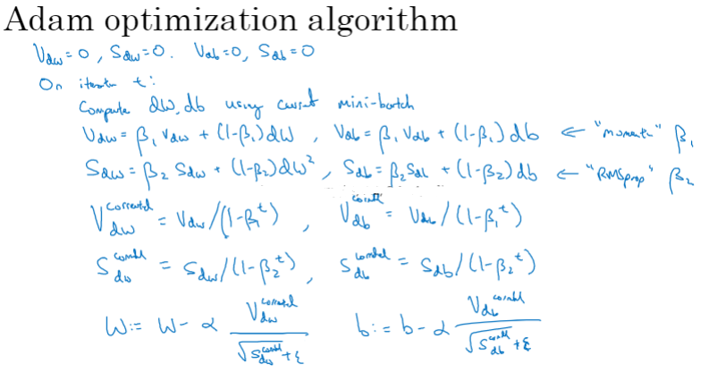

Adam优化算法超参数的选择

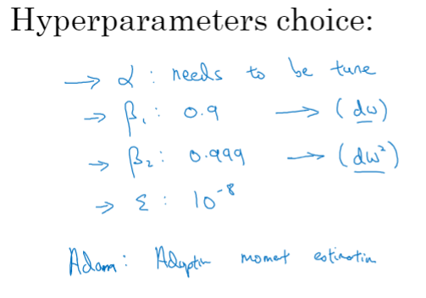

### 学习率衰减

梯度下降过程中，接近最优解时，应降低学习率，以减轻梯度下降曲线“漂移不定“的程度

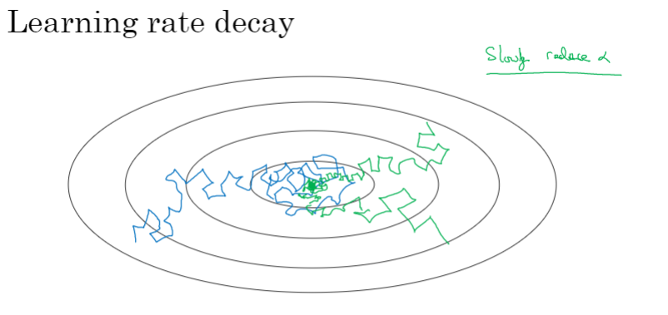

学习率衰减公式

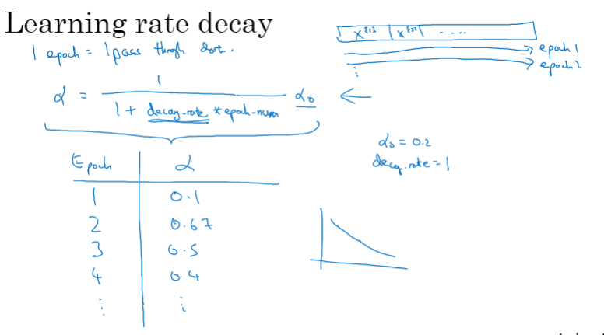

其他学习率衰减方法（如，指数衰减、均方根衰减、离散衰减、手动衰减等）

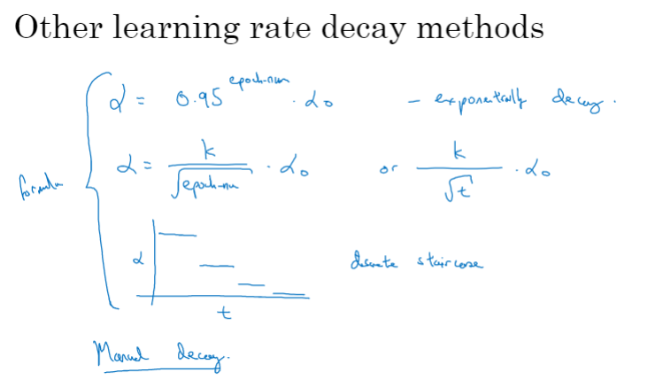

### 局部最优的问题

神经网络中的局部最优问题

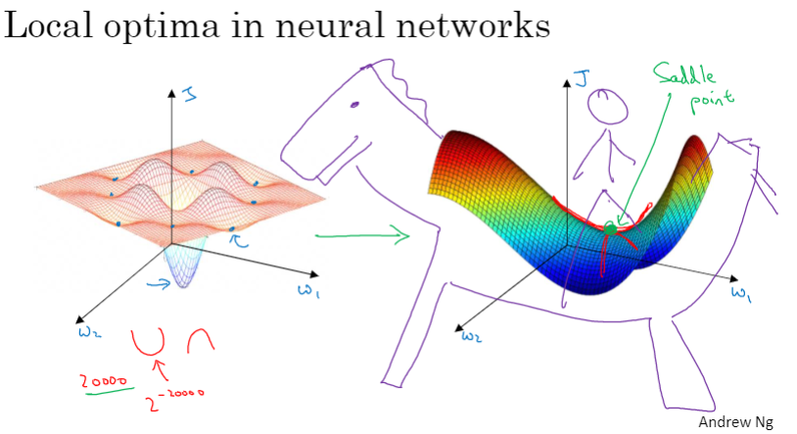

“梯度高原（平稳段）”问题

“梯度高原“是指梯度下降过程可能会进入到梯度下降非常缓慢的平稳段（plateau），使得训练速度非常缓慢

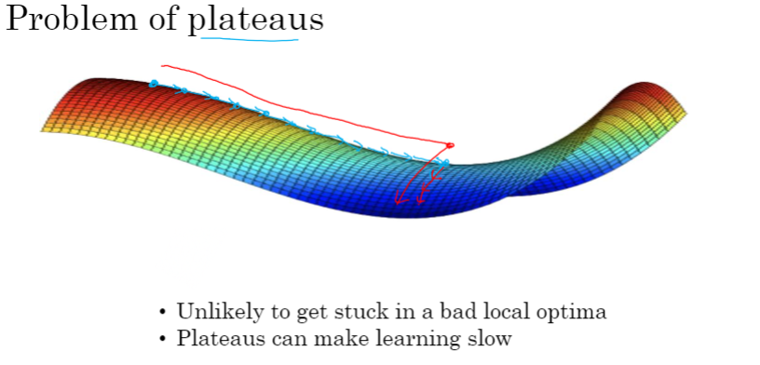

### C2W2 Quiz - Optimization algorithms

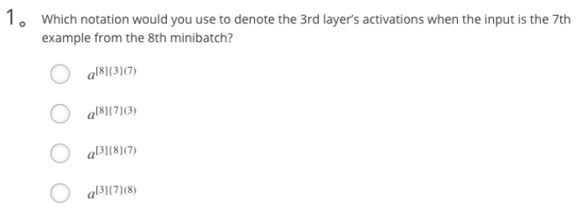

Ans: C

Note: **[i]{j}(k)** superscript means **i-th layer**, **j-th minibatch**, **k-th example**

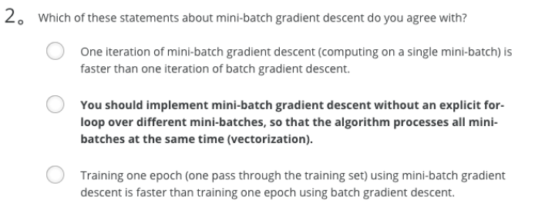

Ans: A

Note: Vectorization is not for computing several mini-batches in the same time.

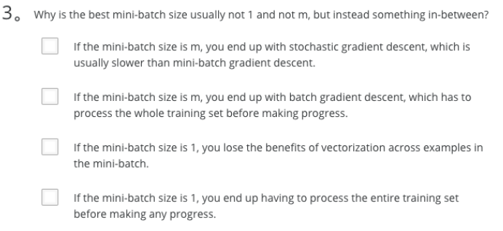

Ans: B、C

Ans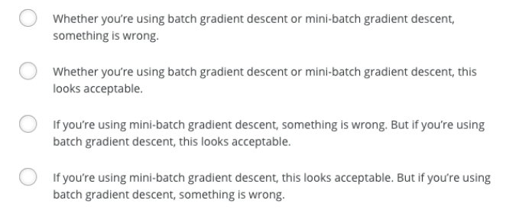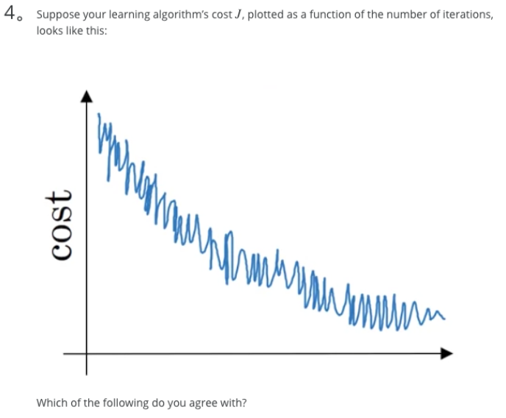: D

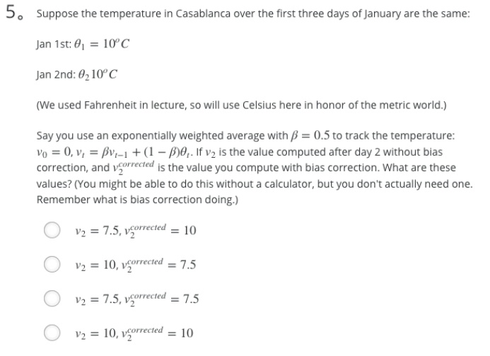

Ans: A

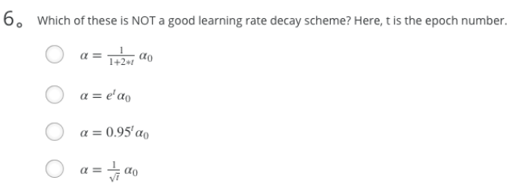

Ans: B

Note: This will explode the learning rate rather than decay it.

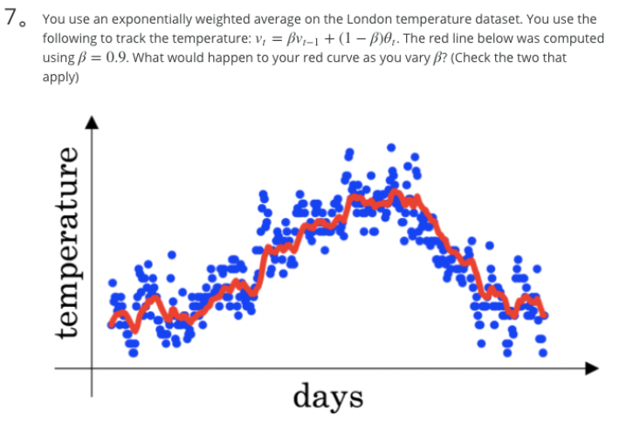

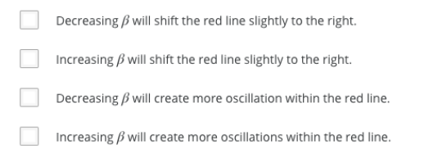

Ans: B、C

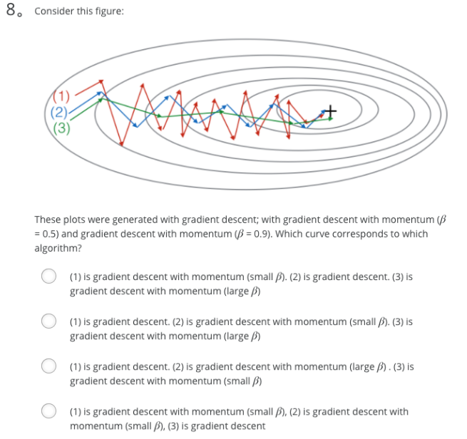

Ans: B

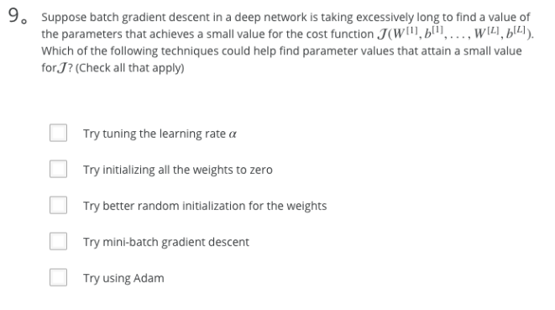

Ans: A、C、D、E

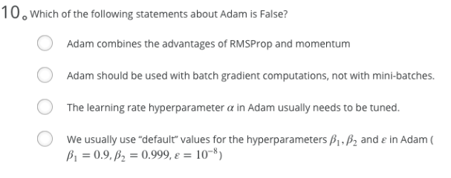

Ans: B

1. Which notation would you use to denote the 3rd layer’s activations when the input is the 7th example from the 8th minibatch?
   * a^[3]{8}(7)

Note: **[i]{j}(k)** superscript means **i-th layer**, **j-th minibatch**, **k-th example**

1. Which of these statements about mini-batch gradient descent do you agree with?
   *  You should implement mini-batch gradient descent without an explicit for-loop over different mini-batches, so that the algorithm processes all mini-batches at the same time (vectorization).
   *  Training one epoch (one pass through the training set) using mini-batch gradient descent is faster than training one epoch using batch gradient descent.
   *  One iteration of mini-batch gradient descent (computing on a single mini-batch) is faster than one iteration of batch gradient descent.

Note: Vectorization is not for computing several mini-batches in the same time.

1. Why is the best mini-batch size usually not 1 and not m, but instead something in-between?
   * If the mini-batch size is 1, you lose the benefits of vectorization across examples in the mini-batch.
   * If the mini-batch size is m, you end up with batch gradient descent, which has to process the whole training set before making progress.
2. Suppose your learning algorithm’s cost ***J***, plotted as a function of the number of iterations, looks like this:
   * If you’re using mini-batch gradient descent, this looks acceptable. But if you’re using batch gradient descent, something is wrong.

Note: There will be some oscillations when you're using mini-batch gradient descent since there could be some noisy data example in batches. However batch gradient descent always guarantees a lower ***J*** before reaching the optimal.

1. Suppose the temperature in Casablanca over the first three days of January are the same:

Jan 1st: θ_1 = 10

Jan 2nd: θ_2 = 10

Say you use an exponentially weighted average with β = 0.5 to track the temperature: v_0 = 0, v_t = βv_t−1 + (1 − β)θ_t. If v_2 is the value computed after day 2 without bias correction, and v^corrected_2 is the value you compute with bias correction. What are these values?

* + v_2 = 7.5, v^corrected_2 = 10

1. Which of these is NOT a good learning rate decay scheme? Here, t is the epoch number.
   * α = e^t * α_0

Note: This will explode the learning rate rather than decay it.

1. You use an exponentially weighted average on the London temperature dataset. You use the following to track the temperature: v_t = βv_t−1 + (1 − β)θ_t. The red line below was computed using β = 0.9. What would happen to your red curve as you vary β? (Check the two that apply)
   * Increasing β will shift the red line slightly to the right.
   * Decreasing β will create more oscillation within the red line.
2. Consider this figure:

These plots were generated with gradient descent; with gradient descent with momentum (β = 0.5) and gradient descent with momentum (β = 0.9). Which curve corresponds to which algorithm?

(1) is gradient descent. (2) is gradient descent with momentum (small β). (3) is gradient descent with momentum (large β)

1. Suppose batch gradient descent in a deep network is taking excessively long to find a value of the parameters that achieves a small value for the cost function J(W[1],b[1],...,W[L],b[L]). Which of the following techniques could help find parameter values that attain a small value forJ? (Check all that apply)
   *  Try using Adam
   *  Try better random initialization for the weights
   *  Try tuning the learning rate α
   *  Try mini-batch gradient descent
   *  Try initializing all the weights to zero
2. Which of the following statements about Adam is False?
   * Adam should be used with batch gradient computations, not with mini-batches.

Note: Adam could be used with both.

## 第三周 超参数调试、Batch正则化和程序框架

### 超参数的调试（调参）

超参数有哪些？学习率α、动量梯度下降法参数β、Adam算法参数（β1、β2、ε）、神经网络的层数、神经网络各隐层的节点数、学习率衰减系数、mini-batch大小等

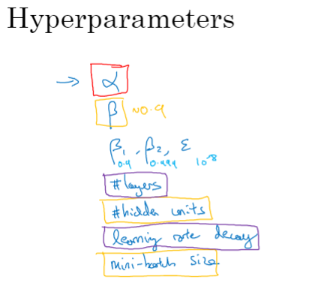

随机选择超参数一般胜过表格法（按照表格中的调整值一步步调整各参数，效率较低）

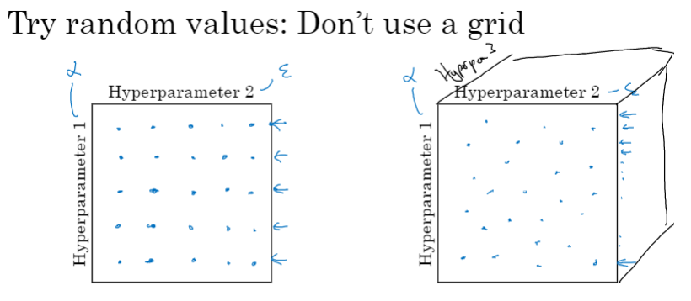

使用由粗到细的方法（coarse to fine）

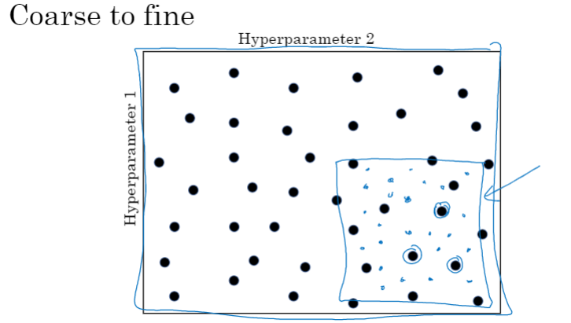

### 为超参数选择合适的范围

使用普通刻度（均匀刻度，uniform scale）随机选择超参数，如神经网络的层数、神经网络各隐层的节点数

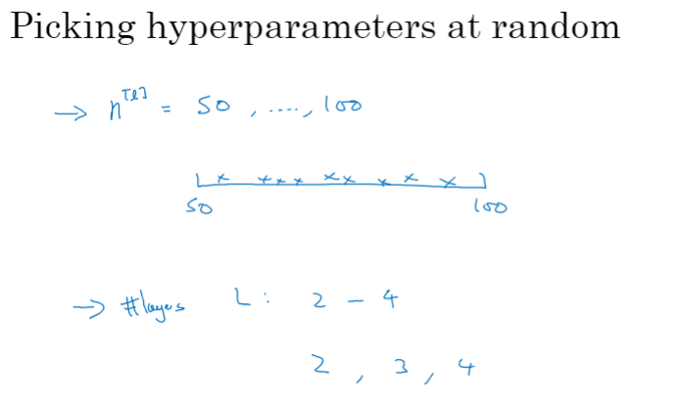

选择合适的超参数刻度（如，学习率可使用对数刻度，而不是均匀分布的普通刻度）

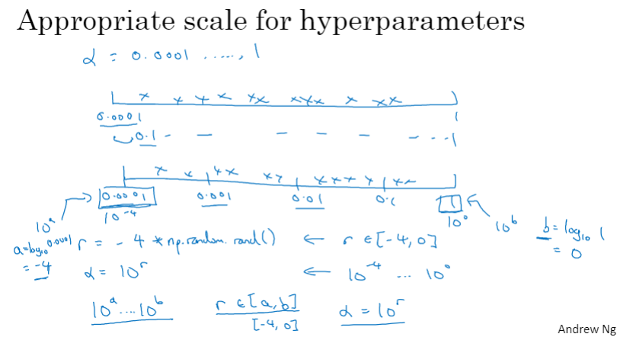

对于指数加权平均数（如，动量梯度下降参数β），应使用指数刻度而不是均匀刻度。如果使用均匀刻度，会发现当β接近1时，模型受更多数据量的影响，如，β从0.999提高到0.9995时，要考虑的历史数据量从1000上升到了2000，远高于β从0.9000提高到0.9005时的情况。

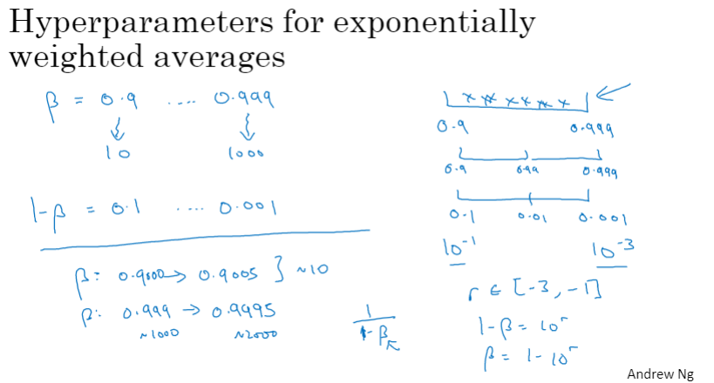

### 超参数训练的实践：Pandas VS Caviar

可从跨学科领域获取灵感（cross-fertilization），重新调整超参数

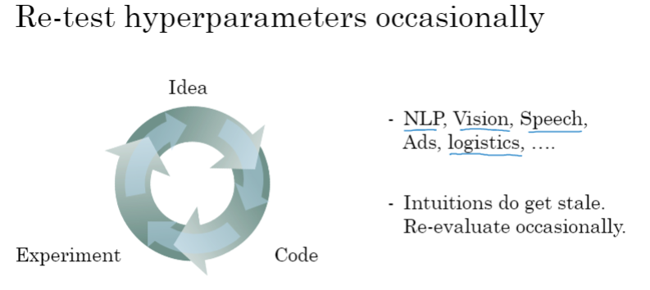

两种调参方式：熊猫育子方式（Panda）和鱼子方式（Caviar）

熊猫方式：针对一个模型精心调节参数，让其变得更优秀

鱼子方式：并行训练多个模型，选择最好的模型

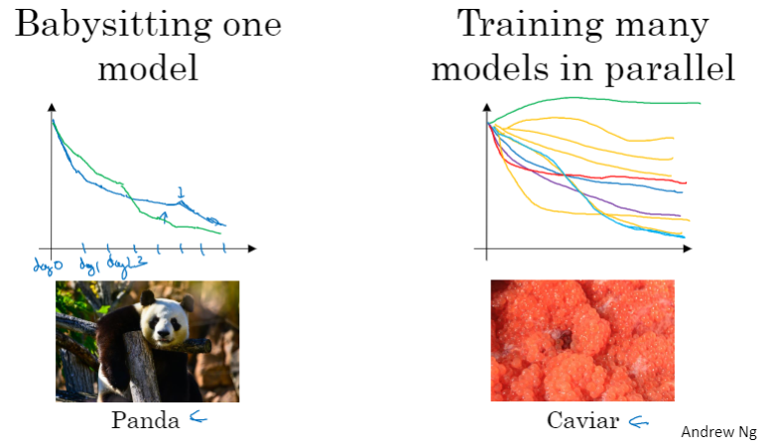

### 正则化网络的激活函数

正则化输入可以加速学习过程

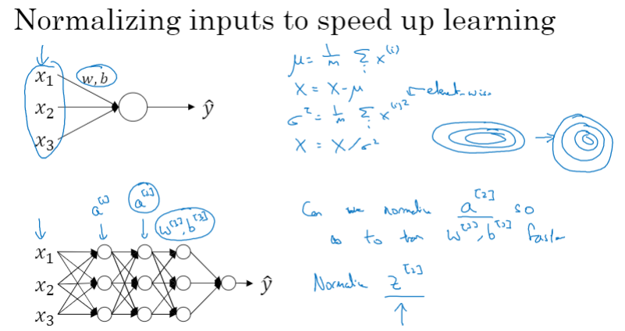

Batch Norm（批次正则化、批次归一化）的实现

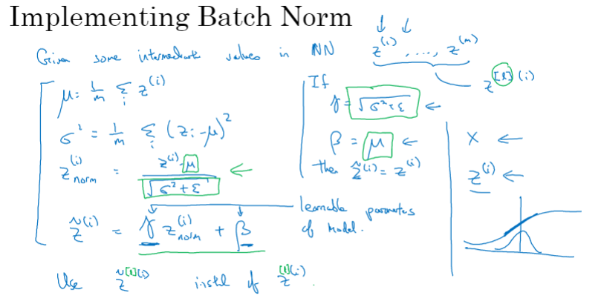

### 在神经网络中应用Batch Norm

在神经网络中加入Batch Norm处理（介于线性值Z和激活函数a之间）

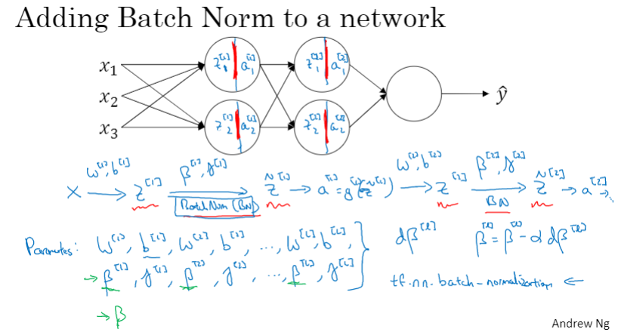

在mini-batch中使用Batch Norm（由于引入了Batch Norm参数β和γ，Z中的偏移项b可以省略或置零）

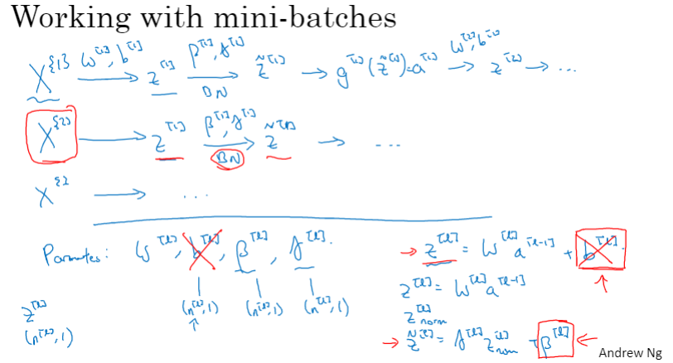

引入Batch Norm后梯度下降的实现

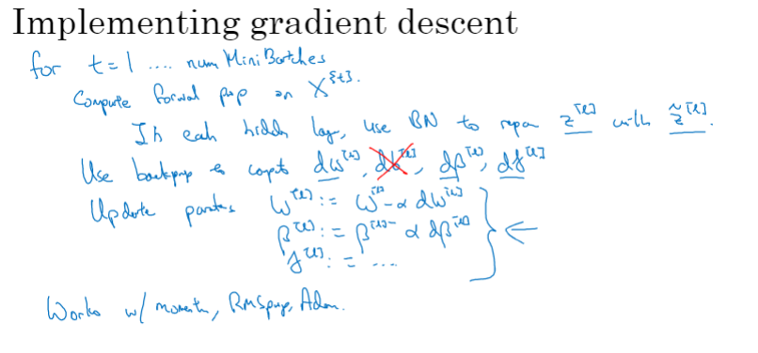

### Batch Norm 为什么奏效？。

样本变动（covariate shift）会使得模型的确定变得困难

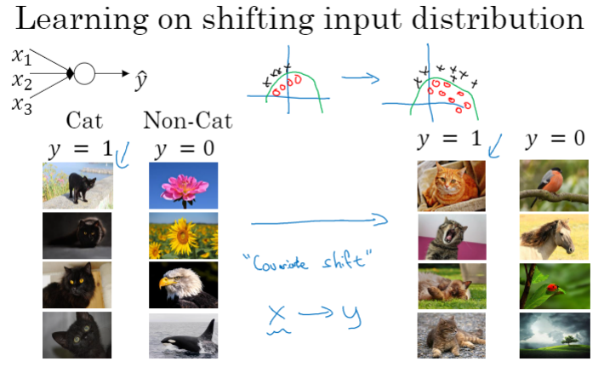

在不同的mini-batch中，激活函数a可能会变化较大，batch norm可使其更加“归一”

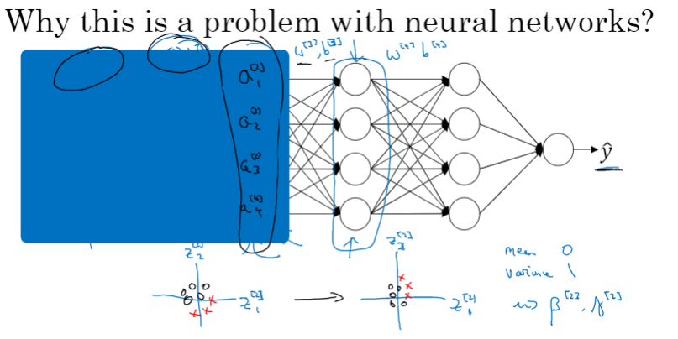

Batch Norm具有轻微的“正则化”效应，但这不是其目的，其目的在于加快训练速度

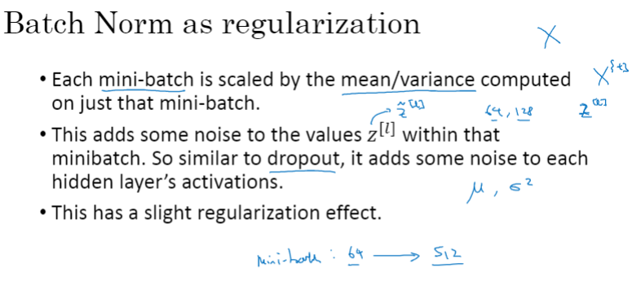

### 测试时如何使用Batch Norm？

测试时，可使用指数加权平均法来计算均值和方差

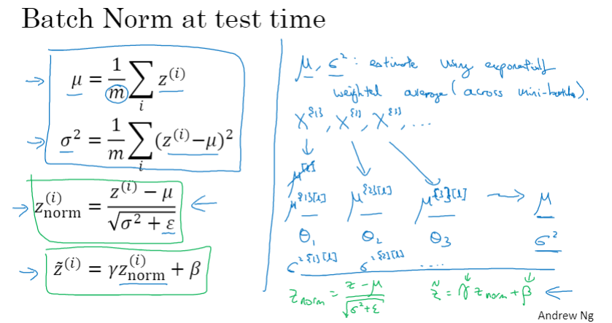

### Softmax 回归

Softmax可用于多分类，是二分类logistic回归的一般形式

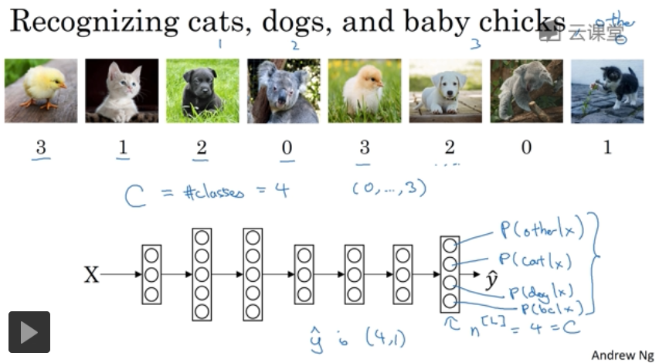

Softmax层的计算

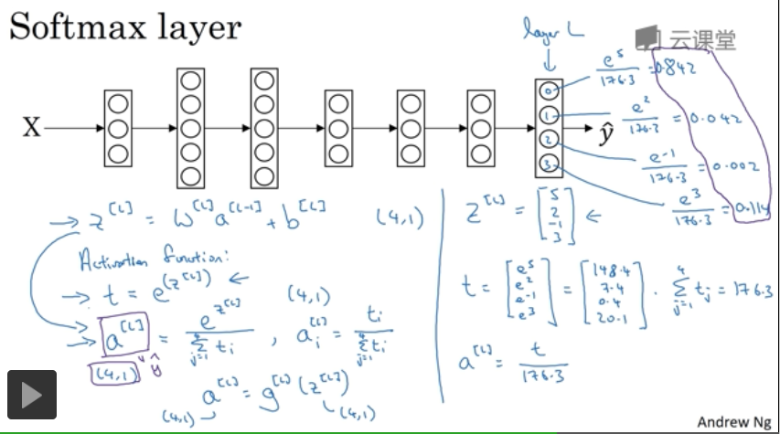

Softmax示例

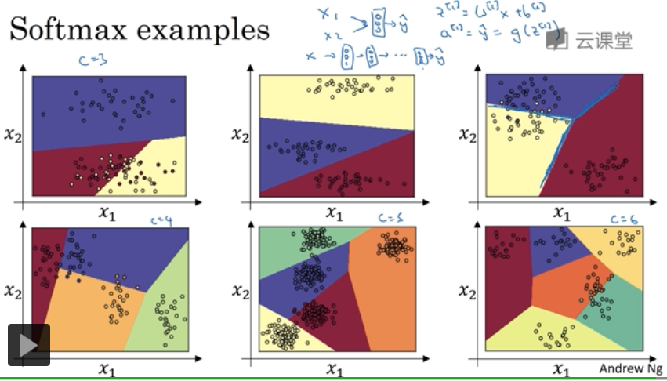

### 训练一个 Softmax 分类器

理解Softmax回归

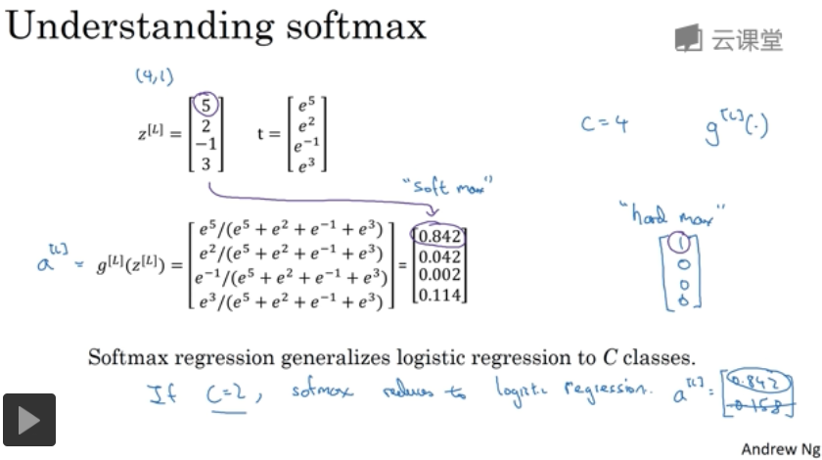

Softmax回归的损失函数

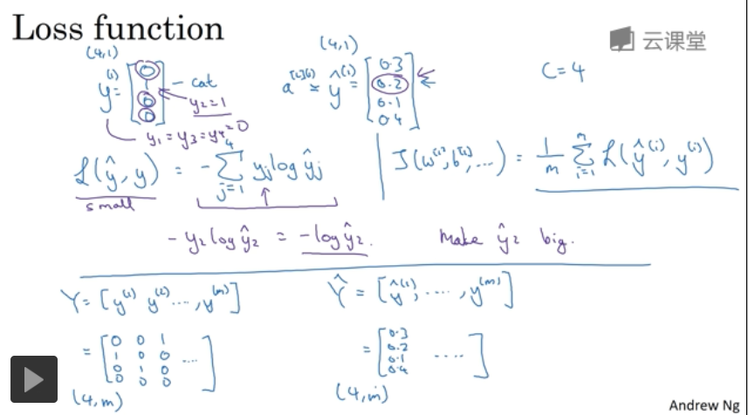

Softmax的梯度下降

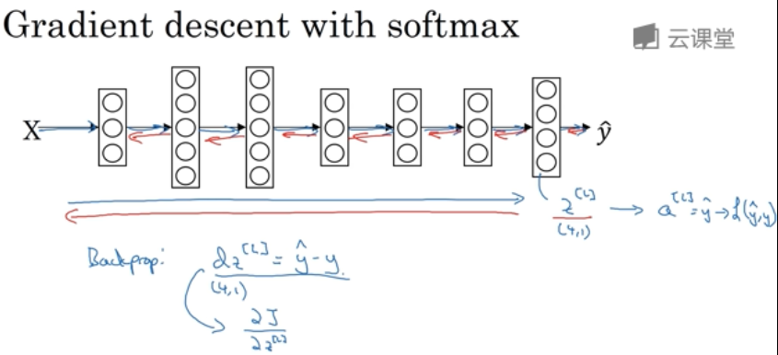

### 深度学习框架

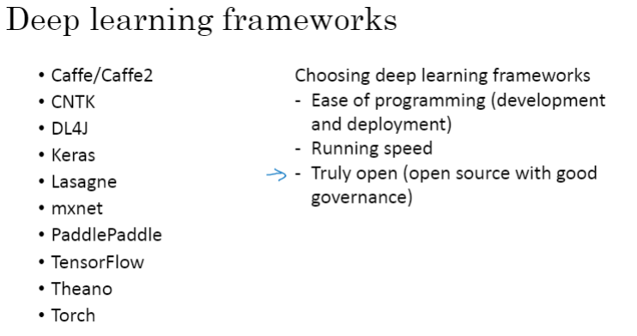

### TensorFlow

问题引入

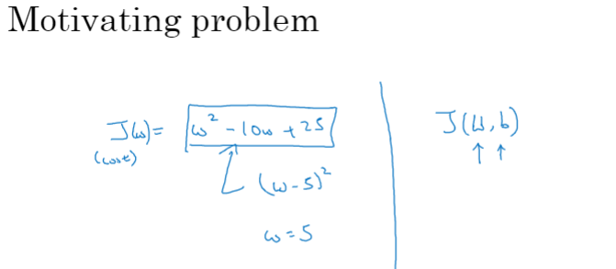

Tensorflow代码示例

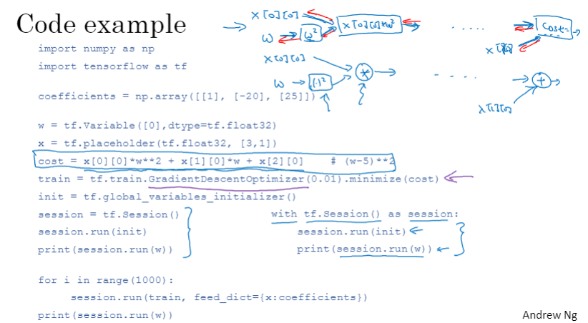

### C2W3 Quiz - Hyperparameter tuning, Batch Normalization, Programming Frameworks

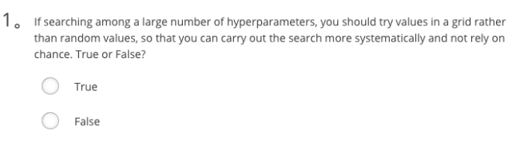

Ans: False

Note: Try random values, don't do grid search. Because you don't know which hyperparameters are more important than others.

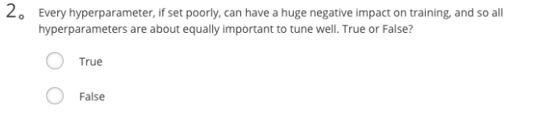

Ans: False

Note: We've seen in lecture that some hyperparameters, such as the learning rate, are more critical than others.

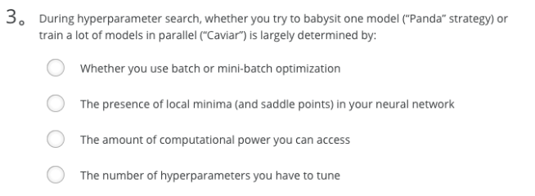

Ans: C

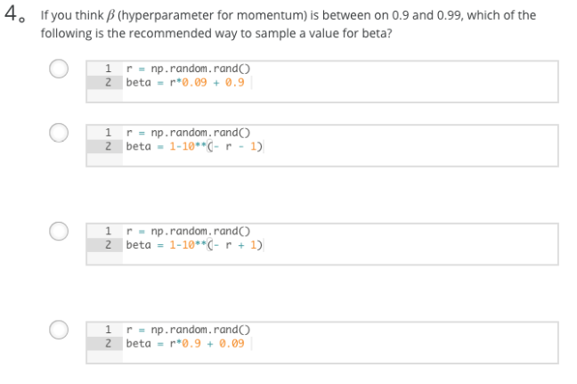

Ans: B

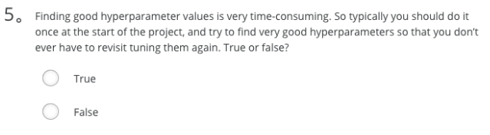

Ans: False

Note: Minor changes in your model could potentially need you to find good hyperparameters again from scratch.

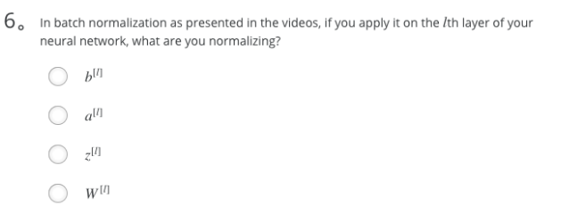

Ans: C

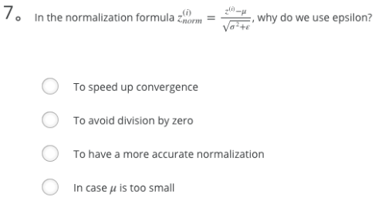

Ans: B

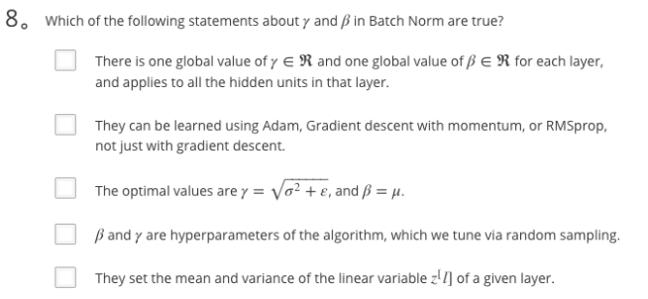

Ans: B、E

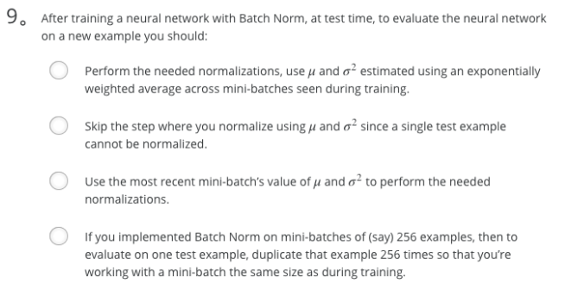

Ans: A

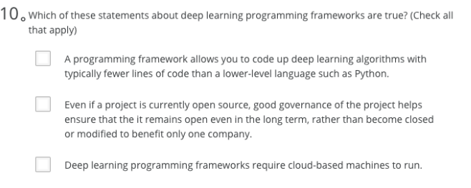

Ans: A、B

1. If searching among a large number of hyperparameters, you should try values in a grid rather than random values, so that you can carry out the search more systematically and not rely on chance. True or False?
   *  False
   *  True

Note: Try random values, don't do grid search. Because you don't know which hyperparameters are more important than others.

And to take an extreme example, let's say that hyperparameter two was that value epsilon that you have in the denominator of the Adam algorithm. So your choice of alpha matters a lot and your choice of epsilon hardly matters.

1. Every hyperparameter, if set poorly, can have a huge negative impact on training, and so all hyperparameters are about equally important to tune well. True or False?
   *  False
   *  True

We've seen in lecture that some hyperparameters, such as the learning rate, are more critical than others.

1. During hyperparameter search, whether you try to babysit one model (“Panda” strategy) or train a lot of models in parallel (“Caviar”) is largely determined by:
   *  Whether you use batch or mini-batch optimization
   *  The presence of local minima (and saddle points) in your neural network
   *  The amount of computational power you can access
   *  The number of hyperparameters you have to tune
2. If you think β (hyperparameter for momentum) is between on 0.9 and 0.99, which of the following is the recommended way to sample a value for beta?

r = np.random.rand()

beta = 1 - 10 ** (-r - 1)

1. Finding good hyperparameter values is very time-consuming. So typically you should do it once at the start of the project, and try to find very good hyperparameters so that you don’t ever have to revisit tuning them again. True or false?
   *  False
   *  True

Note: Minor changes in your model could potentially need you to find good hyperparameters again from scratch.

1. In batch normalization as presented in the videos, if you apply it on the lth layer of your neural network, what are you normalizing?
   * z^[l]
2. In the normalization formula, why do we use epsilon?
   * To avoid division by zero
3. Which of the following statements about γ and β in Batch Norm are true? **Only correct options listed**
   * They can be learned using Adam, Gradient descent with momentum, or RMSprop, not just with gradient descent.
   * They set the mean and variance of the linear variable z^[l] of a given layer.
4. After training a neural network with Batch Norm, at test time, to evaluate the neural network on a new example you should:
   * Perform the needed normalizations, use μ and σ^2 estimated using an exponentially weighted average across mini-batches seen during training.
5. Which of these statements about deep learning programming frameworks are true? (Check all that apply)
   *  A programming framework allows you to code up deep learning algorithms with typically fewer lines of code than a lower-level language such as Python.
   *  Even if a project is currently open source, good governance of the project helps ensure that the it remains open even in the long term, rather than become closed or modified to benefit only one company.
   *  Deep learning programming frameworks require cloud-based machines to run.

# 课程3——结构化机器学习项目

## 第一周 机器学习（ML）策略（1）

### 为什么需要ML策略？

问题引入：如何提高机器学习的水平？可能有很多种想法（如，收集更多数据、收集更丰富多样的训练数据、增加梯度下降法迭代次数、增加网络规模、减小网络规模、使用随机失活（dropout）、添加L2正则化项、改变网络架构（激活函数、隐层单元数等）），应该选择哪些，舍弃哪些？

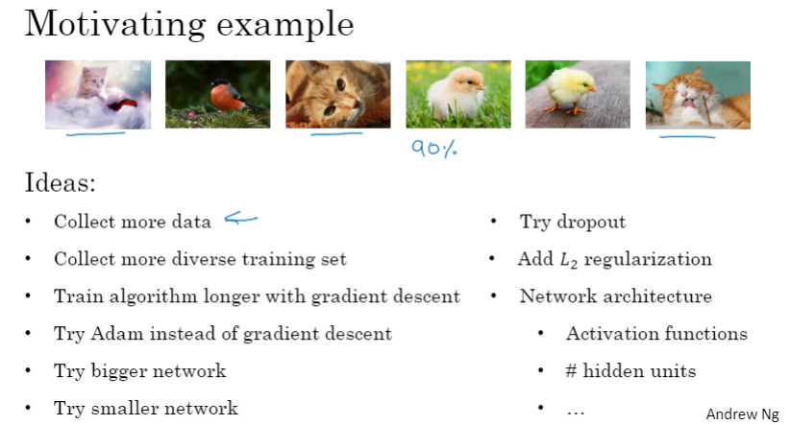

### 正交化

正交化的一个实例：老式电视机的调节按钮（上下、左右、形变等），每个按钮的功能明确而相对对立，即所谓“正交”（orthogonal）

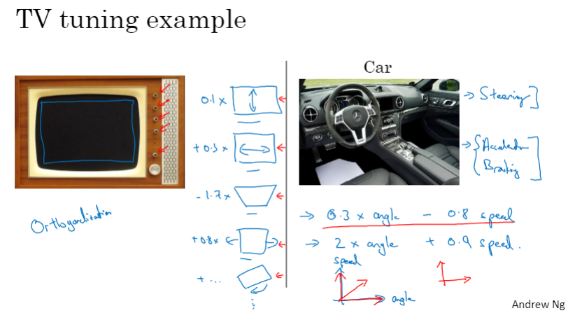

机器学习中的假设链：

成本函数调优顺序：训练集 -> 开发集（验证集）-> 测试集 -> 真实世界

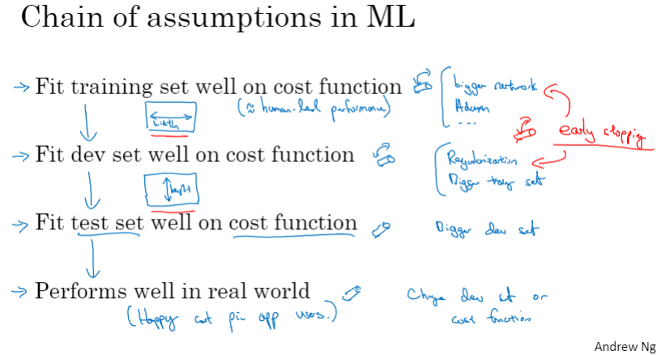

Orthogonalization（正交化）

Orthogonalization or orthogonality is a system design property that assures that modifying an instruction or a component of an algorithm will not create or propagate side effects to other components of the system. It becomes easier to verify the algorithms independently from one another, it reduces testing and development time.

When a supervised learning system is design, these are the 4 assumptions that needs to be true and orthogonal.

1. Fit training set well in cost function

- If it doesn’t fit well, the use of a bigger neural network or switching to a better optimization algorithm might help.

2. Fit development set well on cost function

- If it doesn’t fit well, regularization or using bigger training set might help.

3. Fit test set well on cost function

- If it doesn’t fit well, the use of a bigger development set might help

4. Performs well in real world

- If it doesn’t perform well, the development test set is not set correctly or the cost function is not evaluating the right thing.

### 单一数字评估指标

查准率（Precision）和查全率（Recall）难以同时兼顾，可综合考虑，用F1值来表示（F1=2PR/(P+R)）

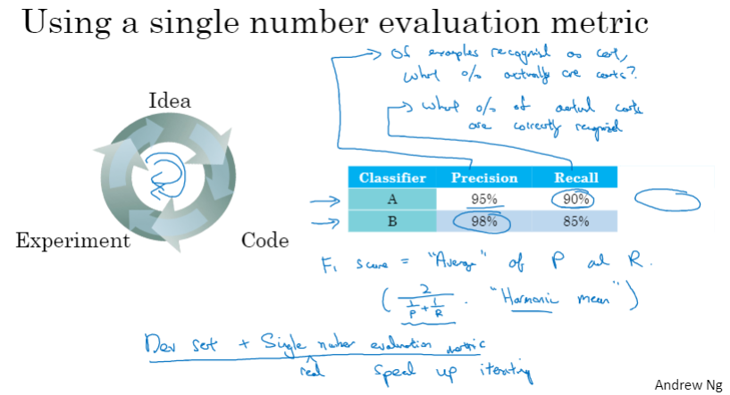

另一个示例：使用平均值评价不同算法

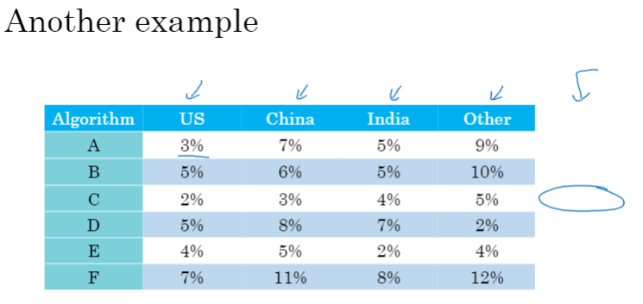

查准率、查全率和F1值

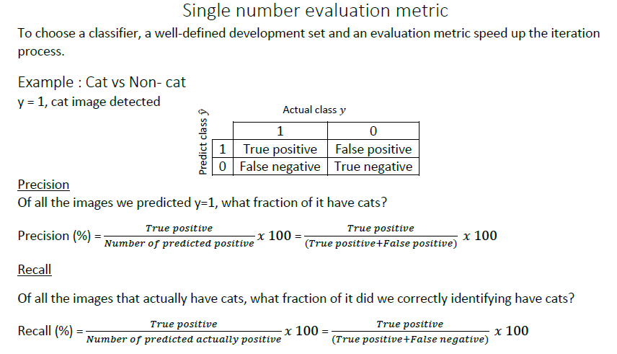

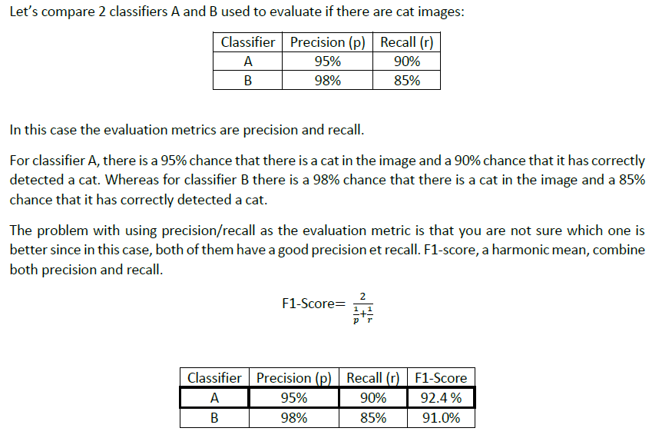

### 优化指标和满足指标

评价指标可分为两类：优化指标（optimizing metrices）和满足指标（satisfying metrices）。优化指标需要重点关注，满足指标相当于约束条件而不得不考虑。

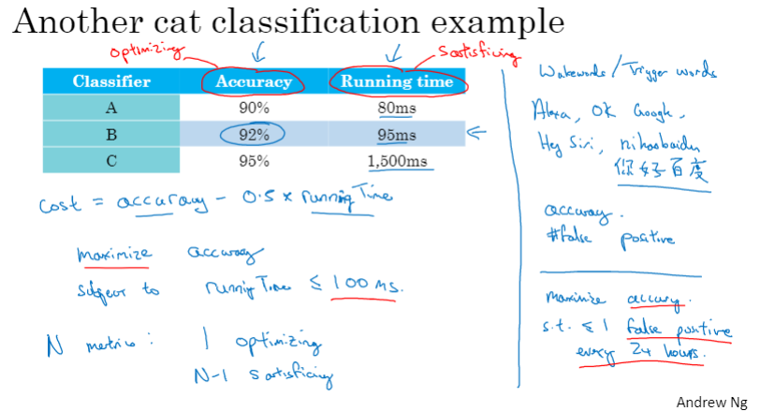

Satisficing and optimizing metric

There are different metrics to evaluate the performance of a classifier, they are called evaluation matrices. They can be categorized as satisficing and optimizing matrices. It is important to note that these evaluation matrices must be evaluated on a training set, a development set or on the test set.

Example: Cat vs Non-cat

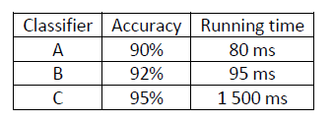

In this case, accuracy and running time are the evaluation matrices. Accuracy is the optimizing metric, because you want the classifier to correctly detect a cat image as accurately as possible. The running time which is set to be under 100 ms in this example, is the satisficing metric which mean that the metric has to meet expectation set.

The general rule is:

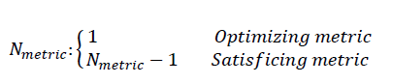

### 训练集、开发集和测试集的划分

训练集和开发集应该具有相同的分布（可通过随机化实现）

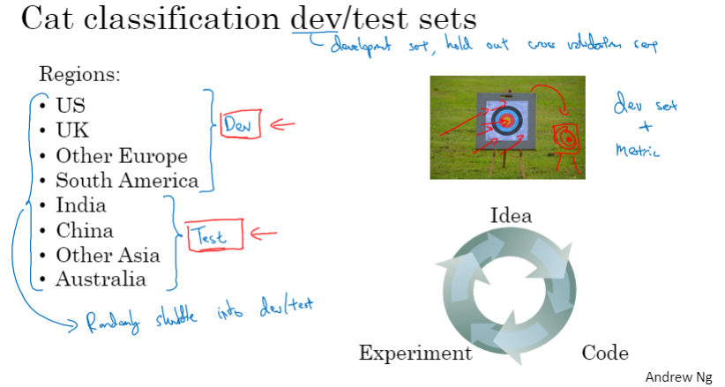

真实的失败案例：在中等收入地区邮编数据上开发（验证），却在低收入地区邮编上测试，浪费了3个月左右的时间

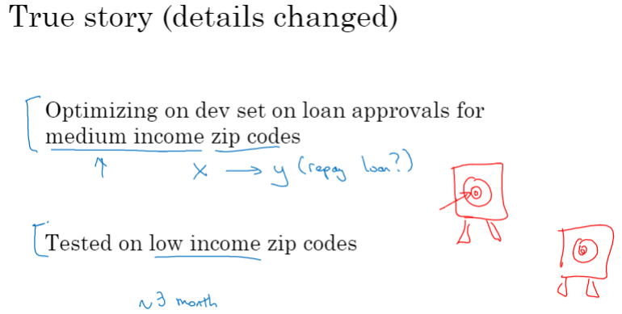

建议：训练集和开发集应该具有相同的分布

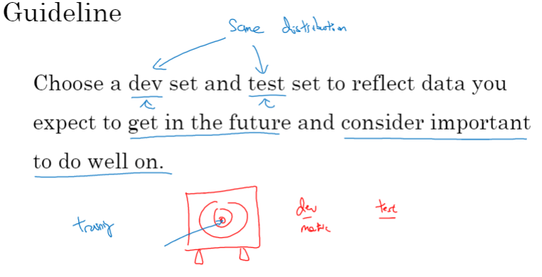

### 开发集和测试集的大小

旧的划分方法（70%训练数据，30%测试数据）在如今的大数据时代不再适用

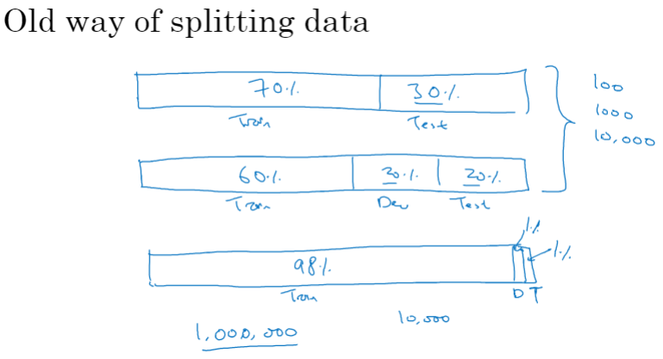

开发集应尽可能大

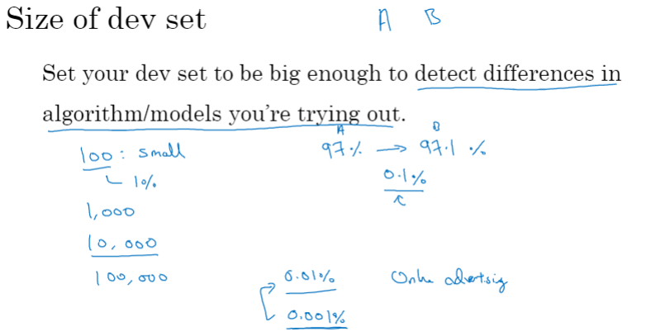

测试集也应尽可能大

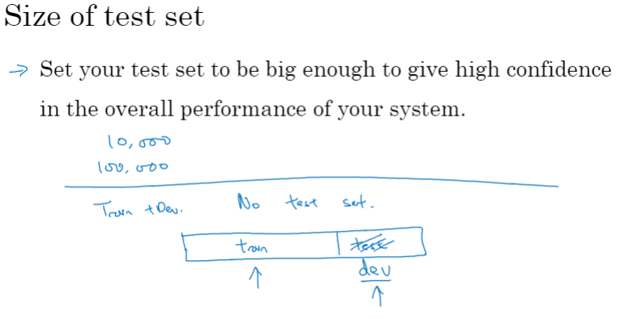

开发集和测试集的划分

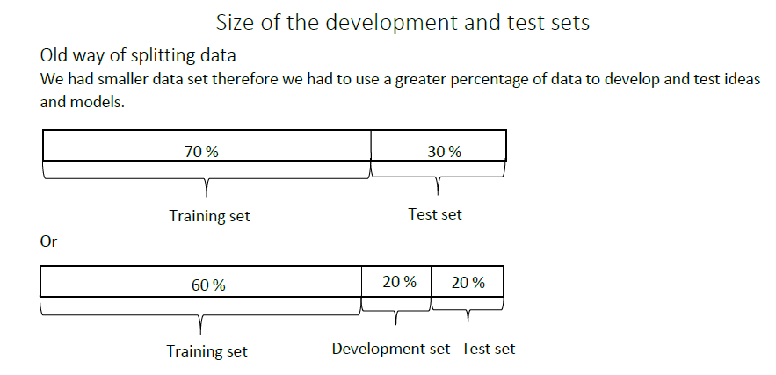

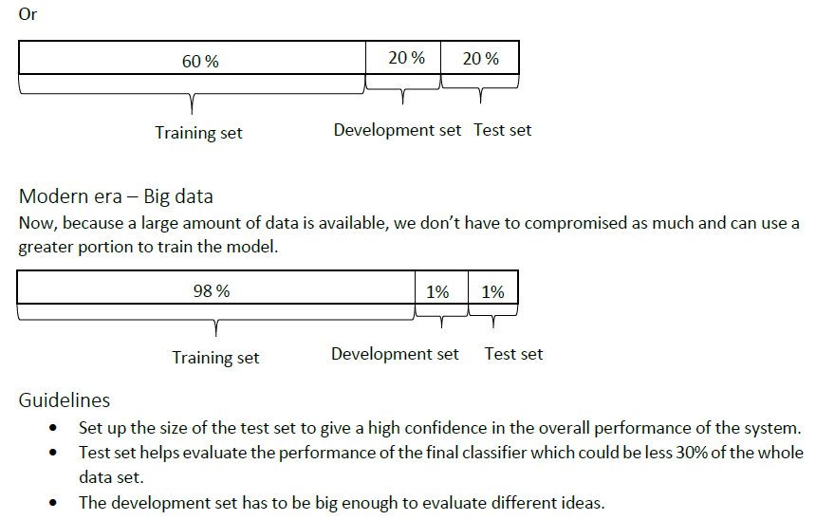

### 什么时候应该改变开发、测试集和指标？

准确率高的算法不一定满足需求，比如，识猫应用中，算法A的识别率虽然高于算法B，却将不少色情图像错误识别为猫，不符合需求。此时，可在在损失函数中增加权重项，提高对色情图像错误分类结果的惩罚度（penalty），从而让算法A的指标劣于算法B

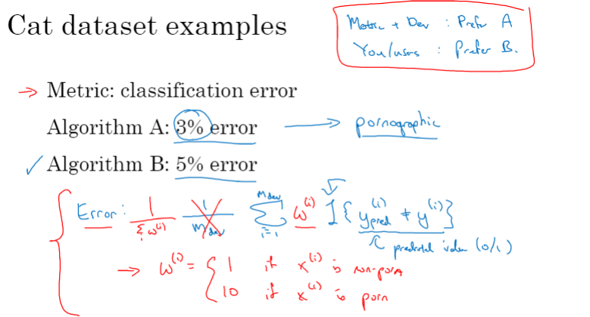

识猫应用中的正交化：两步走策略，首先确定目标（target），其次，优化指标

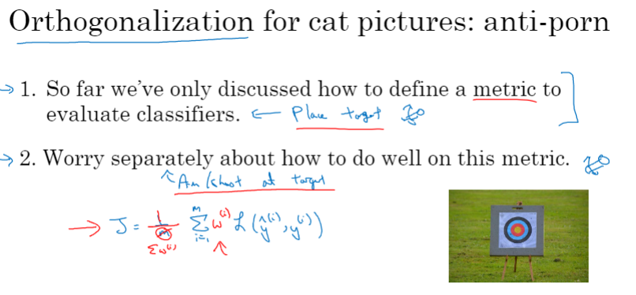

另一个示例：开发集上表现较好（由于图片质量高（清晰）、取景良好等因素，识别效果好），但实际应用效果不太好（由于用户拍摄的照片不够清晰等因素，识别效果差），此时，应考虑调整优化指标、训练集、测试集

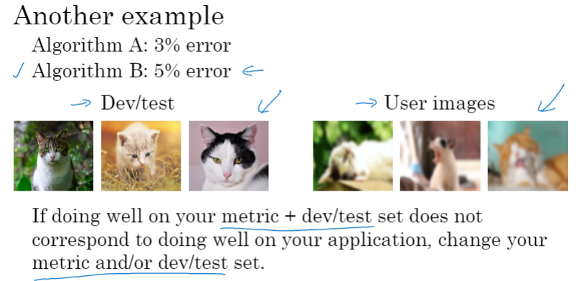

详细说明：

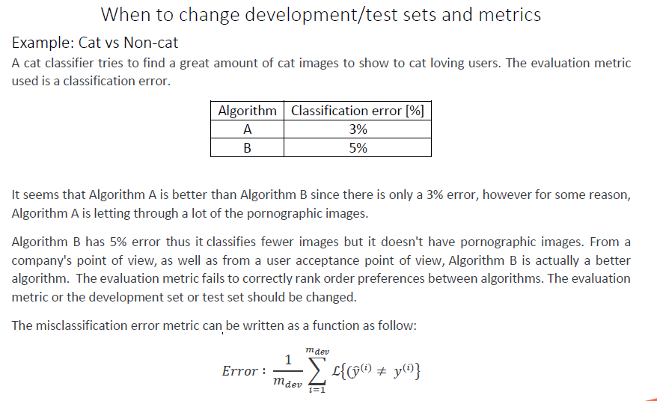

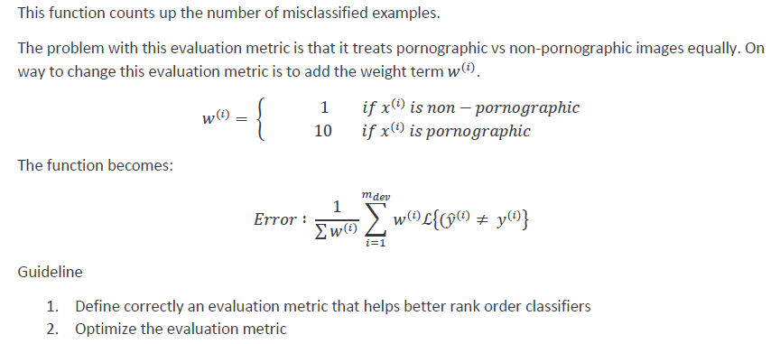

### 为什么要考虑人类的表现？

贝叶斯误差（bayes error)是指在现有特征集上，任意可以基于特征输入进行随机输出的分类器所能达到最小误差。人类水平和机器水平都无法超越贝叶斯误差，产生贝叶斯误差的本质原因是特征集不足以推理出准确预测值，否则贝叶斯误差为0。

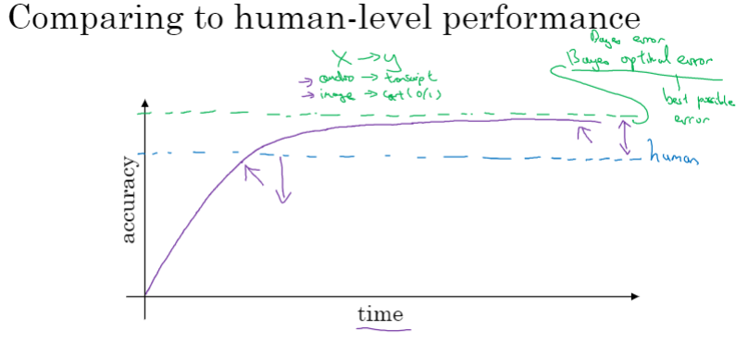

为什么要和人类水平进行比较？人类擅长多种任务，只要机器学习的表现逊于人类，就可以借助人类劳动来提高机器学习的表现。如，让人类来标注数据，分析误差因素，更好地分析偏差和方差

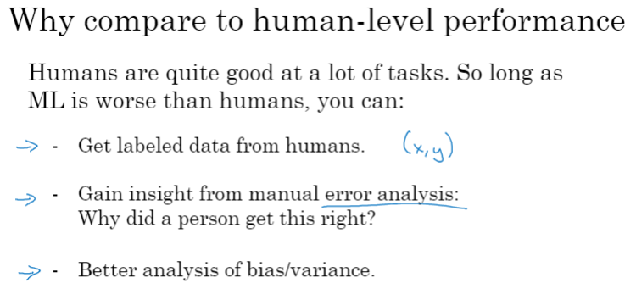

详细说明：

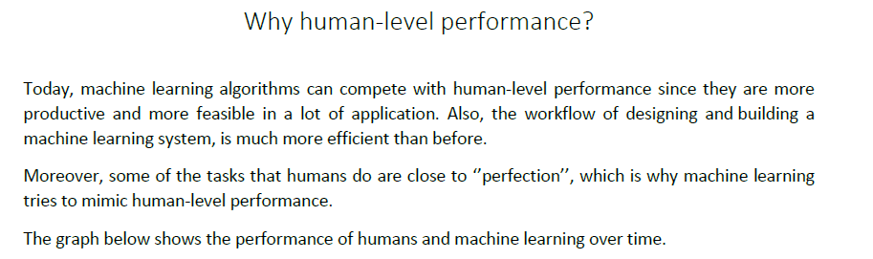

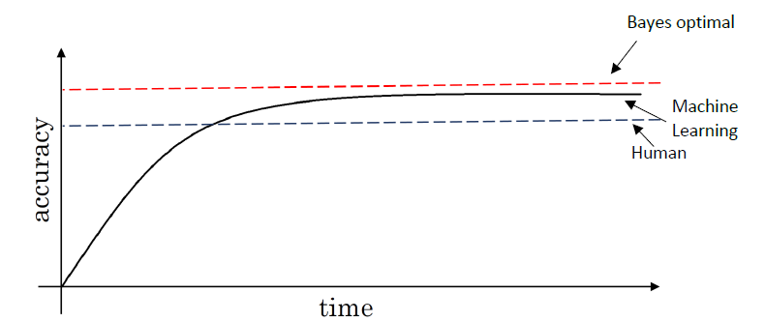

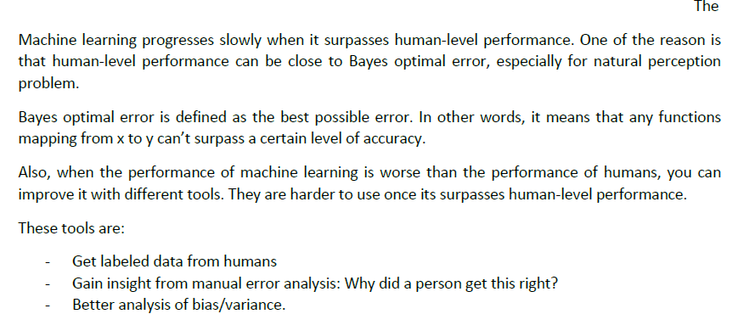

### 可避免偏差

人类水平和训练误差的差距称作可避免误差（avoidable bias）。相同的训练集误差和验证集误差条件下，优化策略取决于人类水平（可看作贝叶斯误差）的高低。比如，图片质量很低时，连人类都难以辨识，此时不应期望机器能够识别

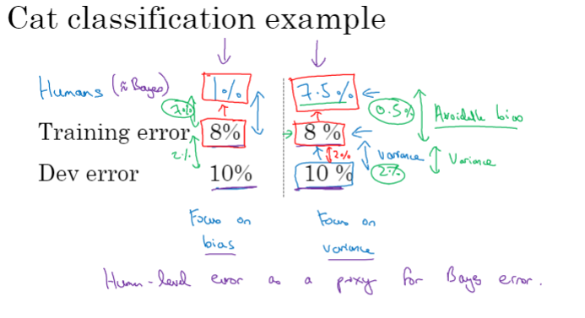

详细说明：

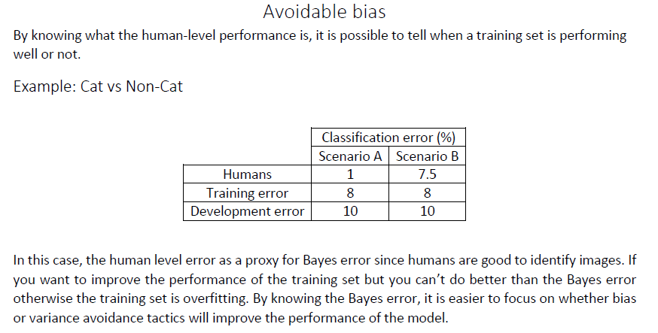

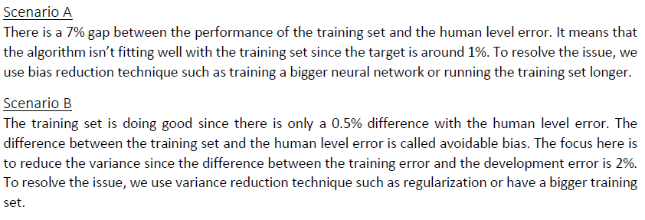

### 理解人的表现

问题引入：在以下图像识别示例中，应该如何定义“人类水平误差”？因为要将人类水平近似看作“贝叶斯误差”，所以这里应该用最高的水平，即，一个经验丰富的医生团队所取得的0.5%的误差，作为“人类水平”

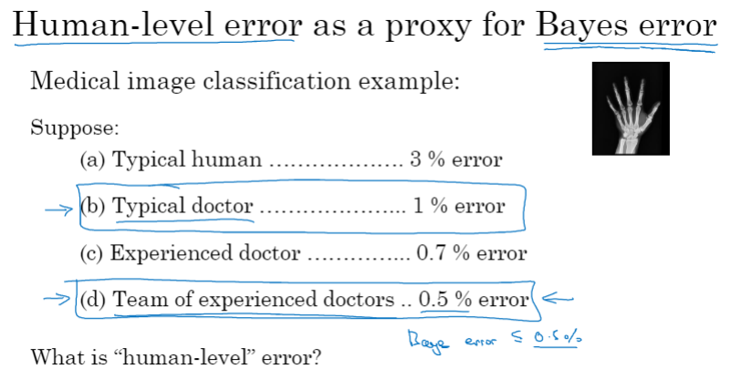

误差分析示例：

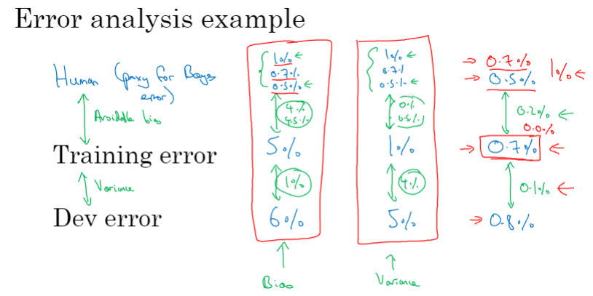

小结：

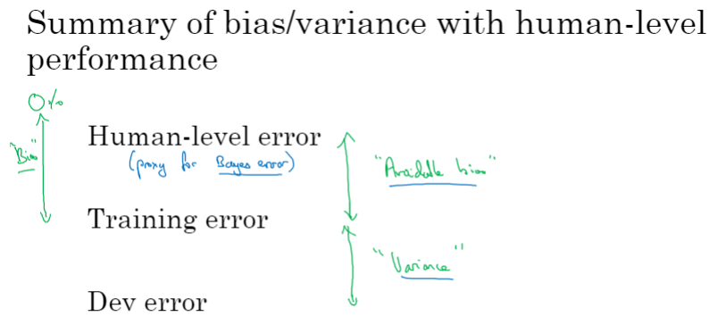

详细说明：

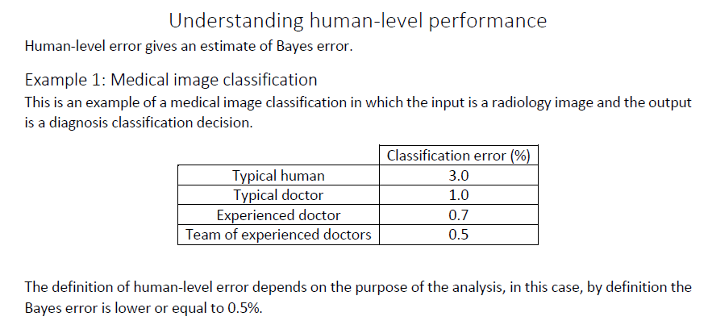

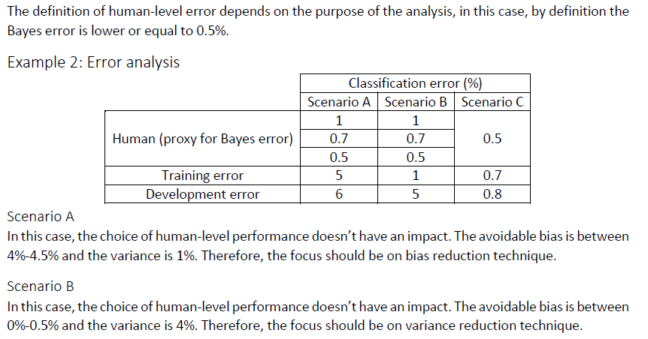

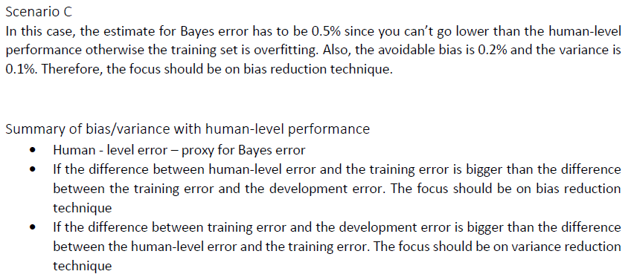

### 超过人的表现

当机器的表现已经超越人类水平后，是该降低偏差还是方差，没有足够信息可以回答。如何让机器做得更好？这是个值得探索的问题。

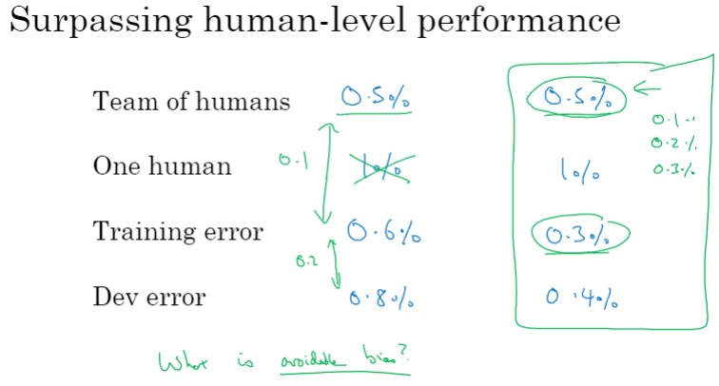

目前，机器已经超越人类的领域有哪些？在线广告、产品推荐、物流、贷款审批（语音识别、部分图像识别（如医学影像（心电图、皮肤癌等））。这些领域的特点：结构化数据、非感官依赖、大数据。

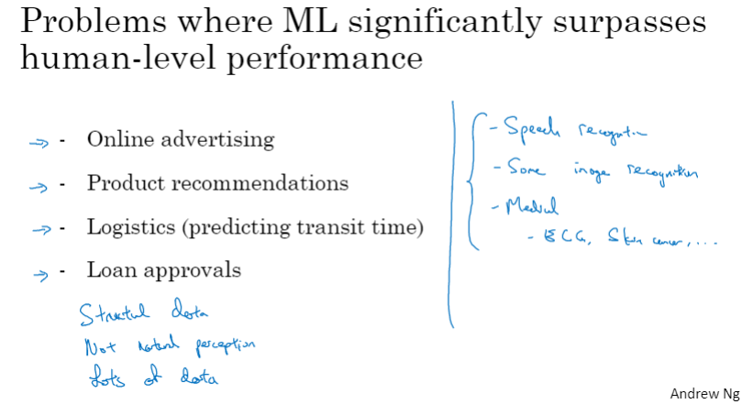

详细说明：

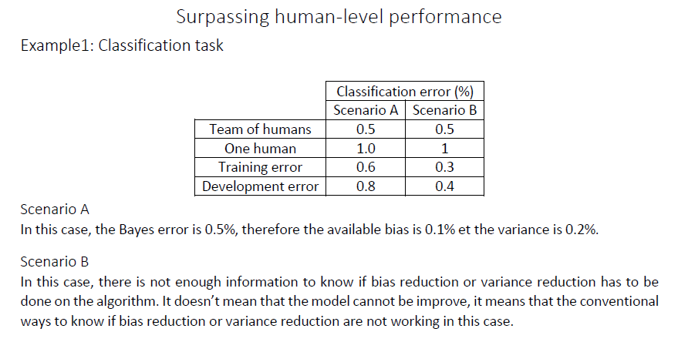

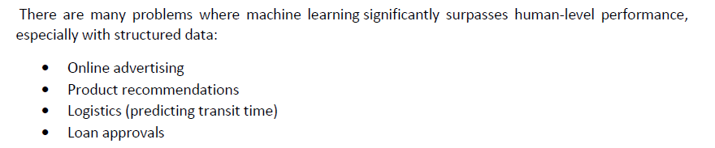

### 改善模型表现

监督学习的两个基本假设：

1. 可以很好地拟合训练集
2. 训练集性能可以很好地泛化到开发集和测试集（即，开发集和测试集上的性能接近训练集上的性能）

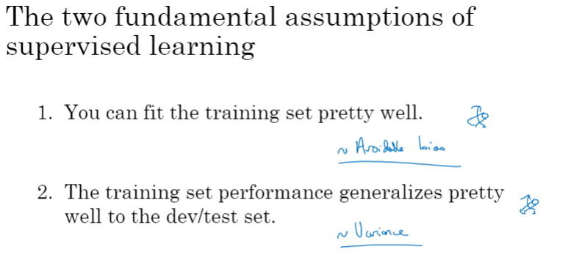

降低可避免偏差及方差的方法

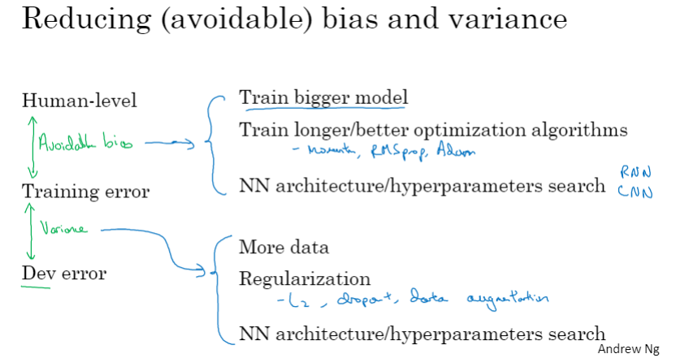

详细描述：

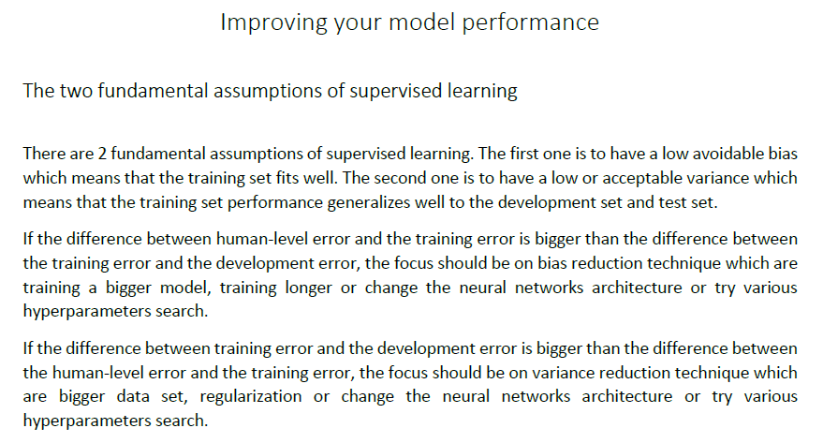

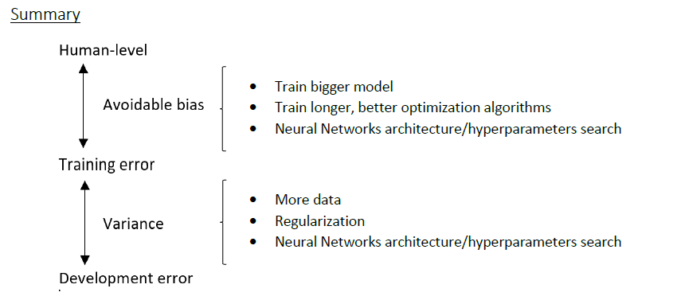

### C3W1 Quiz - Bird recognition in the city of Peacetopia (case study)



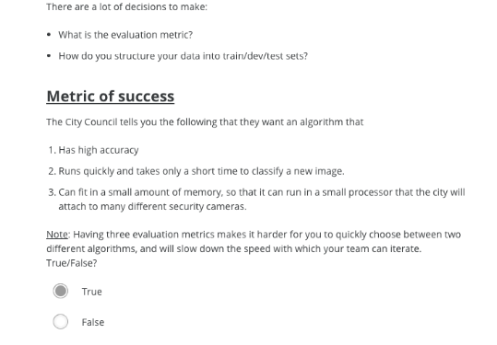

Ans: True

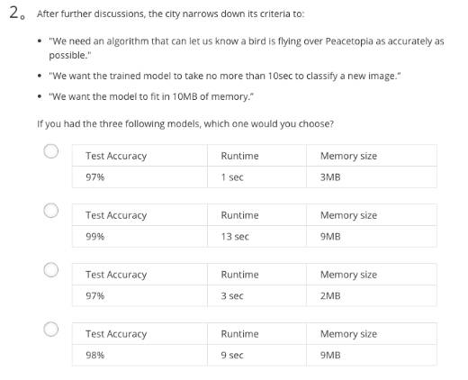

Ans: D

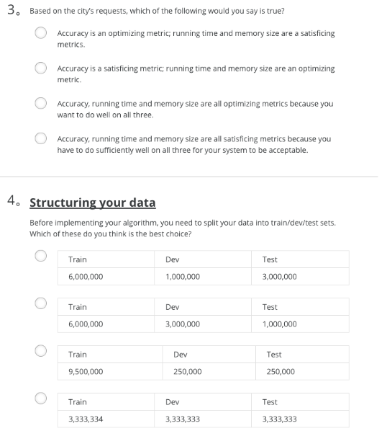

3. Ans: A

4. Ans: C

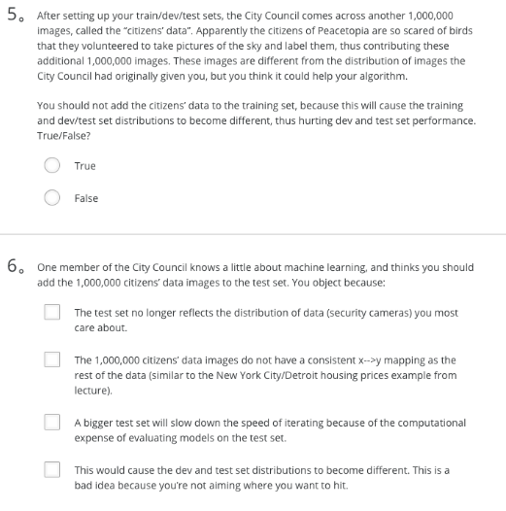

5. Ans: False

6. Ans: A、D

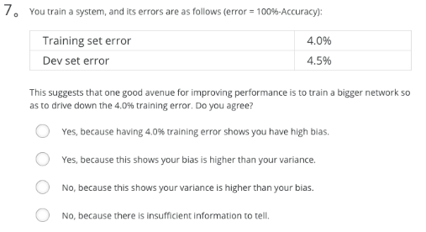

Ans: D

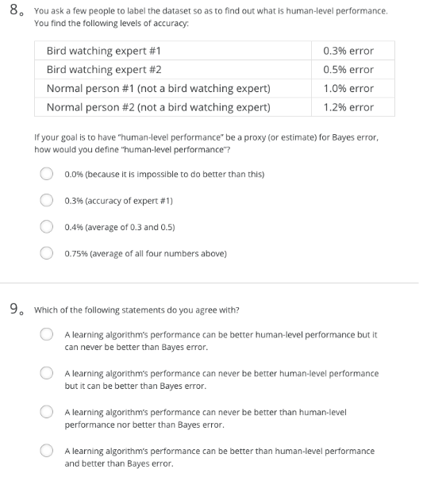

8. Ans: B

9. Ans: A

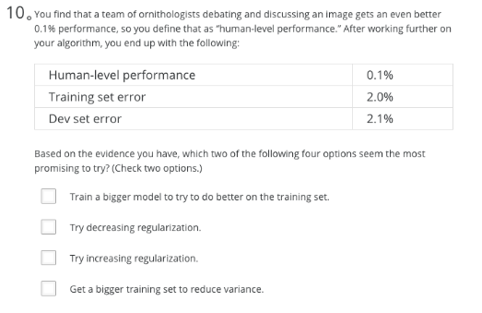

Ans: A、B

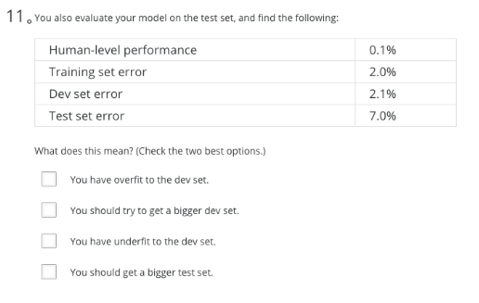

Ans: A、B

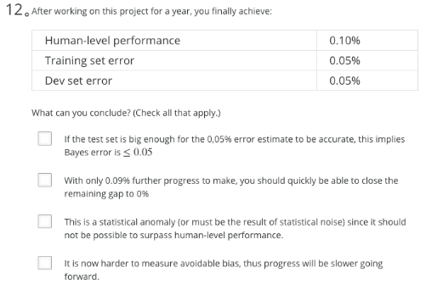

Ans: A、D

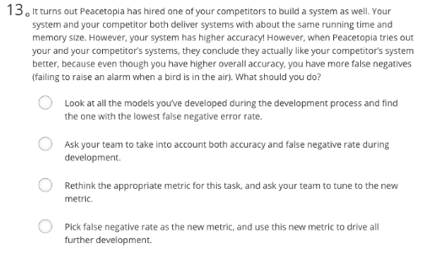

Ans: C

  
 Ans: A

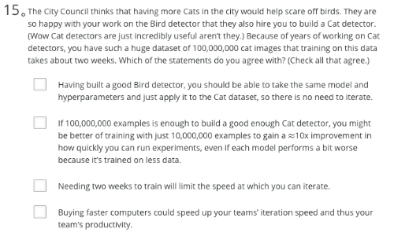

Ans: B、C、D

## 第二周 机器学习（ML）策略（2）

### 进行误差分析

问题引入：在识猫应用中，如果有时会将小狗识别为猫，是否应该花很多时间解决这个问题？

这取决于在错误标记的例子中，将小狗识别为猫的比例高低。如果较高，则值得花时间解决这一问题；否则，未必值得。这个过程即误差分析。

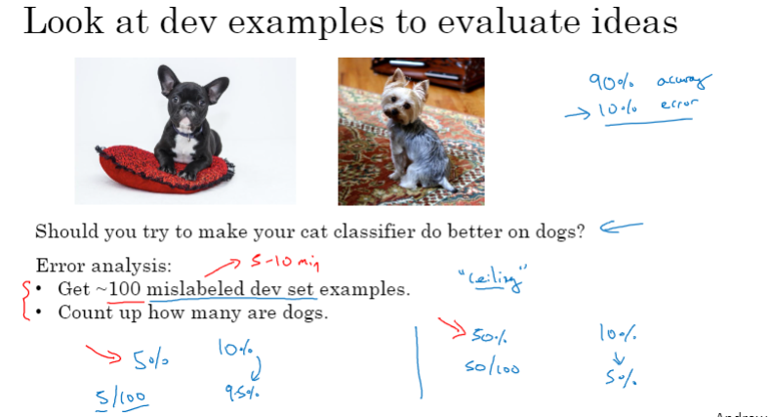

可以并行分析多个问题。如，除了将狗错误识别为猫的问题，还存在将大型猫科动物识别为猫、模糊图像识别率低等问题。

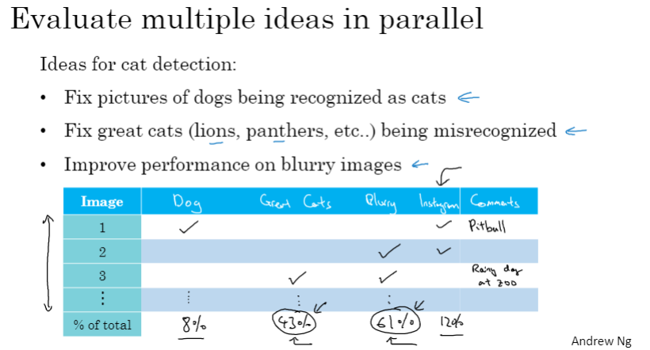

### 关注标注错误的数据

深度学习算法对训练集中的随机误差具有较高的“健壮性”，但对于系统性误差比较脆弱。

举例而言，如果训练集中偶尔有一些图片被错误标记为“猫”，可将其看作随机误差，这对训练结果影响很有限；如果训练集中将白色的动物都标注成了“猫”，那就是系统性错误（systematic errors），会对训练结果产生较大影响。

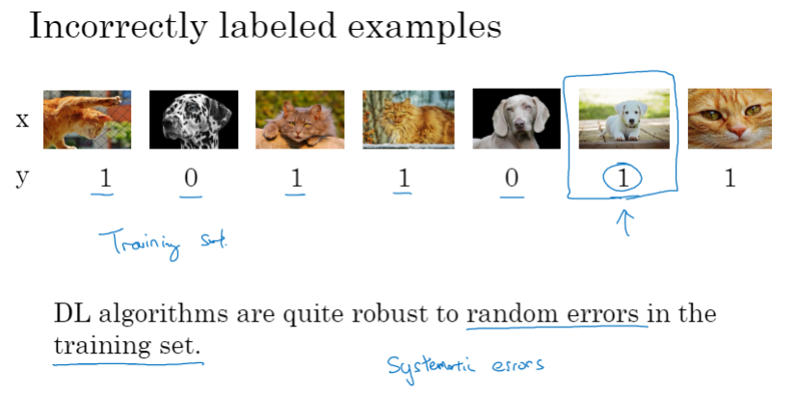

误差分析示例

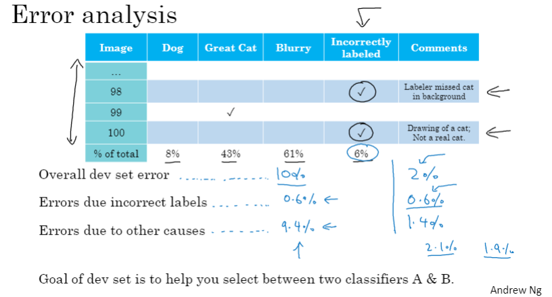

改正开发集、测试集中的数据

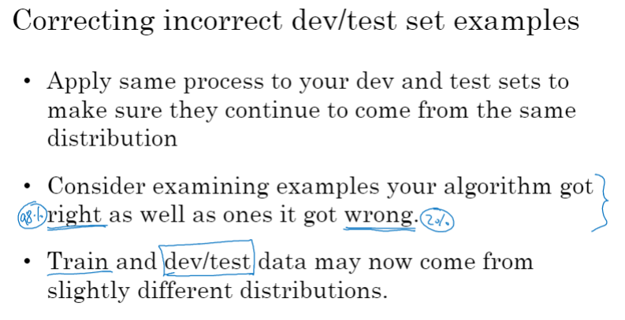

### 快速搭建你的第一个系统，并进行迭代

语音识别示例

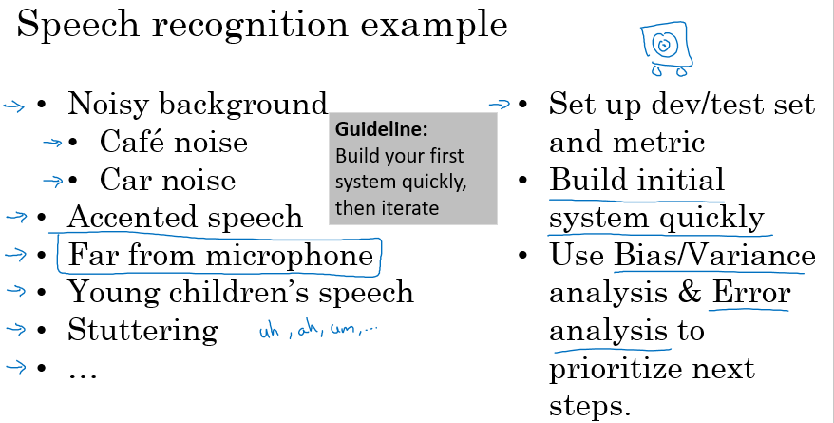

### 在不同的划分上进行训练并测试

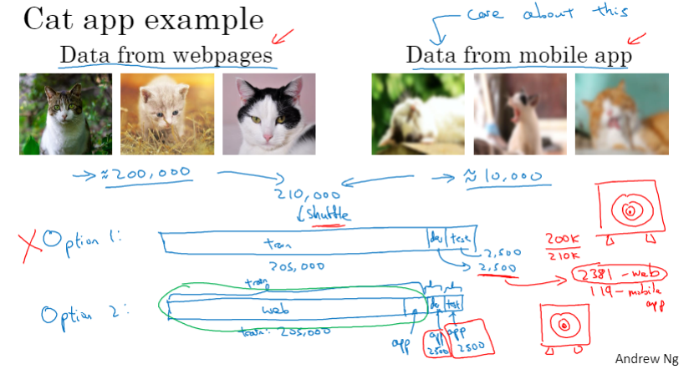

语音识别示例

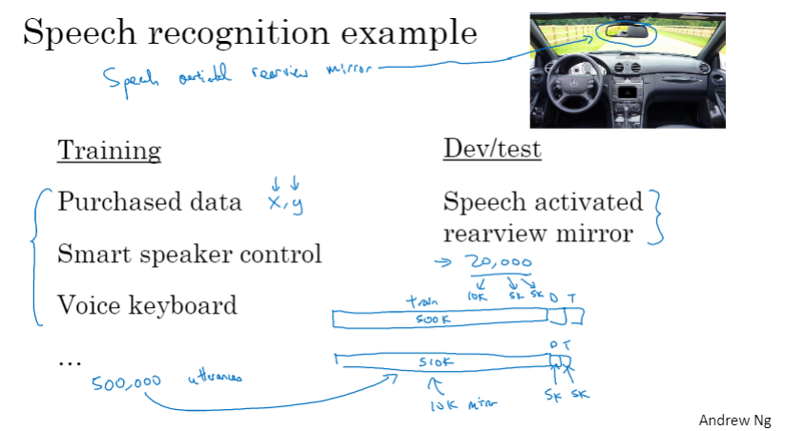

### 不匹配数据划分的偏差和方差

识猫应用中的四种情况：

1. 方差问题
2. 可避免偏差问题
3. 数据不匹配问题
4. 可避免偏差+数据不匹配问题

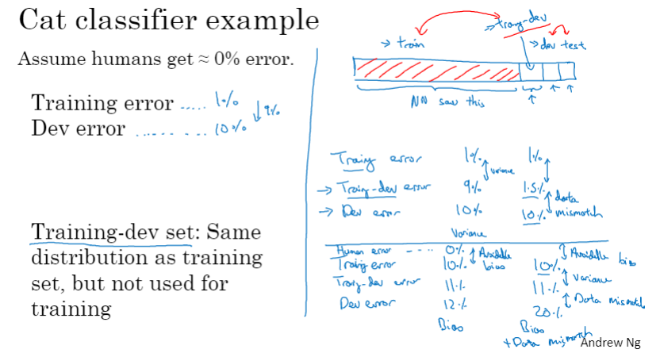

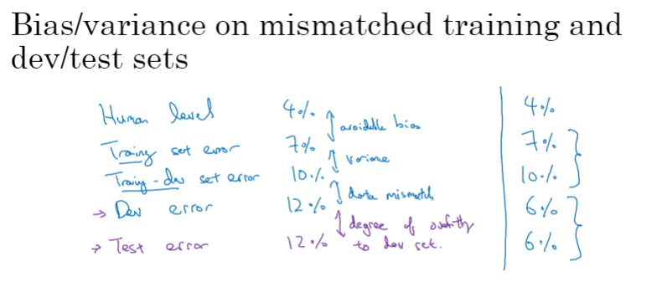

误差分析公式：

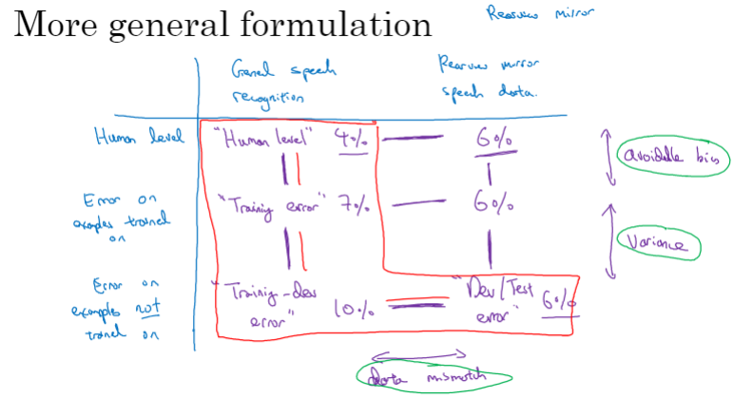

### 解决数据不匹配

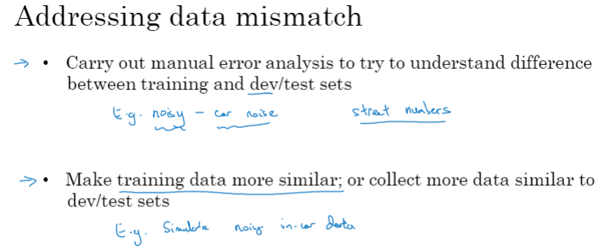

人工数据合成的比例不能太高，否则会导致对合成数据产生过拟合。

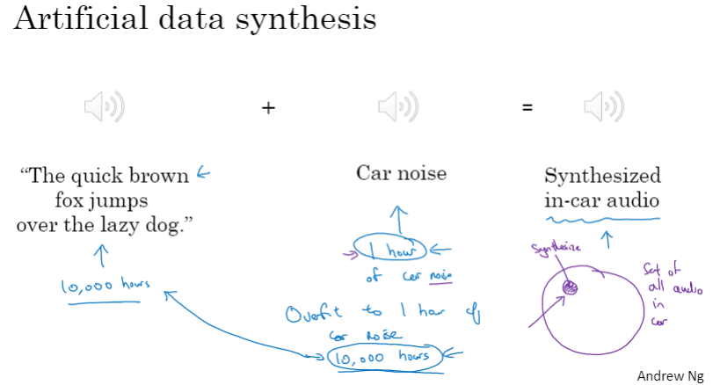

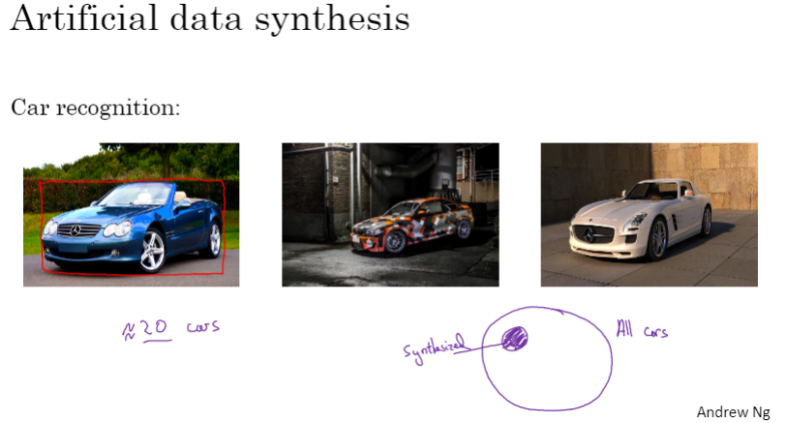

### 迁移学习

迁移学习的两个例子：

1. 图像识别应用迁移到医学影像识别
2. 语音识别应用迁移到唤醒词检测

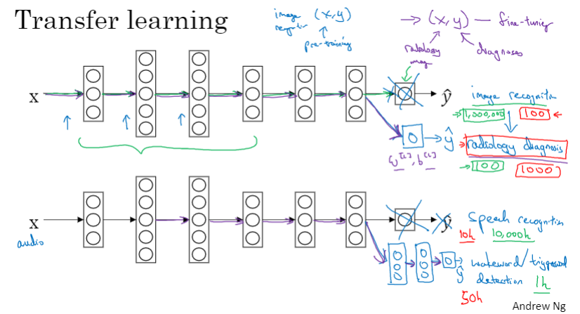

迁移学习的应用场合：

* + 1. 任务A和任务B具有相同的输入
    2. 任务A的可用数据量远大于任务B
    3. 任务A的低层次特征可能对任务B有所帮助

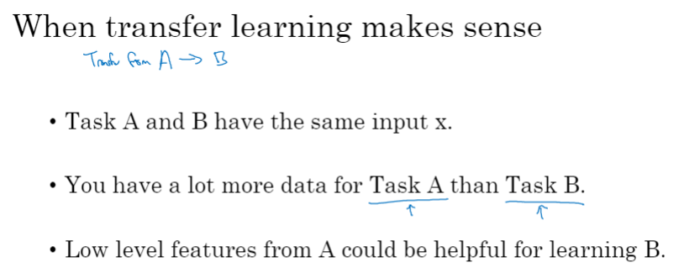

### 多任务学习

多任务学习的一个简单示例：无人驾驶任务中，要同时识别行人、车辆、信号灯、路标等多种对象

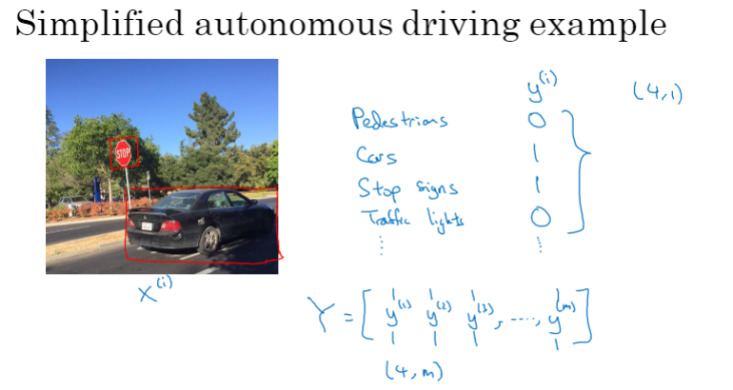

神经网络架构中的多任务学习（与softmax回归只检测一种对象不同，多任务学习要同时检测多种多种对象）

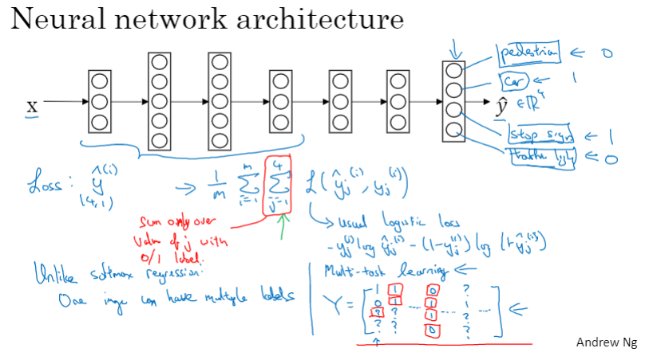

多任务学习的应用场合：

1. 所训练的不同任务之间可以共享一些低层次的特征
2. 各任务所需数据很相似
3. 可以训练一个足够大的神经网络以同时很好地完成所有任务

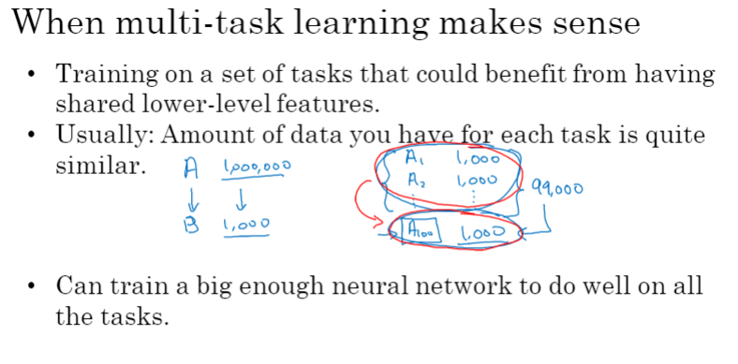

### 什么是端到端的深度学习？

数据量较大时，端对端的学习也能成功，而无需将任务分成很多中间过程

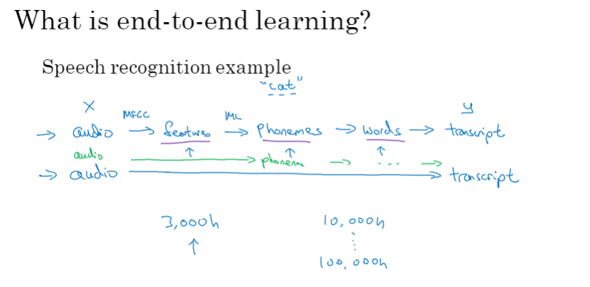

人脸识别可分成两步执行：

1. 从图像中识别出人脸
2. 识别人脸属于谁的脸（当前人脸与数据库中的人脸数据进行一一匹配）

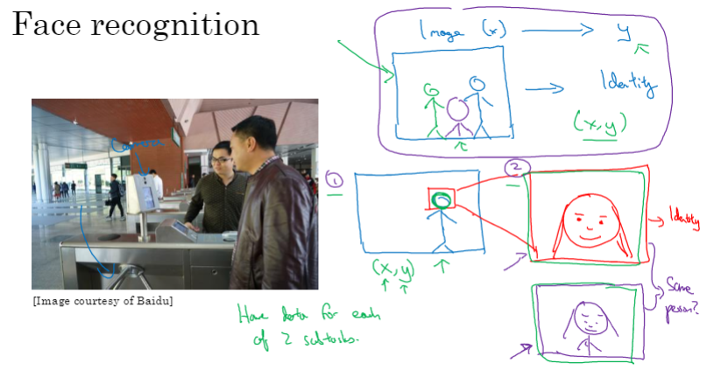

其他示例

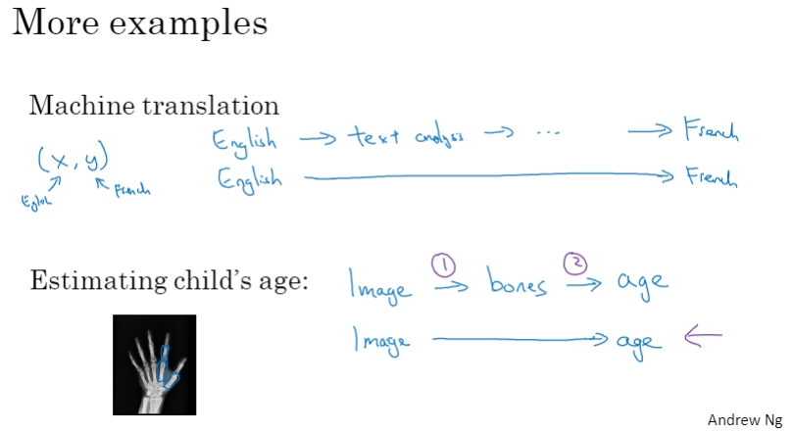

### 是否要使用端到端的深度学习？

端对端学习的优点与缺点：

1. 优点：让数据说话；减少对手动设计的组件的依赖
2. 缺点：可能需要大量数据；没有好好利用一些有用的手动设计的组件

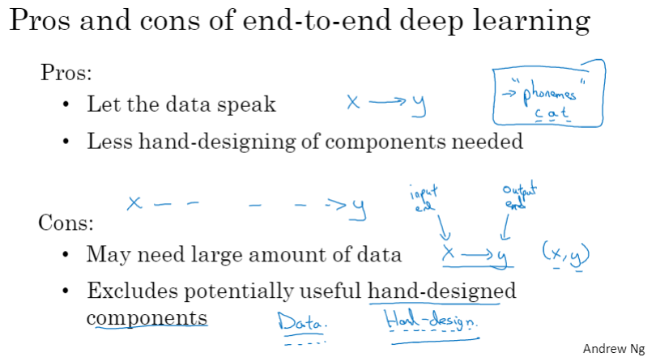

端对端学习的应用：

1. 使用深度学习学习各个组件
2. 仔细选择X->Y映射（端对端）所需的数据

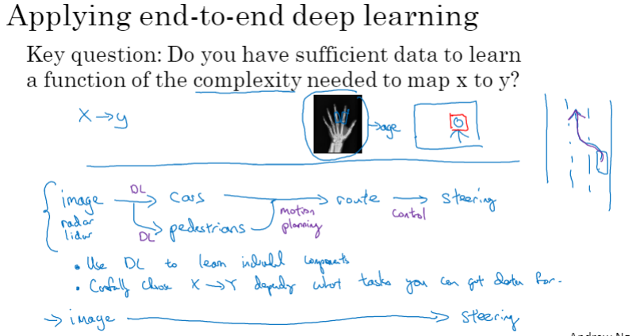

### C3W2 Quiz - Autonomous driving (case study)

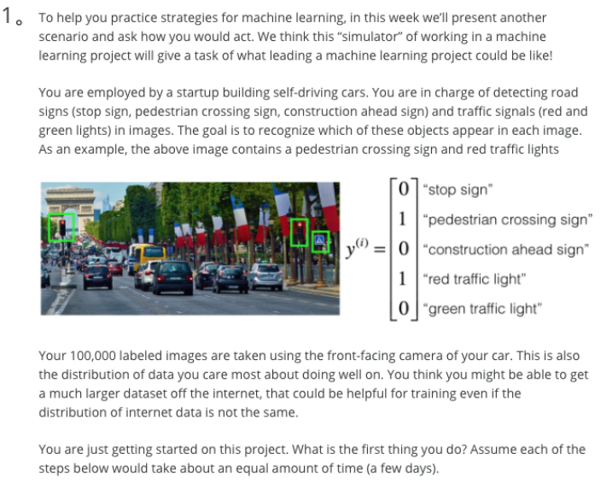

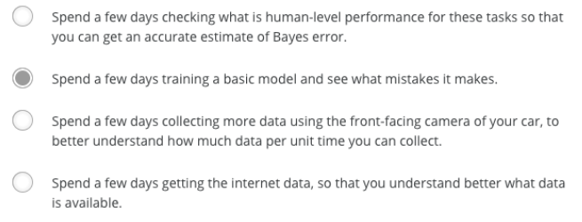

Ans: B

Note: As discussed in lecture, applied ML is a highly iterative process. If you train a basic model and carry out error analysis (see what mistakes it makes) it will help point you in more promising directions.

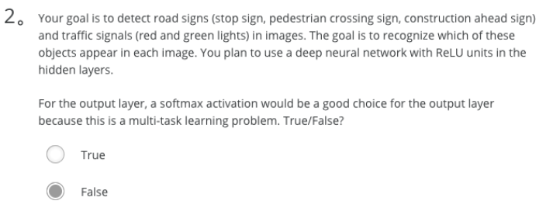

Ans: False

Note: Softmax would be a good choice if one and only one of the possibilities (stop sign, speed bump, pedestrian crossing, green light and red light) was present in each image.

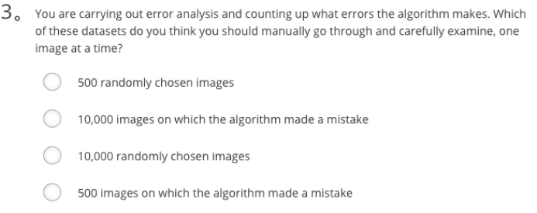

Ans: D

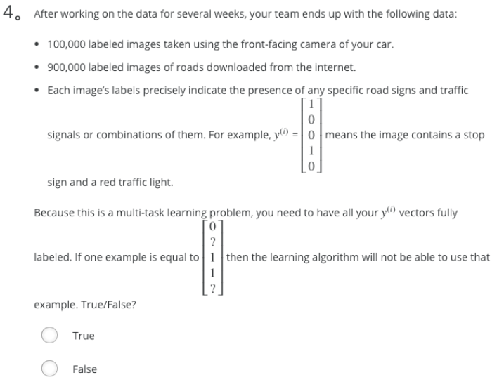

Ans: False

Note: As seen in the lecture on multi-task learning, you can compute the cost such that it is not influenced by the fact that some entries haven’t been labeled.

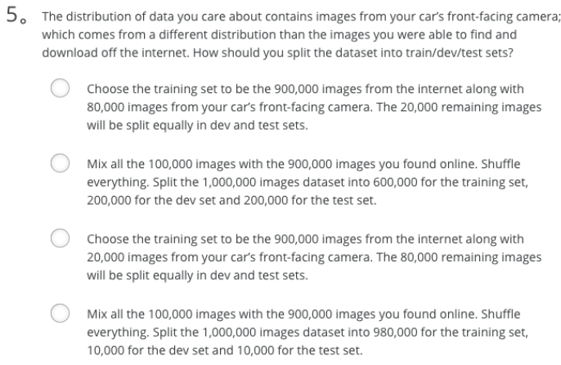

Ans: A

Note: As seen in lecture, it is important that your dev and test set have the closest possible distribution to “real”-data. It is also important for the training set to contain enough “real”-data to avoid having a data-mismatch problem.

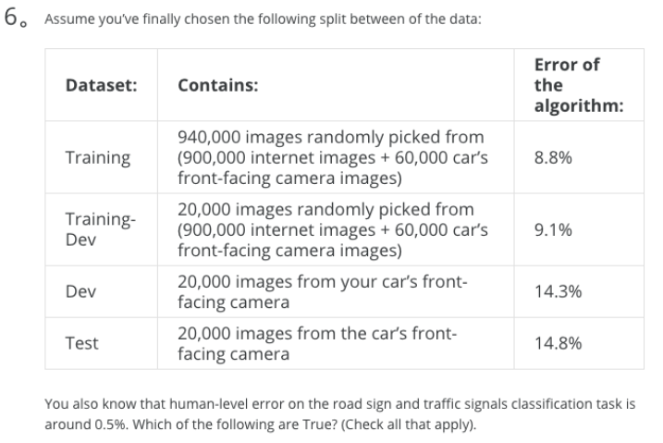

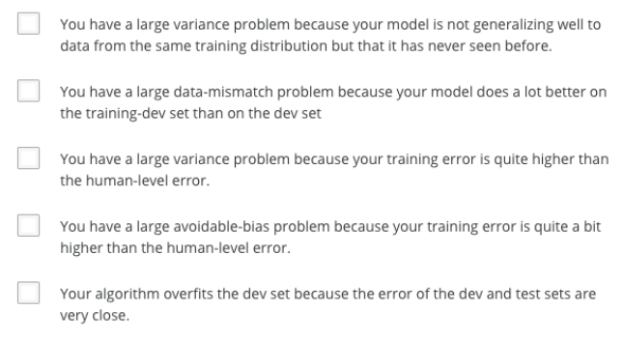

Ans: B、D

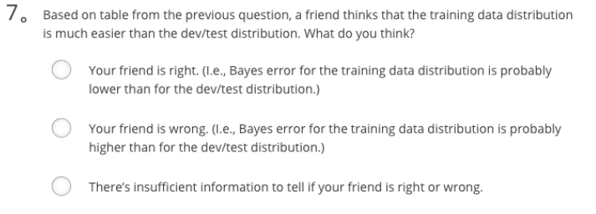

Ans: C

Note: To get an idea of this, we will have to measure human-level error separately on both distributions. The algorithm does better on the distribution data it is trained on. But we do not know for certain that it was because it was trained on that data or if it was really easier than the dev/test distribution.

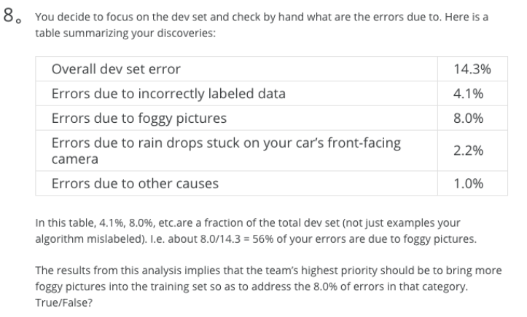

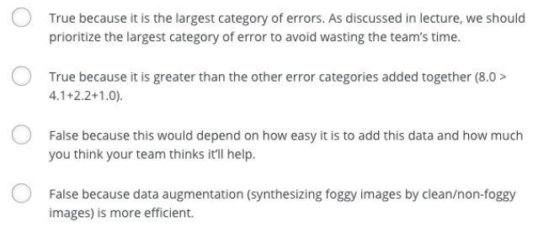

Ans: C

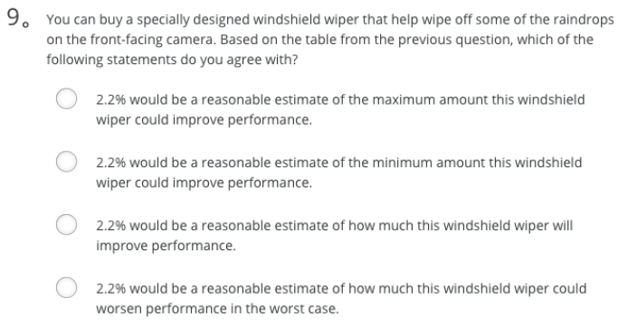

Ans: A

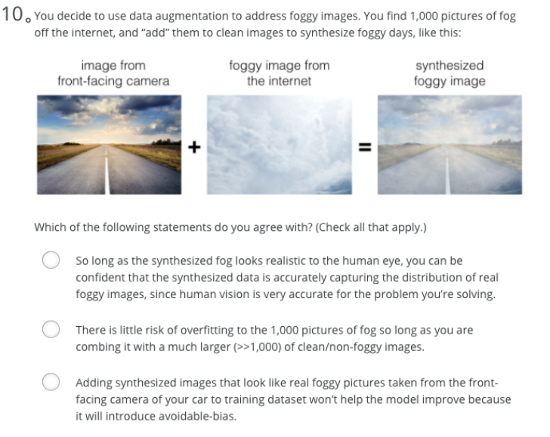

Ans: B

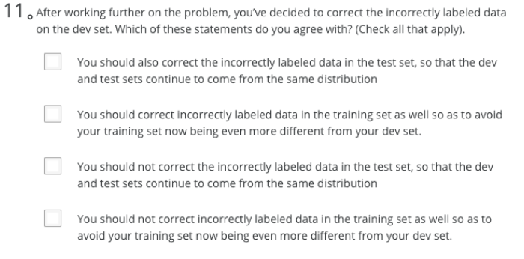

Ans: A

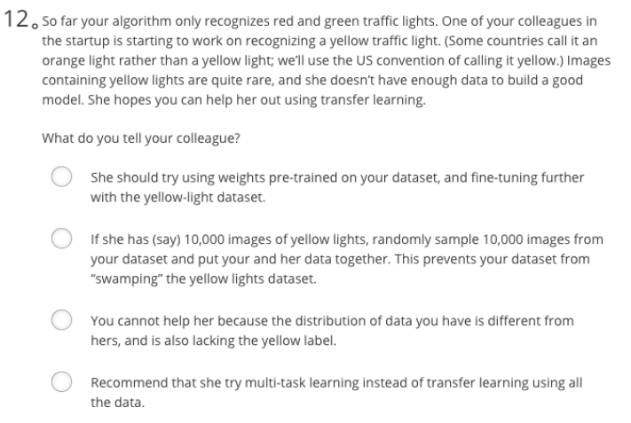

Ans: A

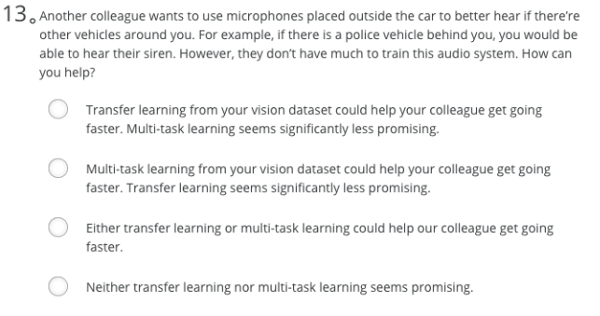

Ans: D

Note: The problem he is trying to solve is quite different from yours. The different dataset structures make it probably impossible to use transfer learning or multi-task learning.

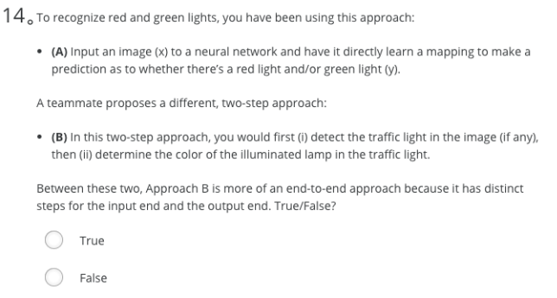

Ans: False

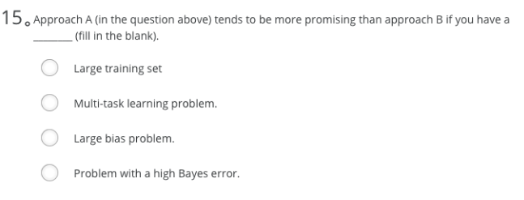

Ans: A

1. To help you practice strategies for machine learning, in this week we’ll present another scenario and ask how you would act. We think this “simulator” of working in a machine learning project will give a task of what leading a machine learning project could be like!

You are employed by a startup building self-driving cars. You are in charge of detecting road signs (stop sign, pedestrian crossing sign, construction ahead sign) and traffic signals (red and green lights) in images. The goal is to recognize which of these objects appear in each image. As an example, the above image contains a pedestrian crossing sign and red traffic lights

Your 100,000 labeled images are taken using the front-facing camera of your car. This is also the distribution of data you care most about doing well on. You think you might be able to get a much larger dataset off the internet, that could be helpful for training even if the distribution of internet data is not the same.

You are just getting started on this project. What is the first thing you do? Assume each of the steps below would take about an equal amount of time (a few days).

**Ans:** Spend a few days training a basic model and see what mistakes it makes.

Note: As discussed in lecture, applied ML is a highly iterative process. If you train a basic model and carry out error analysis (see what mistakes it makes) it will help point you in more promising directions.

1. Your goal is to detect road signs (stop sign, pedestrian crossing sign, construction ahead sign) and traffic signals (red and green lights) in images. The goal is to recognize which of these objects appear in each image. You plan to use a deep neural network with ReLU units in the hidden layers.

For the output layer, a softmax activation would be a good choice for the output layer because this is a multi-task learning problem. True/False?

**Ans:** False

1. You are carrying out error analysis and counting up what errors the algorithm makes. Which of these datasets do you think you should manually go through and carefully examine, one image at a time?

**Ans:** 500 images on which the algorithm made a mistake

1. After working on the data for several weeks, your team ends up with the following data:

100,000 labeled images taken using the front-facing camera of your car.

900,000 labeled images of roads downloaded from the internet.

Each image’s labels precisely indicate the presence of any specific road signs and traffic signals or combinations of them. For example, y(i) = ⎡⎣⎢⎢⎢⎢10010⎤⎦⎥⎥⎥⎥ means the image contains a stop sign and a red traffic light.

Because this is a multi-task learning problem, you need to have all your y(i) vectors fully labeled. If one example is equal to ⎡⎣⎢⎢⎢⎢0?11?⎤⎦⎥⎥⎥⎥ then the learning algorithm will not be able to use that example. True/False?

**Ans:** False

1. The distribution of data you care about contains images from your car’s front-facing camera; which comes from a different distribution than the images you were able to find and download off the internet. How should you split the dataset into train/dev/test sets?

**Ans:** Choose the training set to be the 900,000 images from the internet along with 80,000 images from your car’s front-facing camera. The 20,000 remaining images will be split equally in dev and test sets.

Note: As seen in lecture, it is important that your dev and test set have the closest possible distribution to “real”-data. It is also important for the training set to contain enough “real”-data to avoid having a data-mismatch problem.

1. Assume you’ve finally chosen the following split between of the data:

Dataset: Contains: Error of the algorithm:

Training 940,000 images randomly picked from (900,000 internet images + 60,000 car’s front-facing camera images) 8.8%

Training-Dev 20,000 images randomly picked from (900,000 internet images + 60,000 car’s front-facing camera images) 9.1%

Dev 20,000 images from your car’s front-facing camera 14.3%

Test 20,000 images from the car’s front-facing camera 14.8%

You also know that human-level error on the road sign and traffic signals classification task is around 0.5%. Which of the following are True? (Check all that apply).

**Ans:**

You have a large data-mismatch problem because your model does a lot better on the training-dev set than on the dev set

You have a large avoidable-bias problem because your training error is quite a bit higher than the human-level error.

1. Based on table from the previous question, a friend thinks that the training data distribution is much easier than the dev/test distribution. What do you think?

**Ans:** There’s insufficient information to tell if your friend is right or wrong.

1. You decide to focus on the dev set and check by hand what are the errors due to. Here is a table summarizing your discoveries:

Overall dev set error 14.3%

Errors due to incorrectly labeled data 4.1%

Errors due to foggy pictures 8.0%

Errors due to rain drops stuck on your car’s front-facing camera 2.2%

Errors due to other causes 1.0%

In this table, 4.1%, 8.0%, etc.are a fraction of the total dev set (not just examples your algorithm mislabeled). I.e. about 8.0/14.3 = 56% of your errors are due to foggy pictures.

The results from this analysis implies that the team’s highest priority should be to bring more foggy pictures into the training set so as to address the 8.0% of errors in that category. True/False?

**Ans:** True, because it is the largest category of errors. As discussed in lecture, we should prioritize the largest category of error to avoid wasting the team’s time.

1. You can buy a specially designed windshield wiper that help wipe off some of the raindrops on the front-facing camera. Based on the table from the previous question, which of the following statements do you agree with?

**Ans:** 2.2% would be a reasonable estimate of the maximum amount this windshield wiper could improve performance.

1. You decide to use data augmentation to address foggy images. You find 1,000 pictures of fog off the internet, and “add” them to clean images to synthesize foggy days, like this:

Which of the following statements do you agree with? (Check all that apply.)

**Ans:** There is little risk of overfitting to the 1,000 pictures of fog so long as you are combing it with a much larger (>>1,000) of clean/non-foggy images.

1. After working further on the problem, you’ve decided to correct the incorrectly labeled data on the dev set. Which of these statements do you agree with? (Check all that apply).

**Ans:** You should also correct the incorrectly labeled data in the test set, so that the dev and test sets continue to come from the same distribution

1. So far your algorithm only recognizes red and green traffic lights. One of your colleagues in the startup is starting to work on recognizing a yellow traffic light. (Some countries call it an orange light rather than a yellow light; we’ll use the US convention of calling it yellow.) Images containing yellow lights are quite rare, and she doesn’t have enough data to build a good model. She hopes you can help her out using transfer learning.

What do you tell your colleague?

**Ans:** She should try using weights pre-trained on your dataset, and fine-tuning further with the yellow-light dataset.

1. Another colleague wants to use microphones placed outside the car to better hear if there’re other vehicles around you. For example, if there is a police vehicle behind you, you would be able to hear their siren. However, they don’t have much to train this audio system. How can you help?

**Ans:** Neither transfer learning nor multi-task learning seems promising.

Note: The problem he is trying to solve is quite different from yours. The different dataset structures make it probably impossible to use transfer learning or multi-task learning.

1. To recognize red and green lights, you have been using this approach:

(A) Input an image (x) to a neural network and have it directly learn a mapping to make a prediction as to whether there’s a red light and/or green light (y).

A teammate proposes a different, two-step approach:

(B) In this two-step approach, you would first (i) detect the traffic light in the image (if any), then (ii) determine the color of the illuminated lamp in the traffic light.

Between these two, Approach B is more of an end-to-end approach because it has distinct steps for the input end and the output end. True/False?

**Ans:** False

1. Approach A (in the question above) tends to be more promising than approach B if you have a ________ (fill in the blank).

**Ans:** Large training set

# 课程4——卷积神经网络

## 第一周 卷积神经网络

### 计算机视觉

问题引入：计算机视觉问题

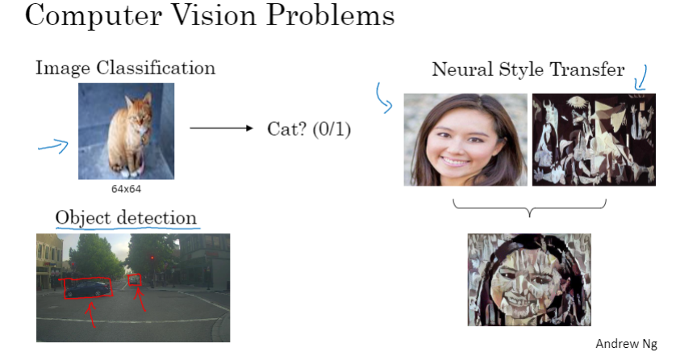

大图像的深度学习面临的一个问题：参数过多（如果按照像素来设置参数，参数会以十亿记）

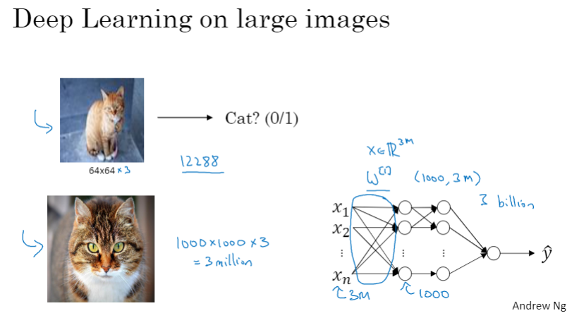

### 边缘检测示例

问题引入：计算机视觉问题，如，边缘检测（纵向、横向）

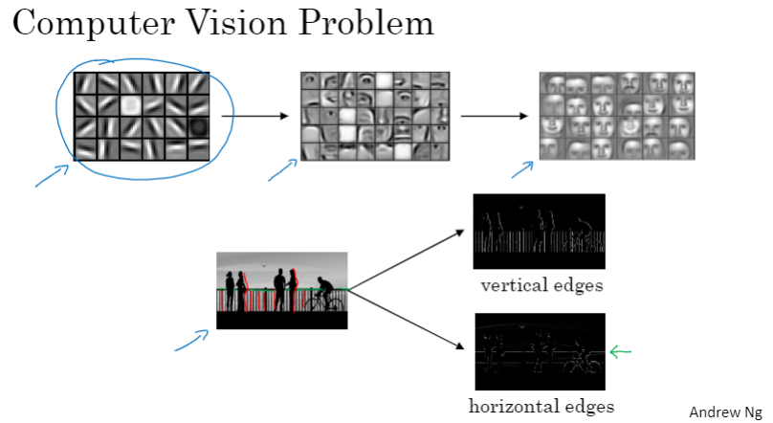

纵向边缘检测、滤波器（filter）（卷积核（kernel））、卷积运算（按位相乘后求和）

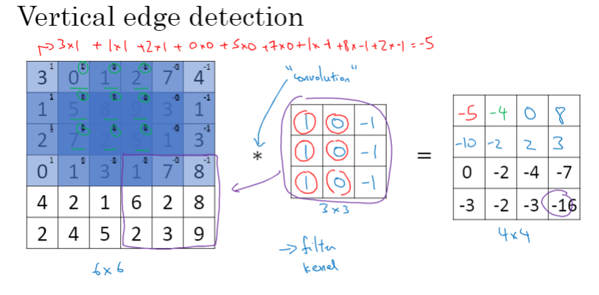

为什么能够检测纵向边缘？卷积运算后图像会出现过渡带（midtone）

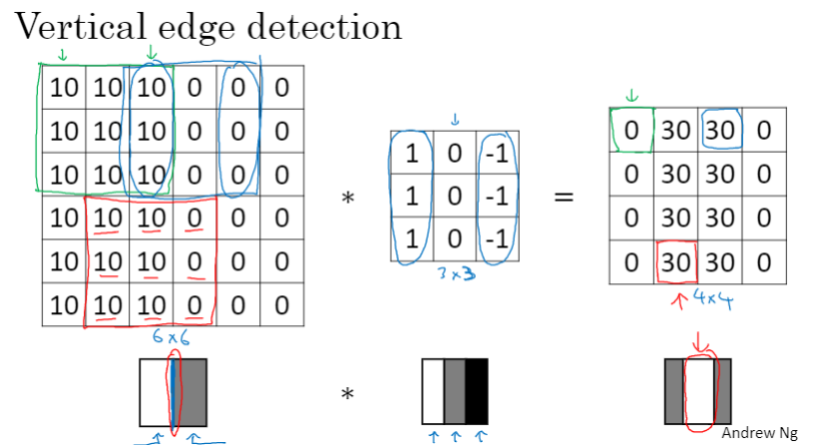

### 更多边缘检测示例

边缘检测可以检测出不同边界类型：从亮到暗，或者，从暗到亮

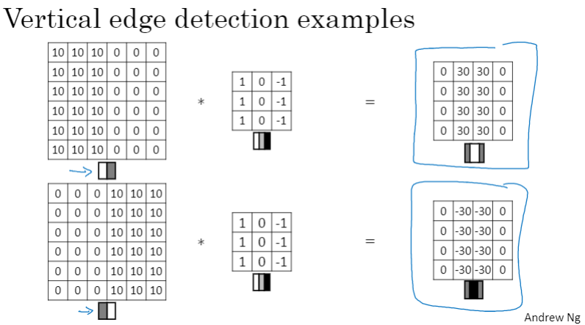

同时检测垂直边缘和水平边缘

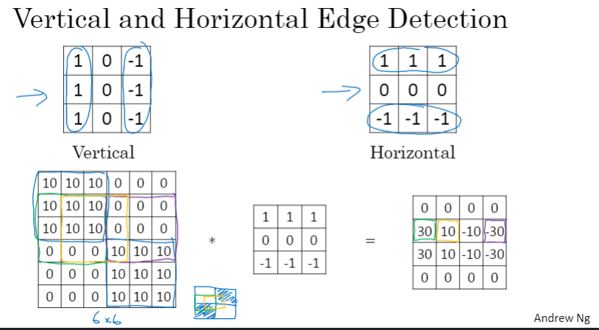

滤波器各元素可通过学习得到，无需手动指定

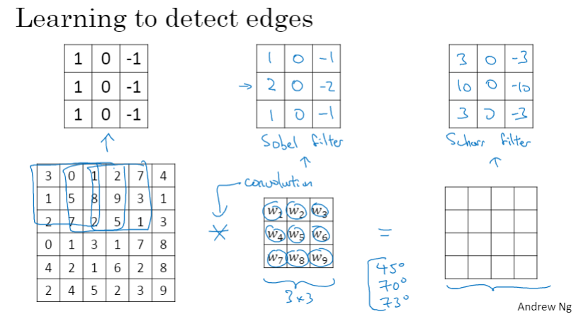

### Padding（填充）

填充的作用：

1. 防止图像大小的收缩（shrinking）
2. 防止图像边缘像素信息被“轻视”（比如，如果不填充，图像左上角的像素只被卷积一次）

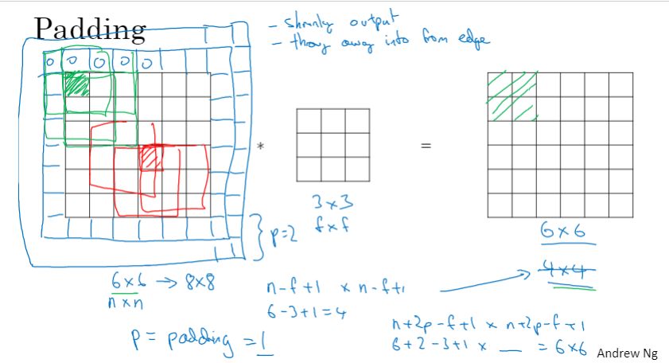

两种卷积方式：

1. Valid：未使用填充，卷积后图像变小
2. Same：使用填充，卷积后图像大小不变

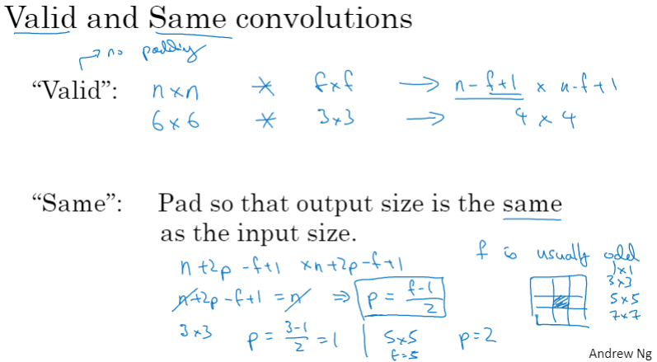

### 卷积步长

步长是指每次移动滤波器时，间隔的像素数（步数）

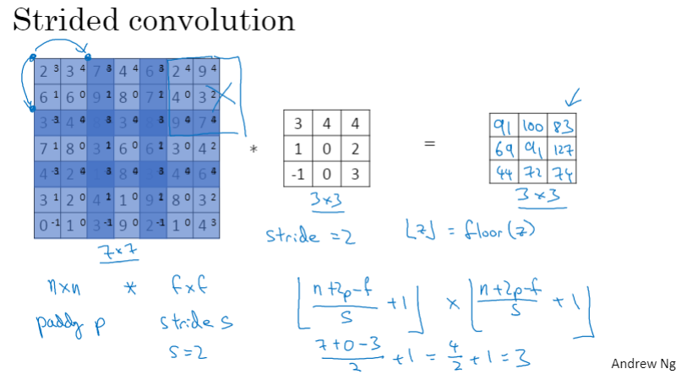

卷积小结

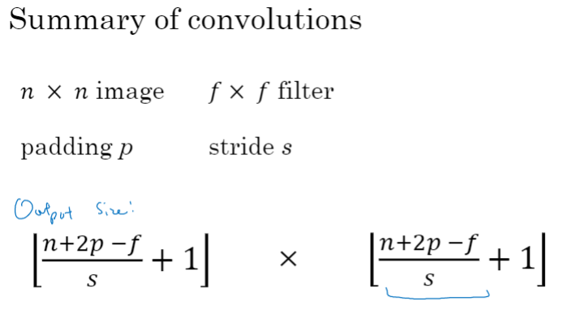

不同于信号处理领域的卷积，深度学习中的“卷积”又名“cross-correlation”，通常不涉及滤波器的翻转（flip）

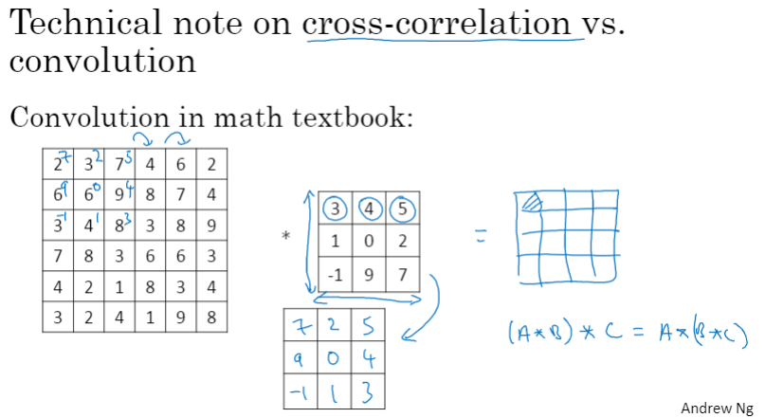

### 平面卷积与立体卷积

灰度图像卷积仅涉及图像长、宽，属于“平面卷积”；彩色图像中加入了色彩通道(channel)，称为立体卷积(3D convolution)

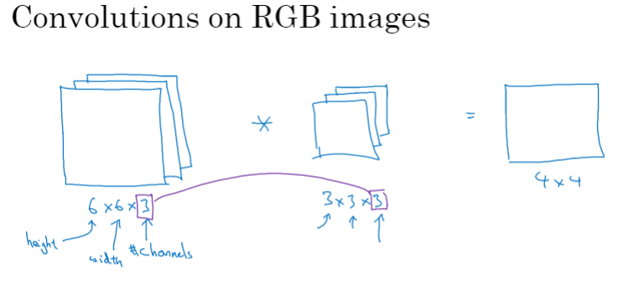

立体卷积相当于使用滤波器立方体在图像立方体中逐块移动，进行滤波

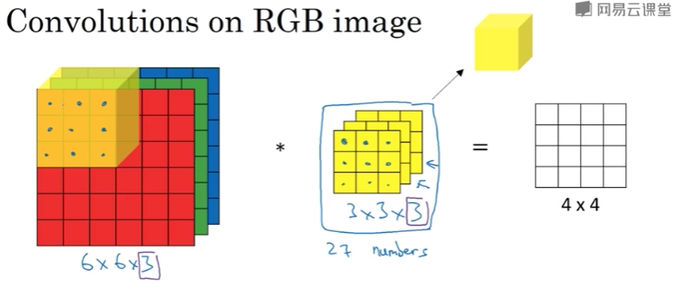

滤波器各层可以相同，也可以不相同

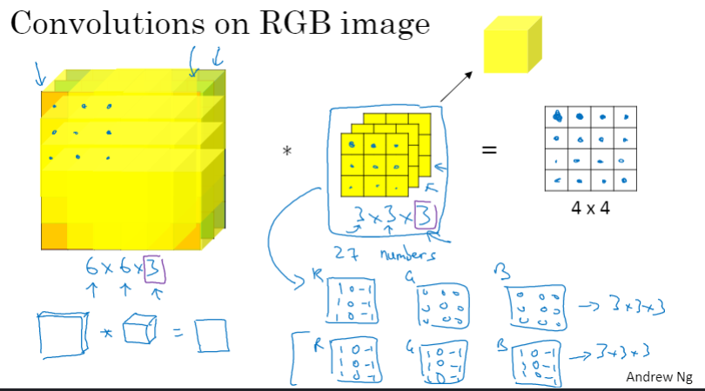

多个滤波器的情况（如，垂直边缘检测滤波器 + 水平边缘检测滤波器）

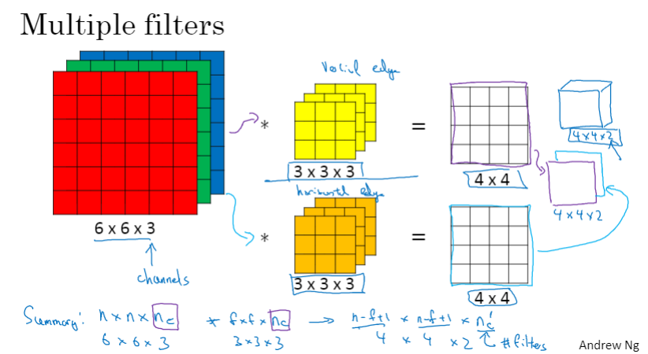

### 单层卷积网络

单层卷积运算与单层神经网络的类比关系：输入为图像a[l-1]（l-1层）卷积核（滤波器）类似于权重W，卷积运算结果类似于判别函数Z，Relu运算为激活函数g，输出为激活函数a[l]（l层）

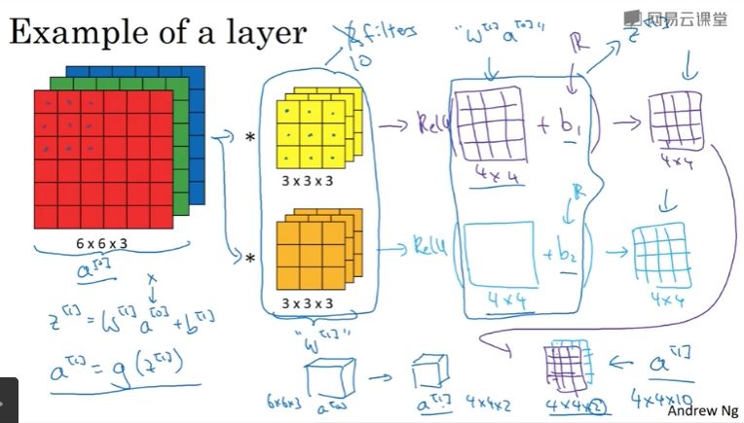

单层卷积网络中有多少个参数？

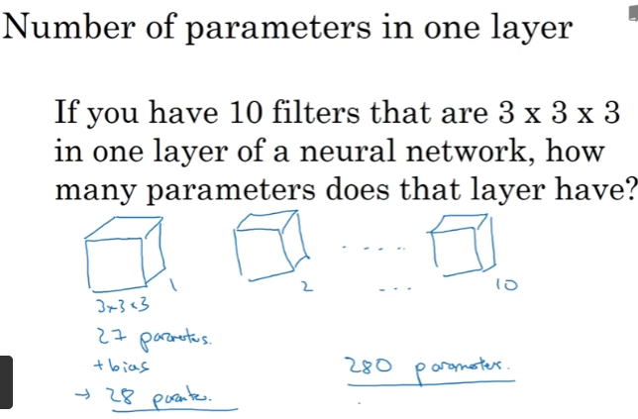

单层卷积网络小结：

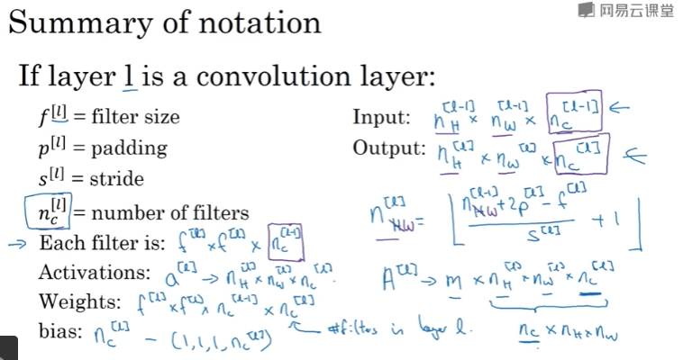

### 简单卷积网络示例

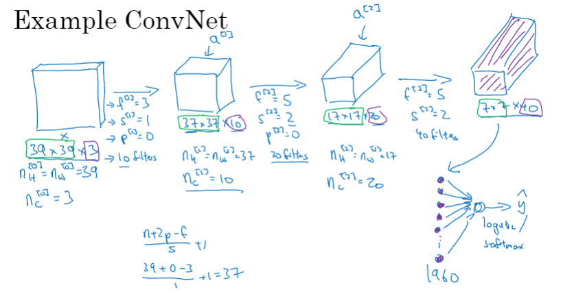

卷积网络的层类型：卷积层、池化层、全连接层

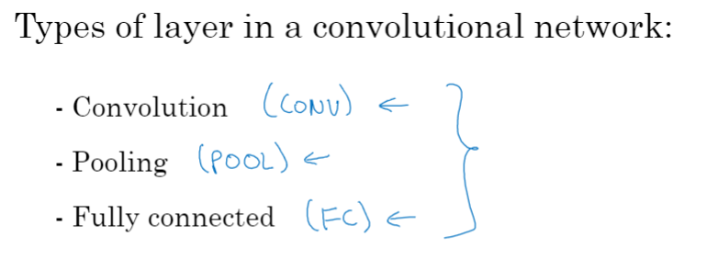

### 池化层

Max（最大值）池化层

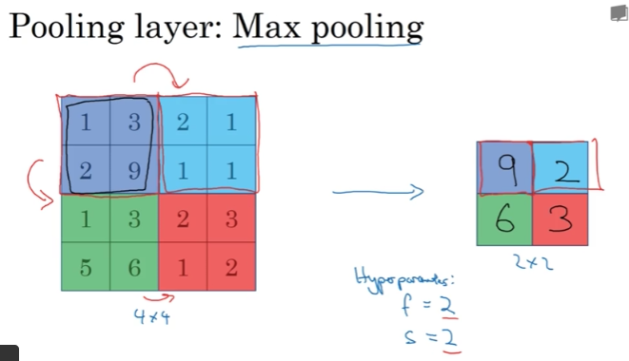

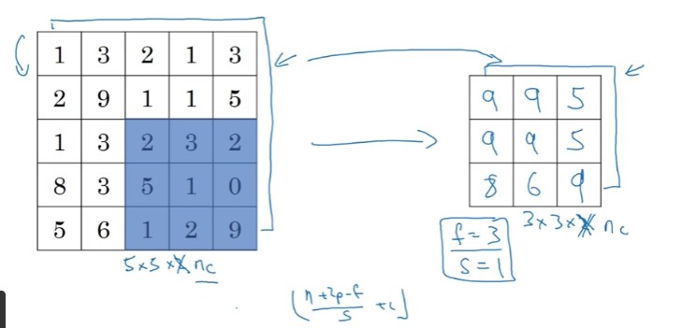

均值池化层

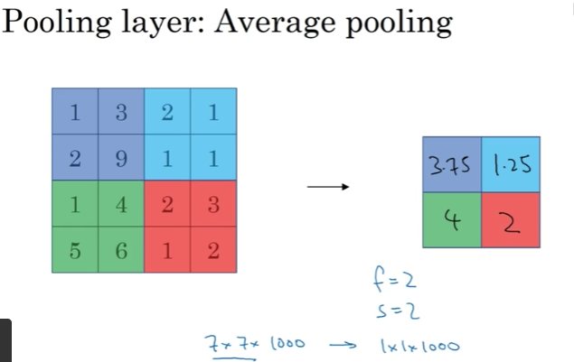

池化层小结：

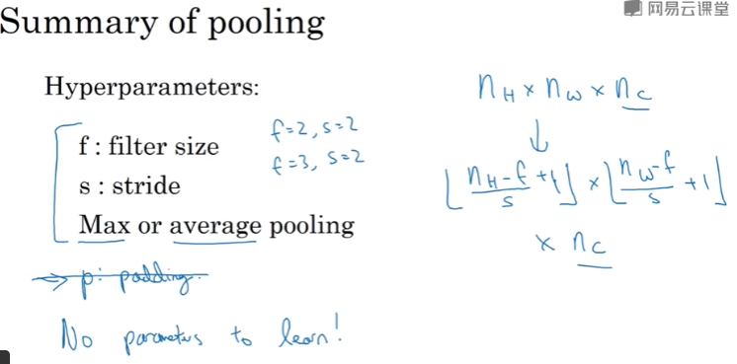

### 卷积神经网络示例

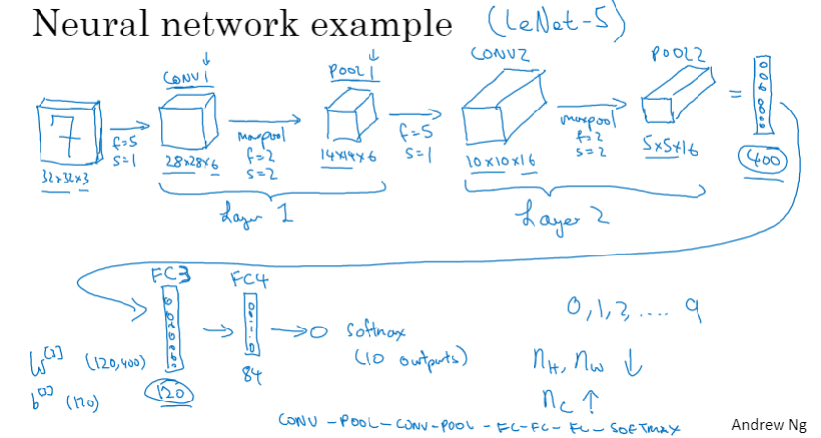

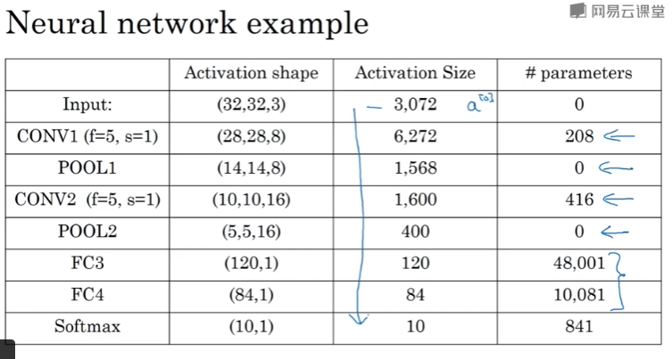

### 为什么使用卷积？

图像较大时，全连接层的参数数量会非常庞大

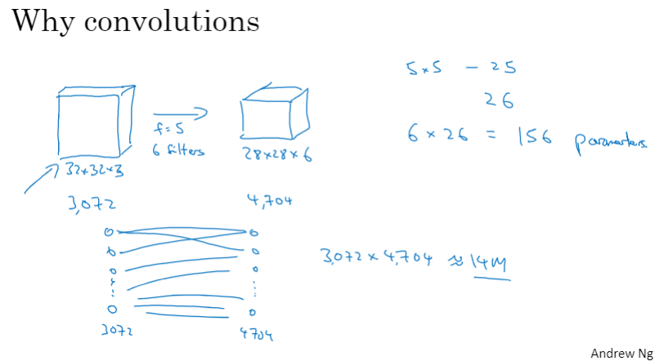

卷积层的两个特点：

1. 参数共享：对图像的一部分有用的特征检测器（滤波器），对图像的另一部分也很可能是有用的
2. 稀疏连接：在每一个卷积层，输出值仅取决于一小部分输入值

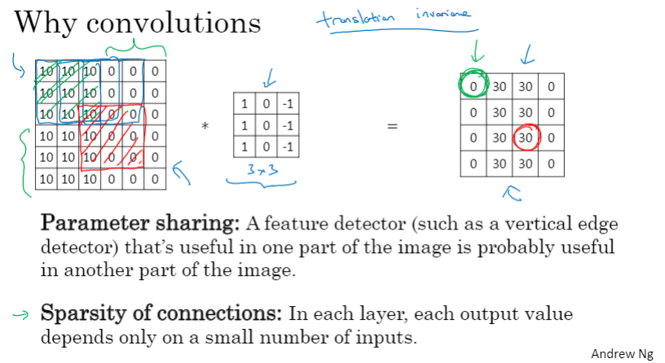

卷积网络的搭建：

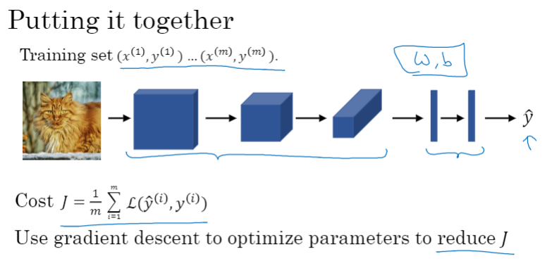

### C4W1 Quiz - The basics of ConvNets

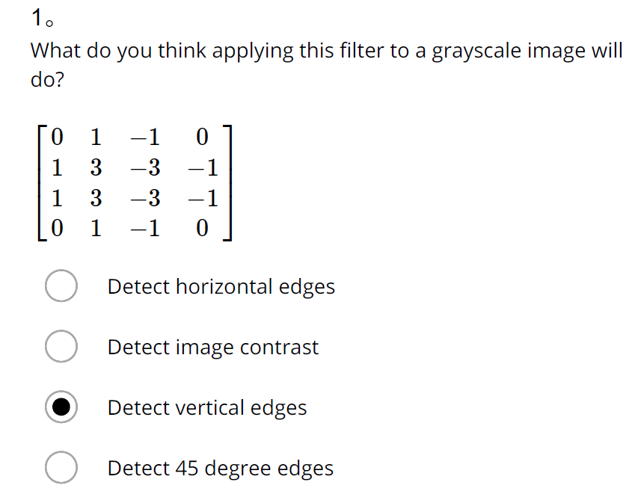

Ans: C

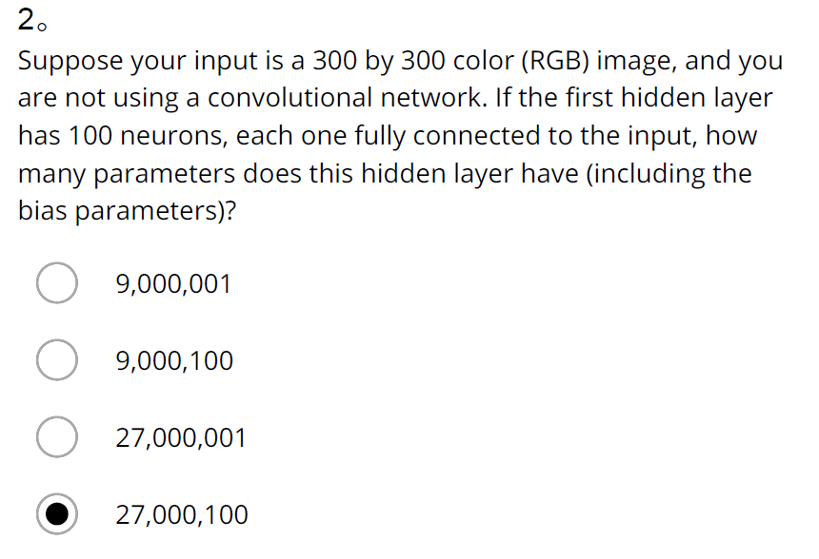

Ans: D

Note: 100*(300*300*3)+100 = 27000100

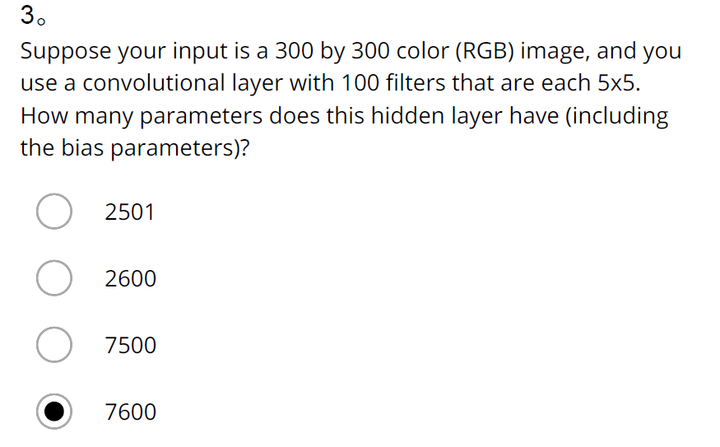

Ans: B

Note: 5*5*100 + 100 = 2600

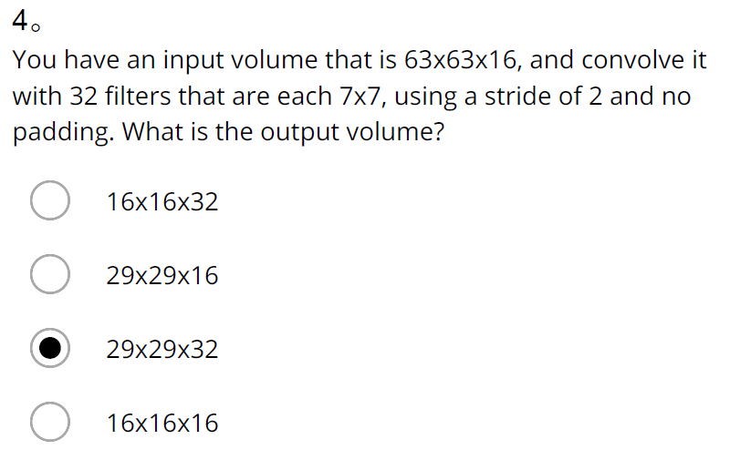

Ans: C

Note: n=63, f=7, nC=32, s=2, p=0

nH=nW=(n+2p-f)/s+1=(63-7)/2+1=29

Shape of output: nH*nW*nC= 29*29*32

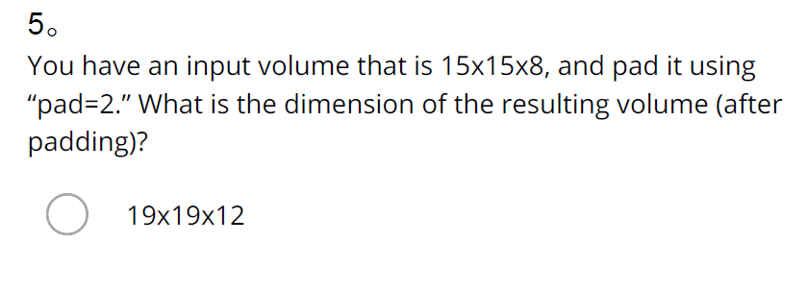

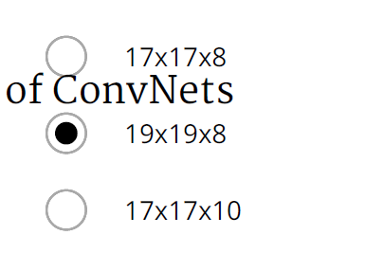

Ans: C

Note: n=15, p=2, nC=8

nH=nW=n+2p=19

Shape of input: nH*nW*nC= 19*19*8

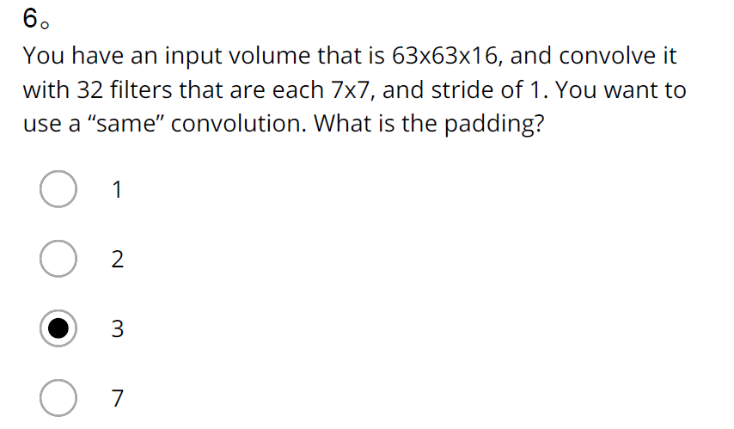

Ans: C

Note: n=63, s=1, f=7

(n+2p-f)/s+1=n => p=((n-1)*s-n+f)/2=(f-1)/2=(7-1)/2=3

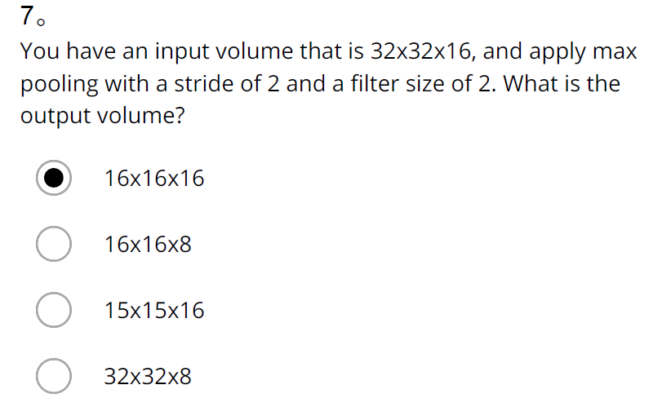

Ans:

Note: n=32, nC=16, s=2

nH=nW=n/s=32/2=16

Shape of output: nH*nW*nC= 16*16*16

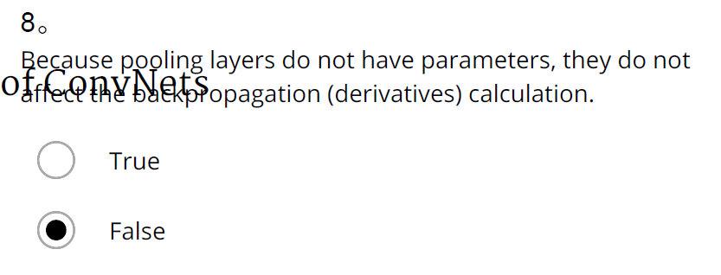

Ans: False

Note: 由卷积层->池化层作为一个layer，在前向传播过程中，池化层里保存着卷积层的各个部分的最大值/平均值，然后由池化层传递给下一层，在反向传播过程中，由下一层传递梯度过来，“不影响反向传播的计算”这意味着池化层到卷积层（反向）没有梯度变化，梯度值就为0，既然梯度值为0，那么例如在W[l]=W[l]−α×dW[l]的过程中，参数W[l]=W[l]−α×0，也就是说它不再更新，那么反向传播到此中断。所以池化层会影响反向传播的计算。

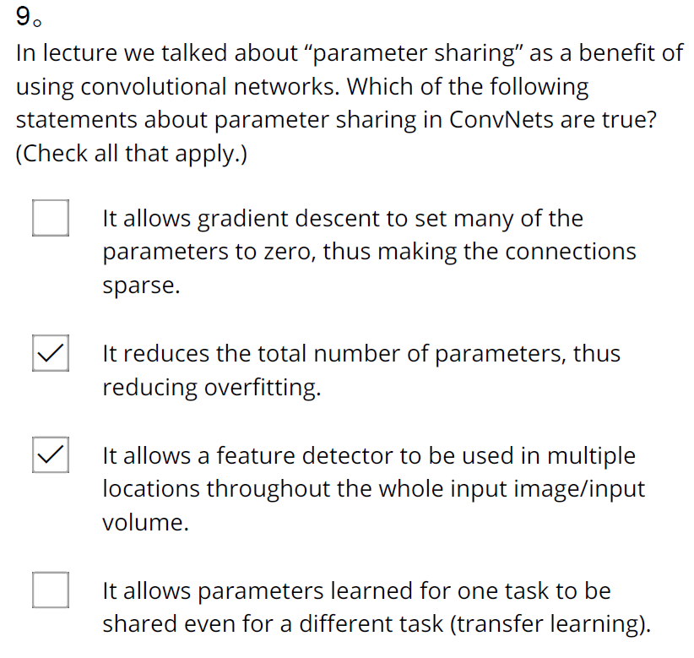

Ans: B、C

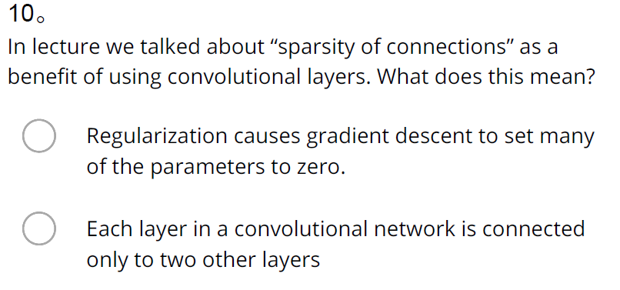

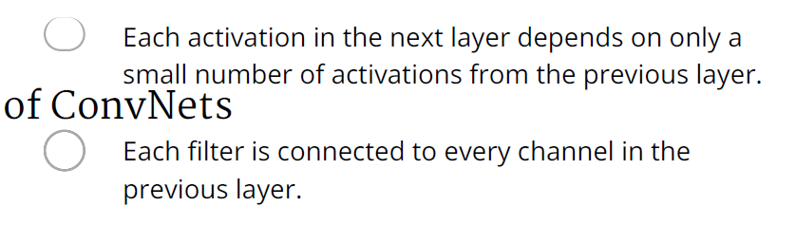

Ans: B

1. What do you think applying this filter to a grayscale image will do?

[[0 1 -1 0][ 1 3 -3 -1][ 1 3 -3 -1][ 0 1 -1 0]]

Ans: Detect vertical edges

1. Suppose your input is a 300 by 300 color (RGB) image, and you are not using a convolutional network. If the first hidden layer has 100 neurons, each one fully connected to the input, how many parameters does this hidden layer have (including the bias parameters)?

Ans: 27,000,100

1. Suppose your input is a 300 by 300 color (RGB) image, and you use a convolutional layer with 100 filters that are each 5x5. How many parameters does this hidden layer have (including the bias parameters)?

Ans: 2600

1. You have an input volume that is 63x63x16, and convolve it with 32 filters that are each 7x7, using a stride of 2 and no padding. What is the output volume?

Ans: 29x29x32

1. You have an input volume that is 15x15x8, and pad it using “pad=2.” What is the dimension of the resulting volume (after padding)?

Ans: 19x19x8

1. You have an input volume that is 63x63x16, and convolve it with 32 filters that are each 7x7, and stride of 1. You want to use a “same” convolution. What is the padding?

Ans: 3

1. You have an input volume that is 32x32x16, and apply max pooling with a stride of 2 and a filter size of 2. What is the output volume?

Ans: 16x16x16

1. Because pooling layers do not have parameters, they do not affect the backpropagation (derivatives) calculation.

Ans: False

1. In lecture we talked about “parameter sharing” as a benefit of using convolutional networks. Which of the following statements about parameter sharing in ConvNets are true? (Check all that apply.)

It reduces the total number of parameters, thus reducing overfitting.

It allows a feature detector to be used in multiple locations throughout the whole input image/input volume.

1. In lecture we talked about “sparsity of connections” as a benefit of using convolutional layers. What does this mean?

Each activation in the next layer depends on only a small number of activations from the previous layer.

## 第二周 深度卷积网络：实例探究

### 为什么要进行实例探究？

了解经典案例，可以获取很多启发，帮助我们开启未来！

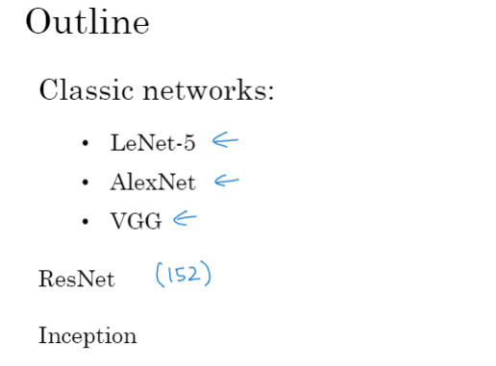

### 经典网络

LeNet-5（论文较难懂）

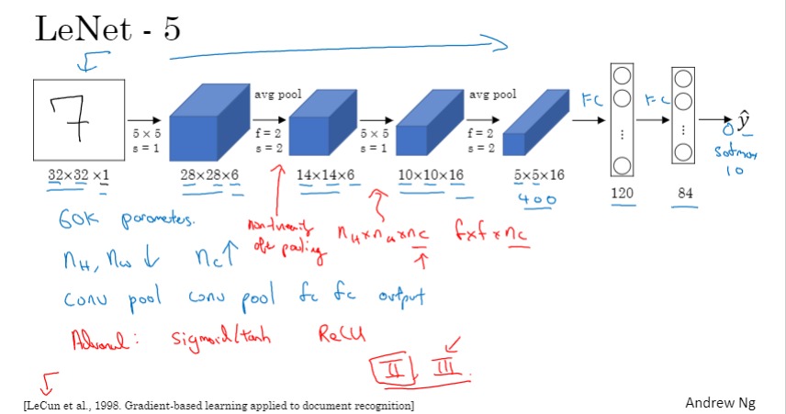

AlexNet（论文容易读，建议先读此篇论文）

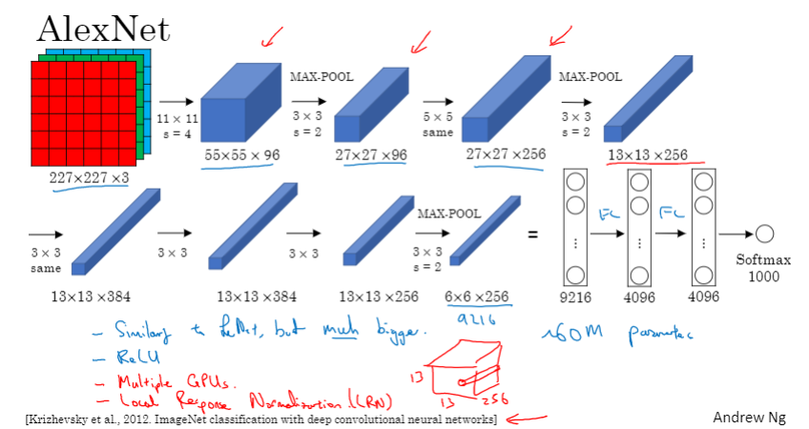

VGG-16（设计比较优雅，卷积层长、宽减半递减的同时，通道数在倍增）

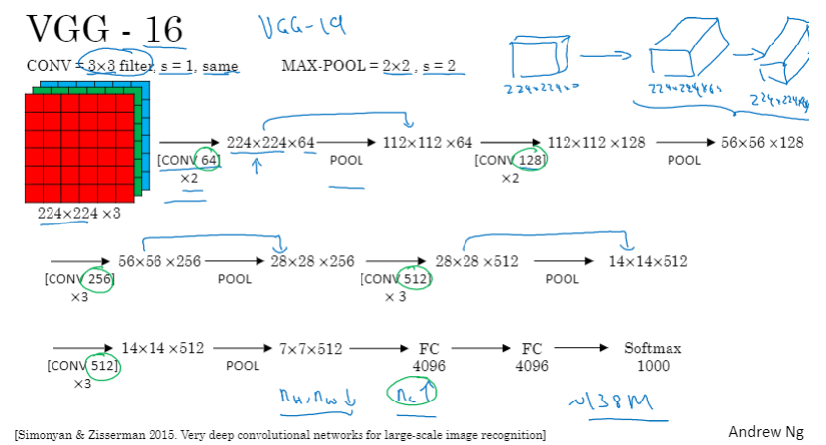

### 残差网络（ResNet）

残差网络是在普通网络（Linear+ReLU）基础上，引入了“跳接”（shortcut, skip connection），产生了残留块（如，a[l+2]=g(z[l+2])，故称“残差”网络。

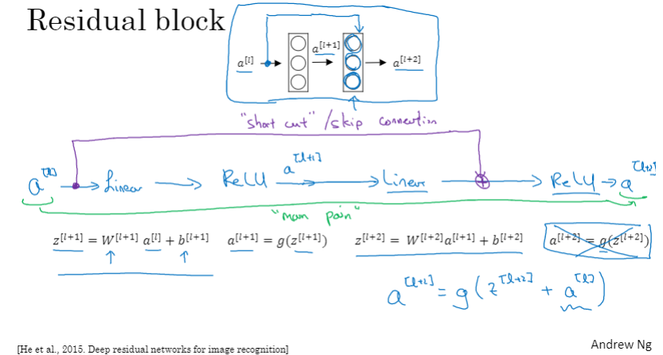

理论上，训练误差应该随着网络深度的增加而一直下降（甚至出现过拟合而下降到零），但实际上，在普通网络（plain network）中，网络层数增加到一定数量后，训练误差会不降反增。残差网络可以减轻深度网络中的梯度消失和梯度爆炸问题，从而减轻上述问题。

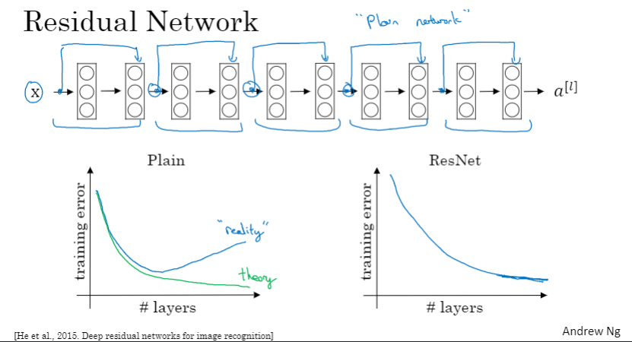

### 残差网络为什么有用？

残差网络更容易学习到恒等函数（identify function），即a[l+2]等于a[l]，相当于直接将a[l]复制到a[l+2]，这样，不容易给模型造成性能损失。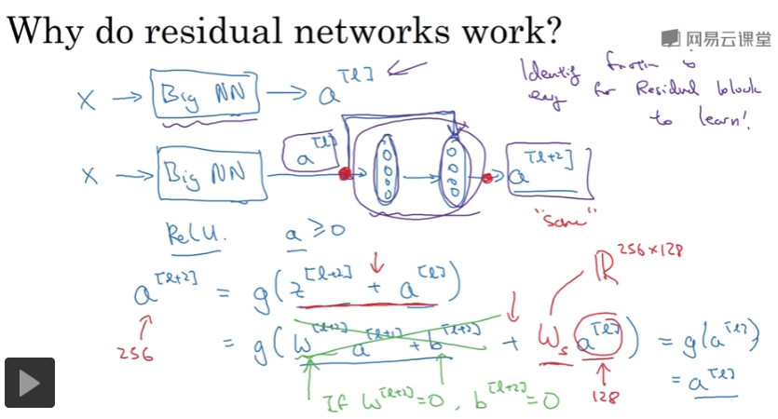

ResNet示例图

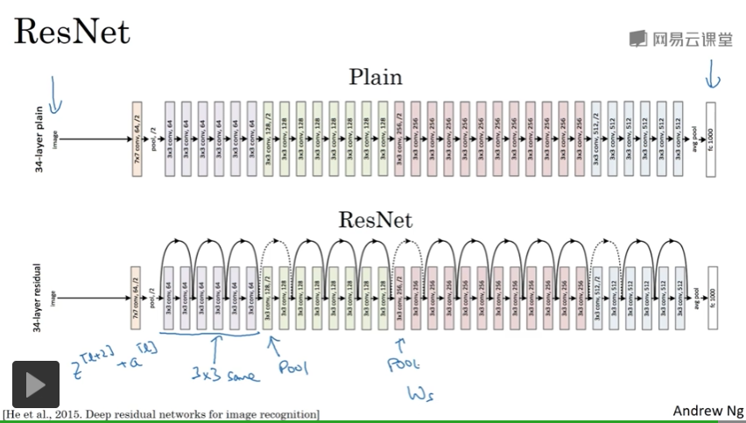

### 网络中的网络以及1×1卷积

1*1卷积类似于一个半侧节点数可伸缩的全连接层，这里的半侧节点数等于滤波器的数量。当滤波器个数小于输入层的通道数时，相当于降维操作；当滤波器个数大于输入层通道数时，相当于升维操作。

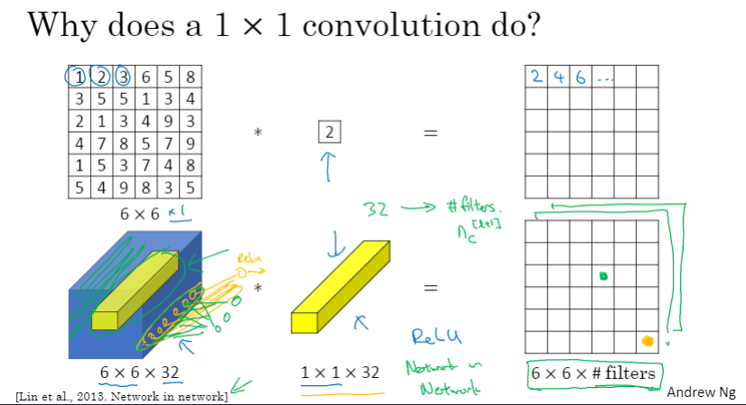

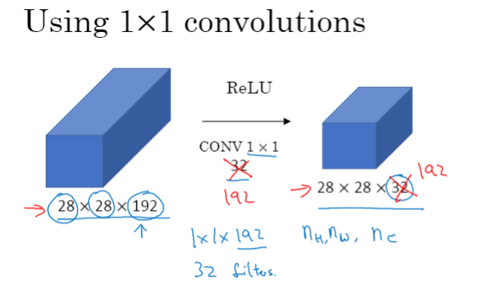

### 谷歌Inception网络简介

Inception网络的创意：需要使用多大的滤波器？1*1， 3*3，5*5还是池化层？为什么不一起完成所有这些任务？

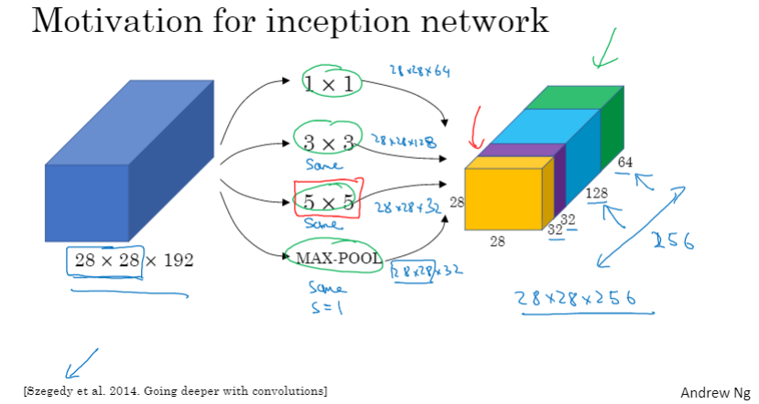

卷积运算中面临着计算成本很高的问题

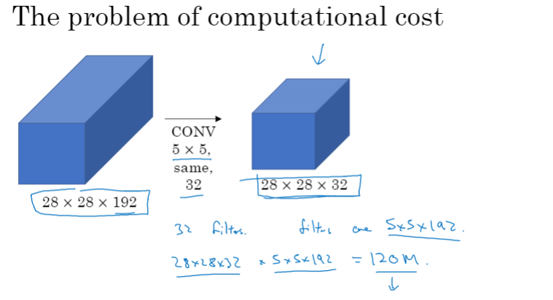

使用1*1卷积可以将卷积运算成本降低一个数量级

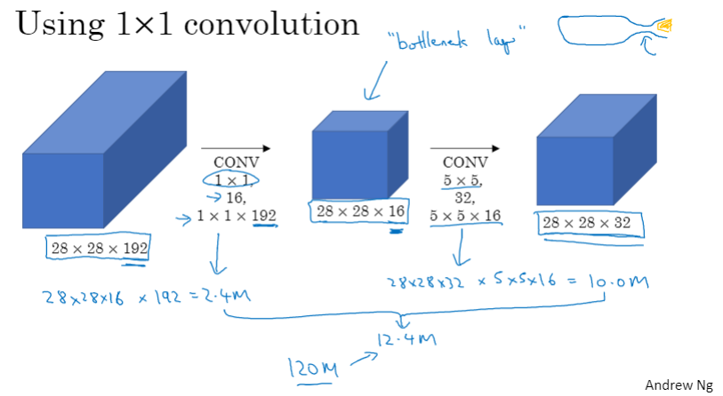

### Inception网络

Inception模块

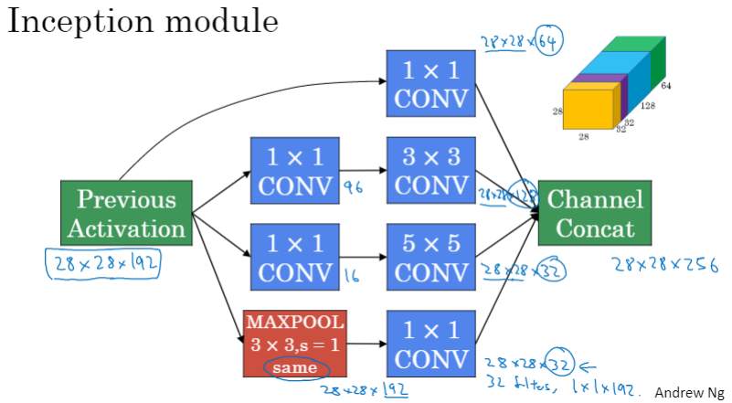

Inception网络

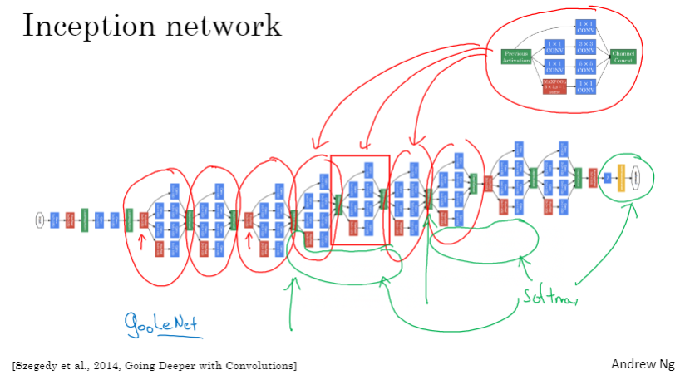

“We need to go deeper!” 表明了深度学习研究者追求更深层次网络的决心。

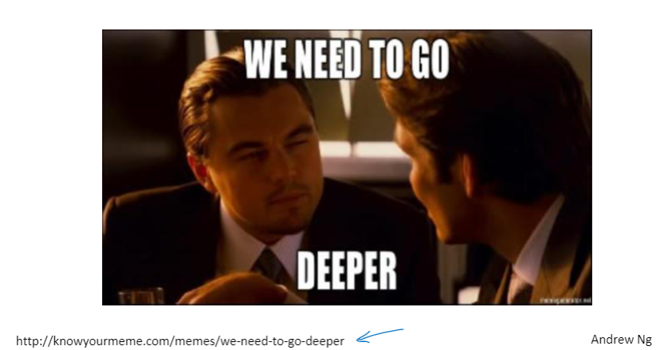

### 使用开源的实现方案

仅仅阅读文献来学习和研究深度学习是不现实的，利用开源资源是个不错的选择！

### 迁移学习

如果我们手头的数据量不够大，使用别人已经训练好的模型数据（代码、权重）作为预训练数据（pre-trained）是个不错的选择，称为“迁移学习”。

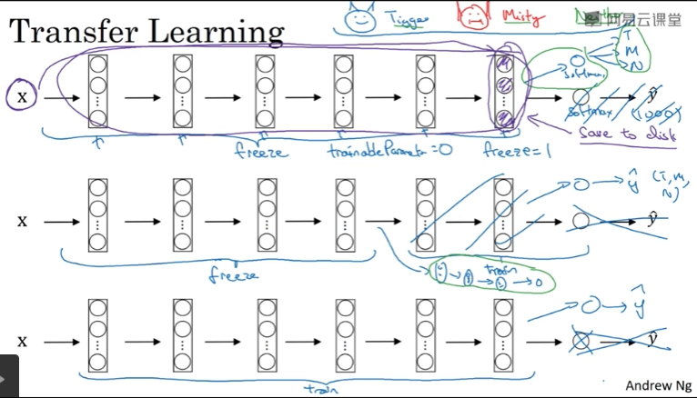

### 数据扩充

使用色彩偏移增广数据

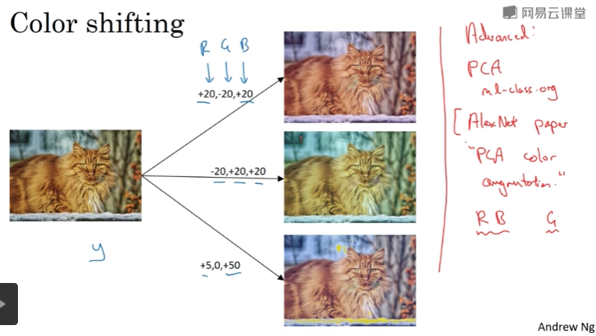

使用增广数据进行训练

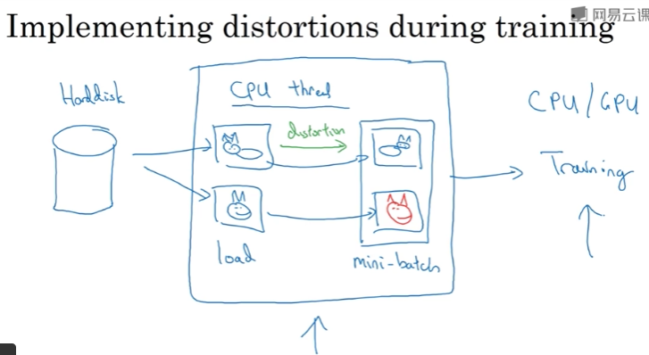

### 计算机视觉现状

手动作业（hand-engineering）在数据量较小等情况下在所难免，数据量较大时，有利于减少对手动作业的依赖

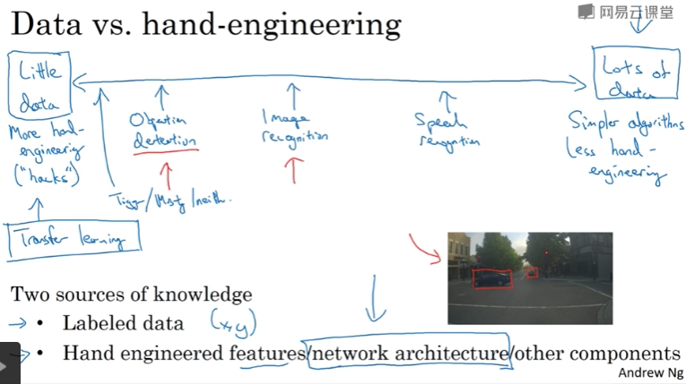

赢得竞赛的一些技巧（集成学习、多剪切）

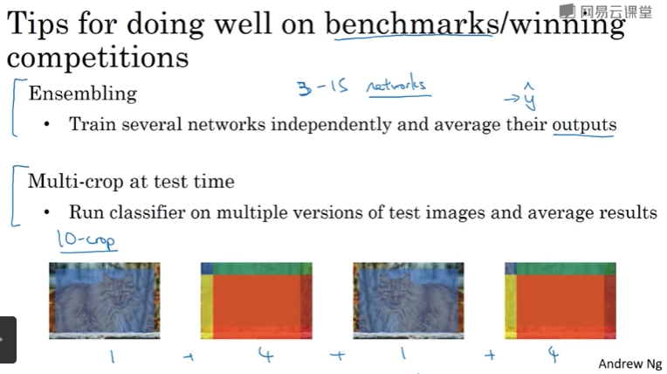

使用开源代码

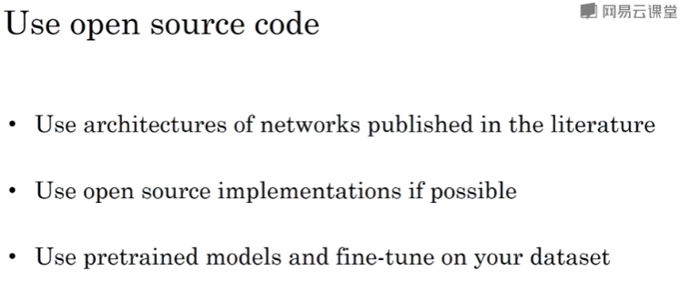

### C4W2 Quiz - **Deep-convolutional-models**

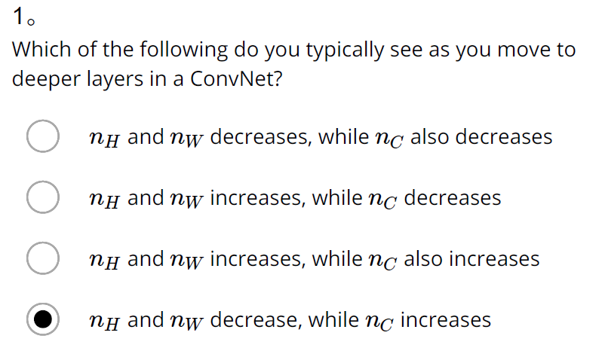

Ans: D

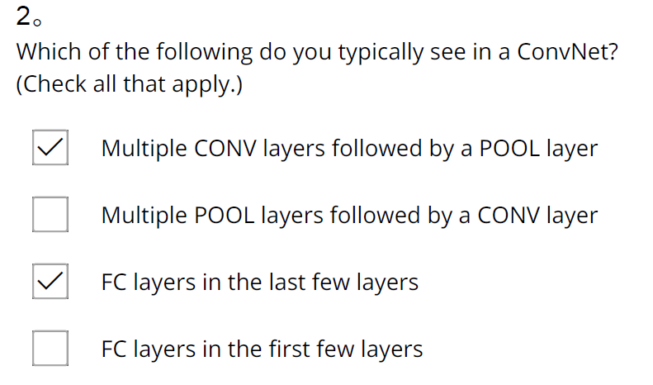

Ans: A、C

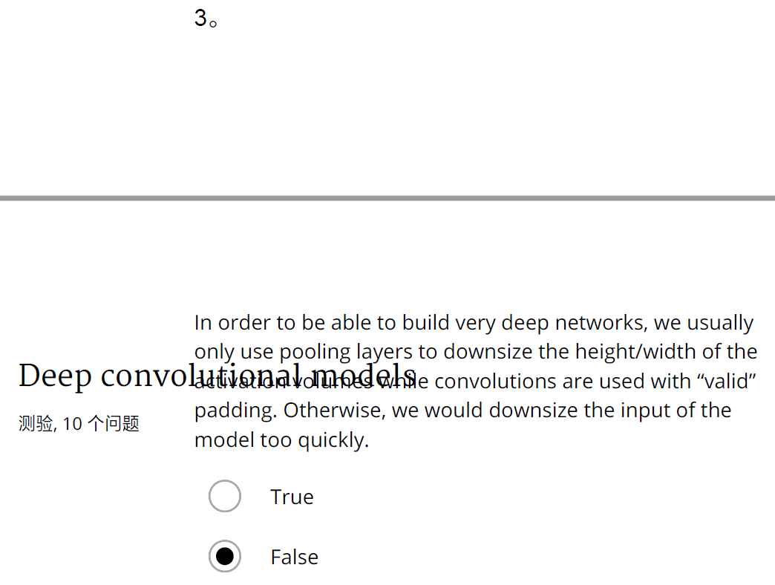

Ans: False

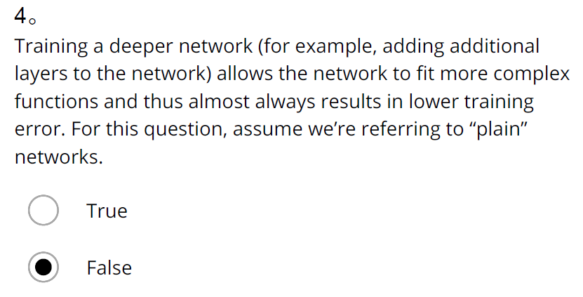

Ans: False

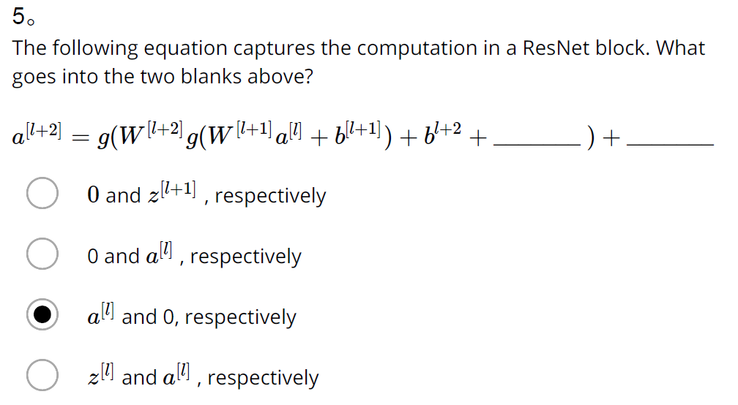

Ans: C

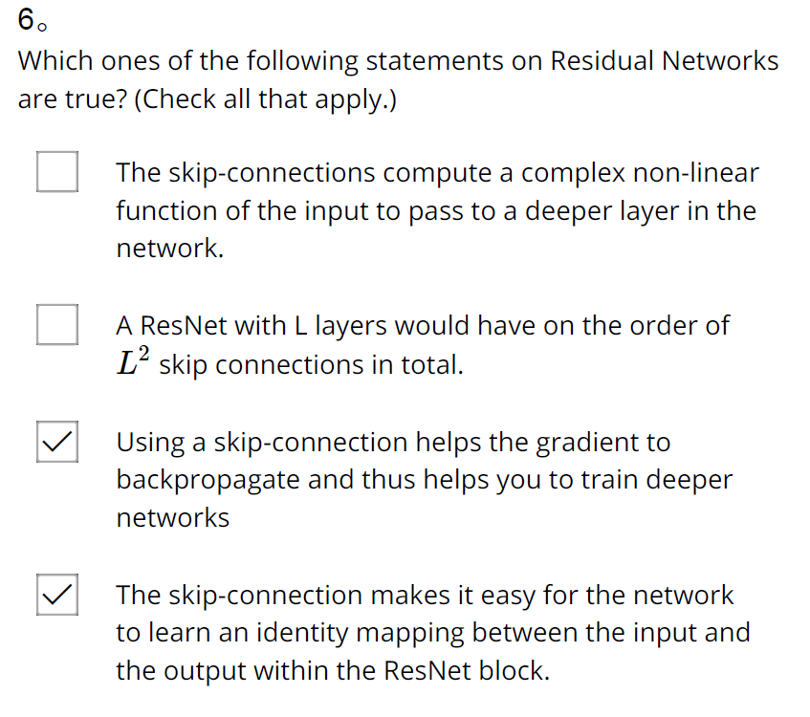

Ans: C、D

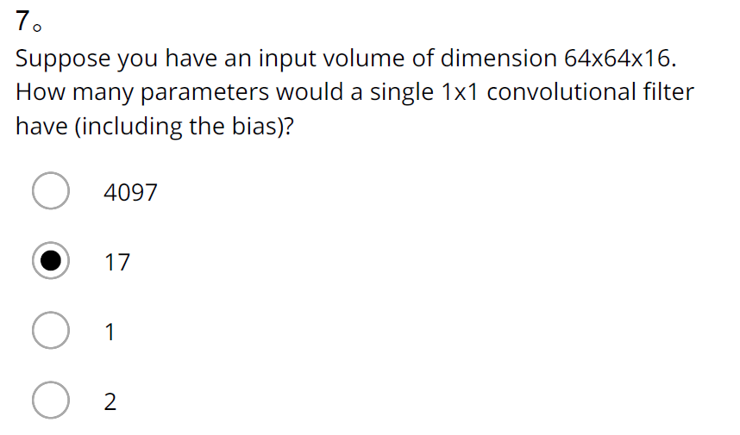

Ans: B

8.

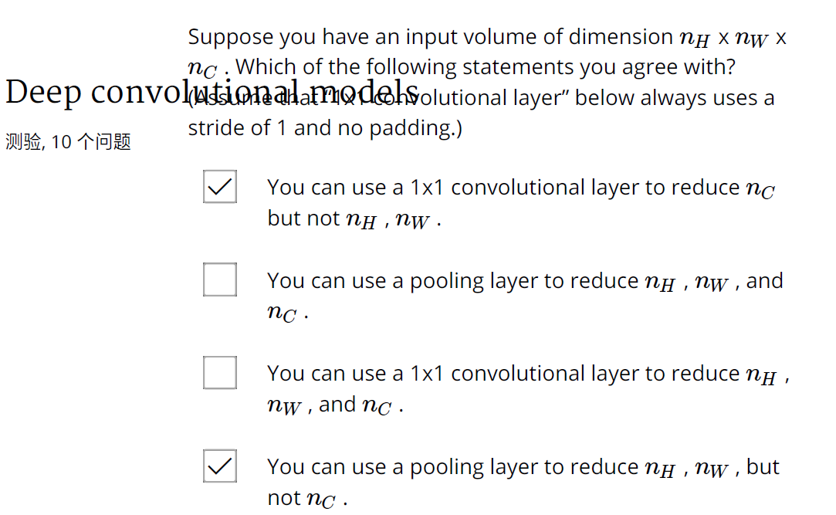

Ans: A、D

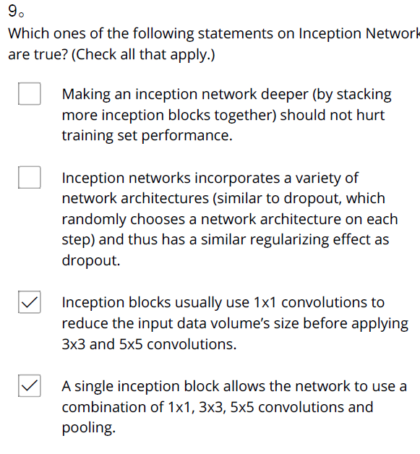

Ans: C、D

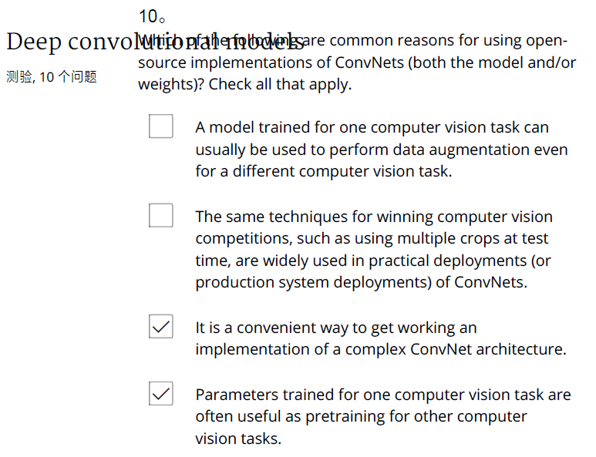

Ans: C、D

1. Which of the following do you typically see as you move to deeper layers in a ConvNet?

Ans: nH and nW decrease, while nC increases

1. Which of the following do you typically see in a ConvNet? (Check all that apply.)

Ans:

Multiple CONV layers followed by a POOL layer

FC layers in the last few layers

1. In order to be able to build very deep networks, we usually only use pooling layers to downsize the height/width of the activation volumes while convolutions are used with “valid” padding. Otherwise, we would downsize the input of the model too quickly.

Ans: False

1. Training a deeper network (for example, adding additional layers to the network) allows the network to fit more complex functions and thus almost always results in lower training error. For this question, assume we’re referring to “plain” networks.

Ans: False

1. The following equation captures the computation in a ResNet block. What goes into the two blanks above?

a[l+2]=g(W[l+2]g(W[l+1]a[l]+b[l+1])+b[l+2]+_______ )+_______

Ans: a[l] and 0, respectively

1. Which ones of the following statements on Residual Networks are true? (Check all that apply.)

Ans:

Using a skip-connection helps the gradient to backpropagate and thus helps you to train deeper networks

The skip-connection makes it easy for the network to learn an identity mapping between the input and the output within the ResNet block.

1. Suppose you have an input volume of dimension 64x64x16. How many parameters would a single 1x1 convolutional filter have (including the bias)?

Ans: 17

1. Suppose you have an input volume of dimension nH x nW x nC. Which of the following statements do you agree with? (Assume that “1x1 convolutional layer” below always uses a stride of 1 and no padding.)

Ans:

You can use a 1x1 convolutional layer to reduce nC but not nH, nW.

You can use a pooling layer to reduce nH, nW, but not nC.

1. Which ones of the following statements on Inception Networks are true? (Check all that apply.)

Ans:

Inception blocks usually use 1x1 convolutions to reduce the input data volume’s size before applying 3x3 and 5x5 convolutions.

A single inception block allows the network to use a combination of 1x1, 3x3, 5x5 convolutions and pooling.

1. Which of the following are common reasons for using open-source implementations of ConvNets (both the model and/or weights)? Check all that apply.

Ans:

Parameters trained for one computer vision task are often useful as pretraining for other computer vision tasks.

It is a convenient way to get working an implementation of a complex ConvNet architecture.

## 第三周 目标检测

### 3.1 目标定位

### 3.2 特征点检测

### 3.3 目标检测

### 3.4 卷积的滑动窗口实现

### 3.5 Bounding Box预测

### 3.6 交并比

### 3.7 非极大值抑制

### 3.8 Anchor Boxes

### 3.9 YOLO算法

### 3.10 （选修）RPN 网络

### C4W3 Quiz - Detection algorithms

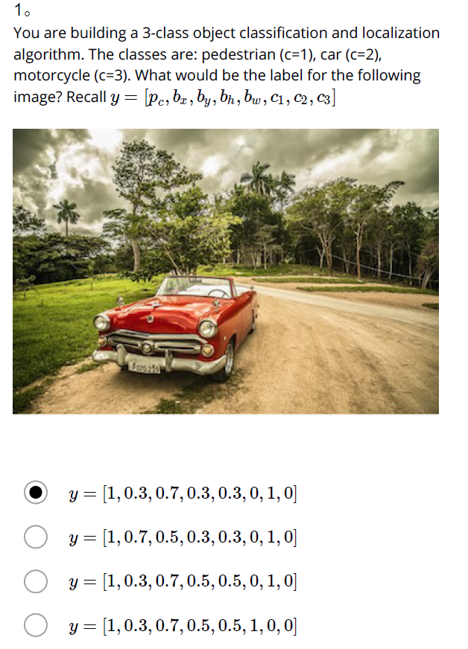

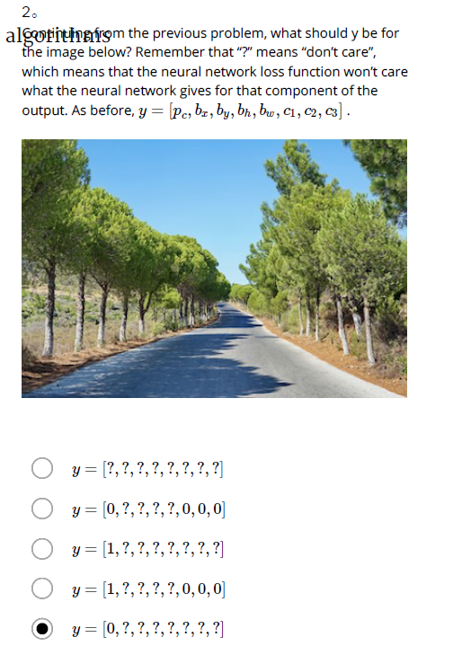

3.

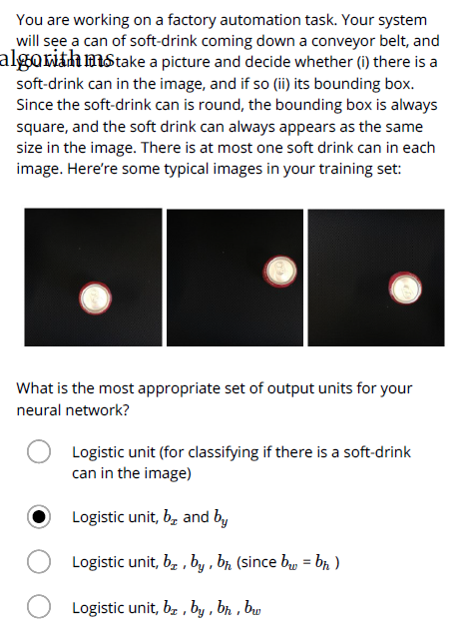

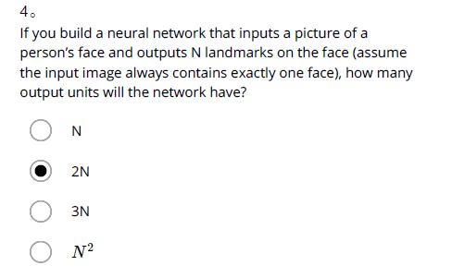

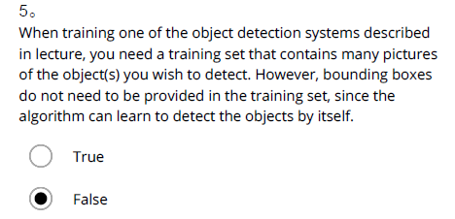

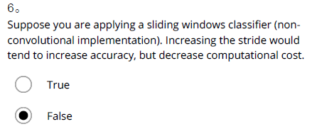

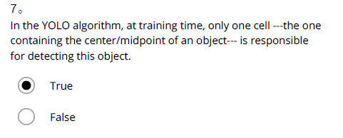

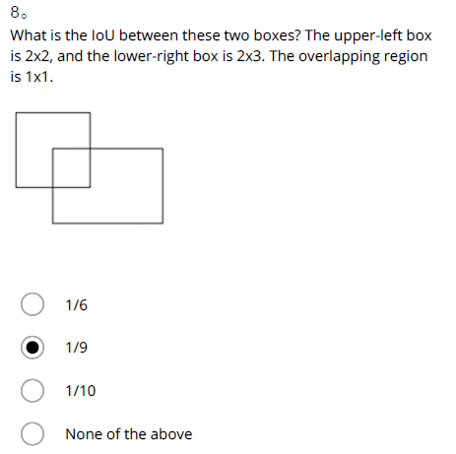

9.

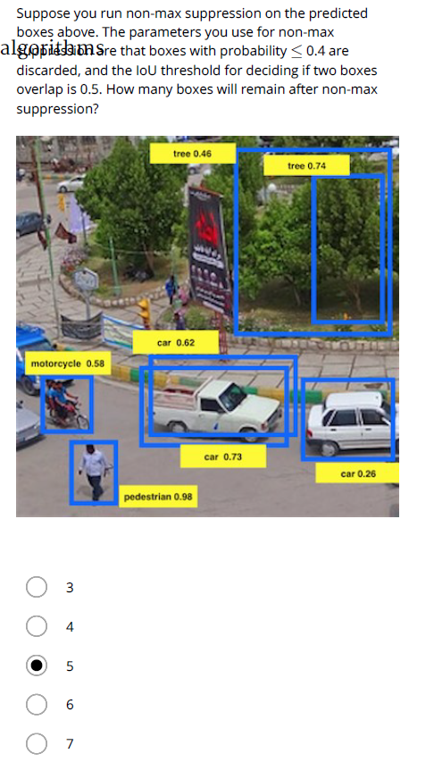

10.

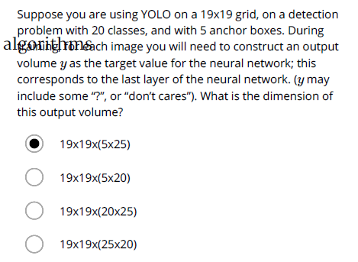

1. You are building a 3-class object classification and localization algorithm. The classes are: pedestrian (c=1), car (c=2), motorcycle (c=3). What would be the label for the following image? Recall y=[pc,bx,by,bh,bw,c1,c2,c3]

Ans: y=[1,0.3,0.7,0.3,0.3,0,1,0]

1. Continuing from the previous problem, what should y be for the image below? Remember that “?” means “don’t care”, which means that the neural network loss function won’t care what the neural network gives for that component of the output. As before, y=[pc,bx,by,bh,bw,c1,c2,c3].

Ans: y=[0,?,?,?,?,?,?,?]

1. You are working on a factory automation task. Your system will see a can of soft-drink coming down a conveyor belt, and you want it to take a picture and decide whether (i) there is a soft-drink can in the image, and if so (ii) its bounding box. Since the soft-drink can is round, the bounding box is always square, and the soft drink can always appears as the same size in the image. There is at most one soft drink can in each image. Here’re some typical images in your training set:

What is the most appropriate set of output units for your neural network?

Ans: Logistic unit, bx, by, bh (since bw = bh)

1. If you build a neural network that inputs a picture of a person’s face and outputs N landmarks on the face (assume the input image always contains exactly one face), how many output units will the network have?

Ans: 2N

1. When training one of the object detection systems described in lecture, you need a training set that contains many pictures of the object(s) you wish to detect. However, bounding boxes do not need to be provided in the training set, since the algorithm can learn to detect the objects by itself.

Ans: True

1. Suppose you are applying a sliding windows classifier (non-convolutional implementation). Increasing the stride would tend to increase accuracy, but decrease computational cost.

Ans: False

1. In the YOLO algorithm, at training time, only one cell ---the one containing the center/midpoint of an object--- is responsible for detecting this object.

Ans: True

1. What is the IoU between these two boxes? The upper-left box is 2x2, and the lower-right box is 2x3. The overlapping region is 1x1.

Ans: 1/9

1. Suppose you run non-max suppression on the predicted boxes above. The parameters you use for non-max suppression are that boxes with probability ≤ 0.4 are discarded, and the IoU threshold for deciding if two boxes overlap is 0.5. How many boxes will remain after non-max suppression?

Ans: 4

1. Suppose you are using YOLO on a 19x19 grid, on a detection problem with 20 classes, and with 5 anchor boxes. During training, for each image you will need to construct an output volume y as the target value for the neural network; this corresponds to the last layer of the neural network. (y may include some “?”, or “don’t cares”). What is the dimension of this output volume?

Ans: 19x19x(5x25)

## 第四周 特殊应用：人脸识别和神经风格转换

### 4.1 什么是人脸识别？

### 4.2 One-Shot 学习

### 4.3 Siamese 网络

### 4.4 Triplet 损失

### 4.5 面部验证与二分类

### 4.6 什么是神经风格转换？

### 4.7 深度卷积网络在学什么？

### 4.8 代价函数

### 4.9 内容代价函数

### 4.10 风格损失函数

### 4.11 一维到三维推广

### C4W4 Quiz - Face Recognition & Neural Style Transfer

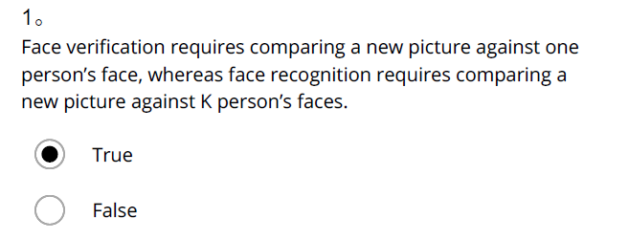

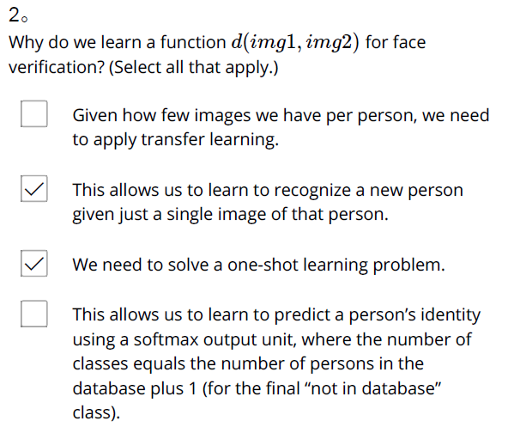

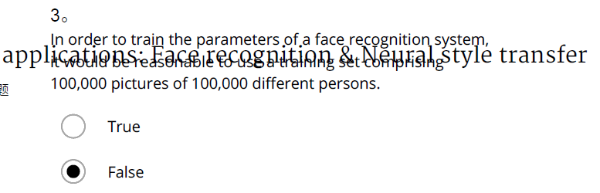

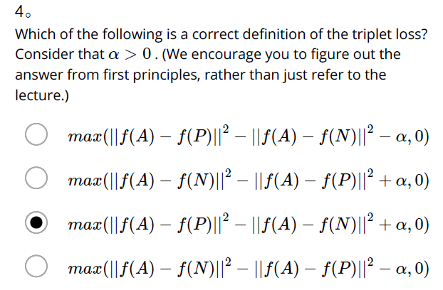

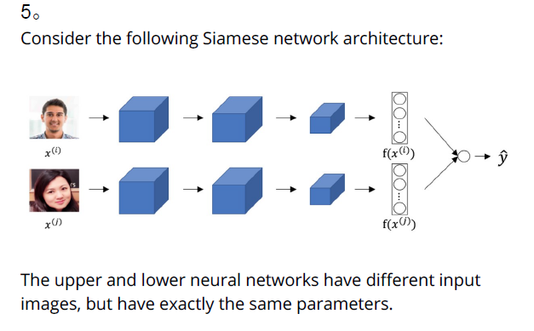

**True**

False

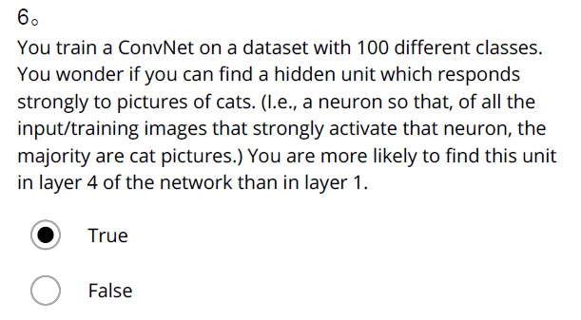

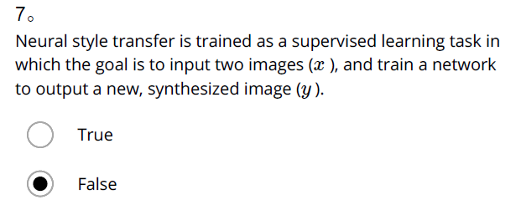

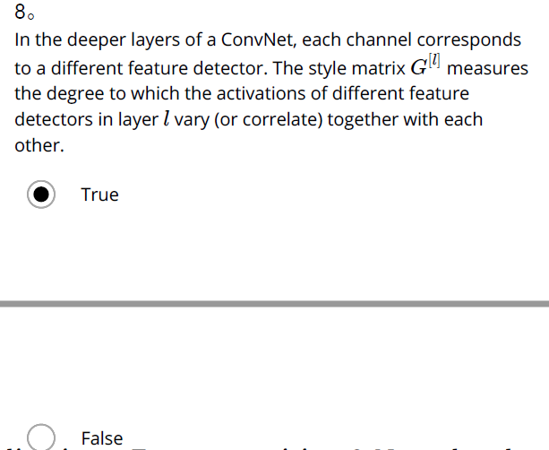

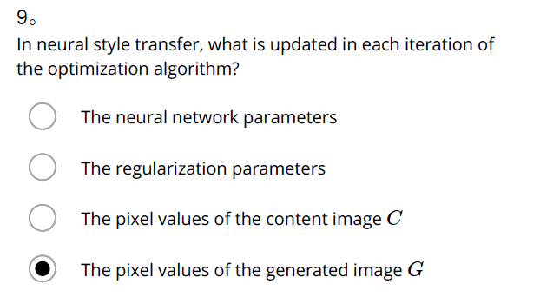

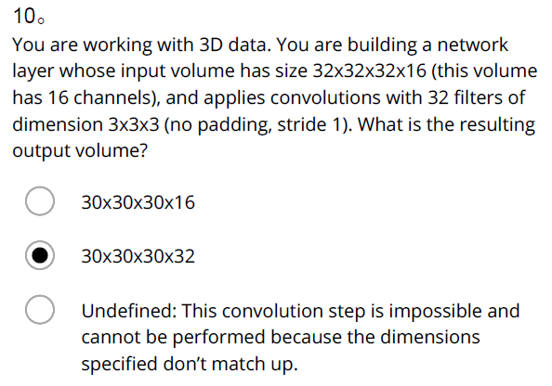

1. Face verification requires comparing a new picture against one person’s face, whereas face recognition requires comparing a new picture against K person’s faces.

Ans: True

1. Why do we learn a function d(img1,img2) for face verification? (Select all that apply.)

# Ans:

- We need to solve a one-shot learning problem.

- This allows us to learn to recognize a new person given just a single image of that person.

1. In order to train the parameters of a face recognition system, it would be reasonable to use a training set comprising 100,000 pictures of 100,000 different persons.

Ans: False

1. Which of the following is a correct definition of the triplet loss? Consider that ```a>0```. (We encourage you to figure out the answer from first principles, rather than just refer to the lecture.)

Ans: max(||f(A)-f(P)||^2-||f(A)-f(N)||^2+a,0)

1. Consider the following Siamese network architecture:

The upper and lower neural networks have different input images, but have exactly the same parameters.

Ans: True

1. You train a ConvNet on a dataset with 100 different classes. You wonder if you can find a hidden unit which responds strongly to pictures of cats. (I.e., a neuron so that, of all the input/training images that strongly activate that neuron, the majority are cat pictures.) You are more likely to find this unit in layer 4 of the network than in layer 1.

Ans: True

1. Neural style transfer is trained as a supervised learning task in which the goal is to input two images (x), and train a network to output a new, synthesized image (y).

Ans: False

1. In the deeper layers of a ConvNet, each channel corresponds to a different feature detector. The style matrix G^{[l]} measures the degree to which the activations of different feature detectors in layer l vary (or correlate) together with each other.

Ans: True

1. In neural style transfer, what is updated in each iteration of the optimization algorithm?

Ans: The pixel values of the generated image G

1. You are working with 3D data. You are building a network layer whose input volume has size 32x32x32x16 (this volume has 16 channels), and applies convolutions with 32 filters of dimension 3x3x3 (no padding, stride 1). What is the resulting output volume?

Ans: 30x30x30x32

# 课程5——序列模型

## 第一周 循环序列模型

### 1.1 为什么选择序列模型

### 1.2 数学符号

### 1.3 循环神经网络模型

### 1.4 通过时间的反向传播

### 1.5 不同类型的循环神经网络

### 1.6 语言模型和序列生成

### 1.7 对新序列采样

### 1.8 带有神经网络的梯度消失

### 1.9 GRU 单元

### 1.10 长短期记忆（LSTM）

### 1.11 双向神经网络

### 1.12 深层循环神经网络

### C5W1 Quiz - Recurrent Neural Networks

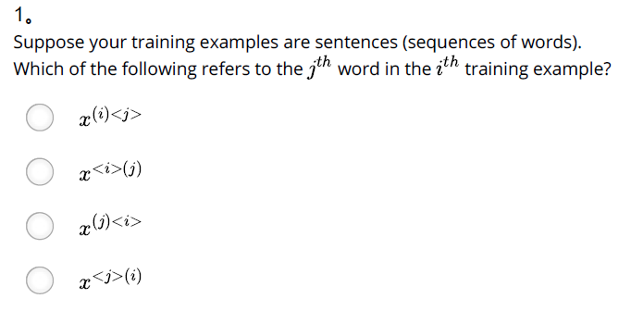

Ans: A

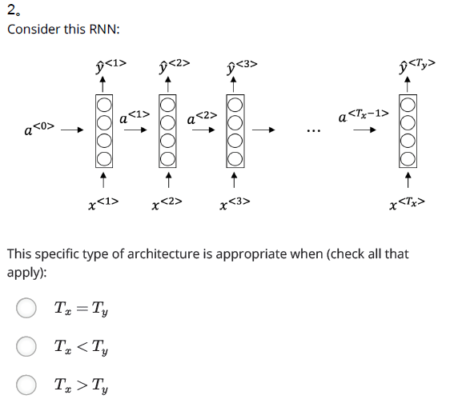



Ans: A

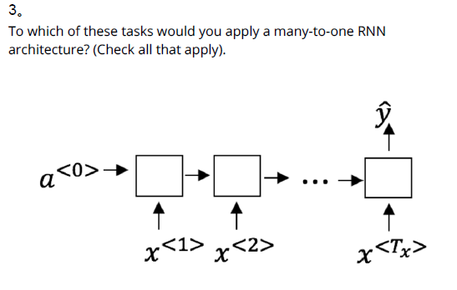

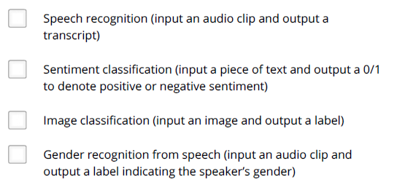

Ans: B、D

4.

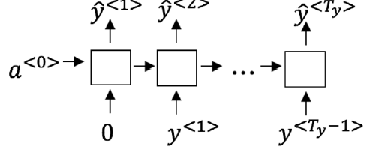

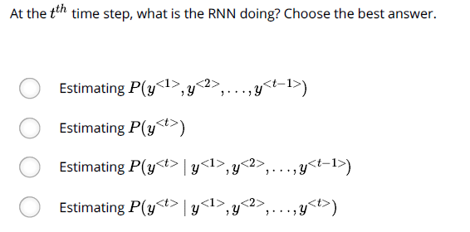

Ans: C

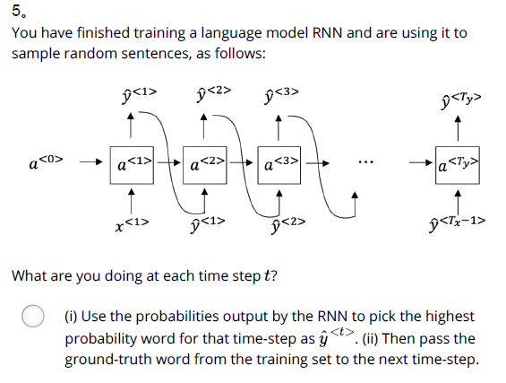

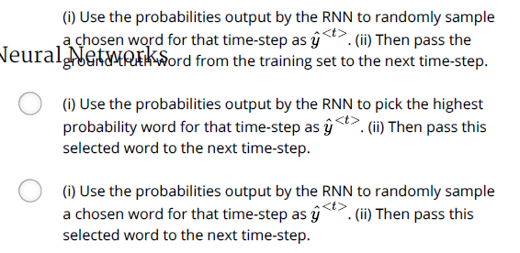

Ans: D

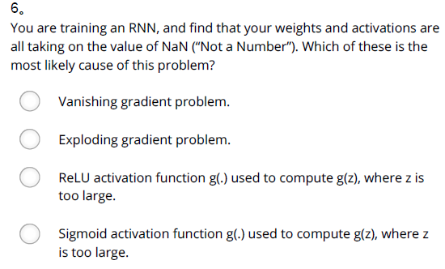

Ans: B

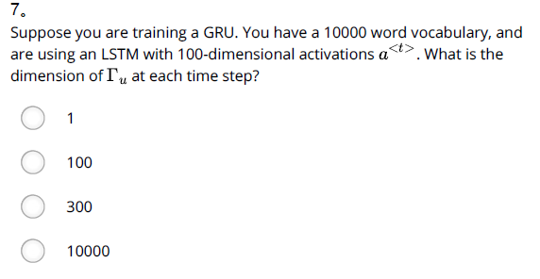

Ans: D

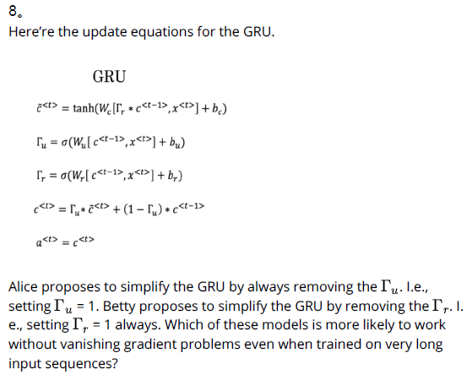

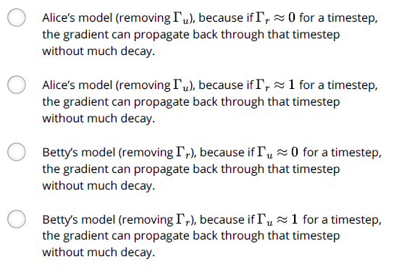

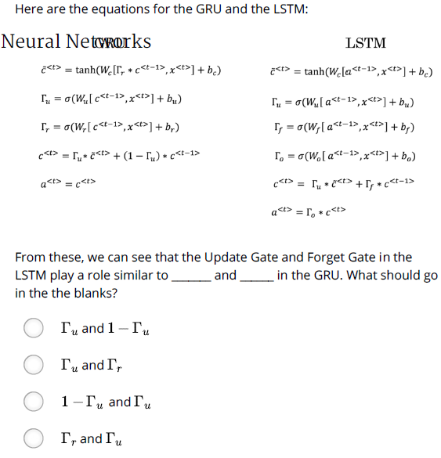

Ans: A

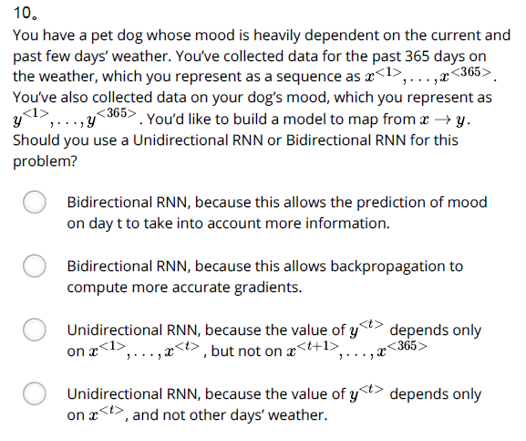

Ans: C

1. Suppose your training examples are sentences (sequences of words). Which of the following refers to the j^{th}jth word in the i^{th}ith training example?

**Ans:** x(i)<j>

1. Consider this RNN: This specific type of architecture is appropriate when:

**Ans:** T_x = T_y

1. To which of these tasks would you apply a many-to-one RNN architecture? (Check all that apply).

**Ans:** Sentiment classification (input a piece of text and output a 0/1 to denote positive or negative sentiment)

Gender recognition from speech (input an audio clip and output a label indicating the speaker’s gender)

1. You are training this RNN language model. At the t^{th} time step, what is the RNN doing? Choose the best answer.

**Ans:** Estimating P(y^{<t>} | y^{<1>}, y^{<2>}, …, y^{<t-1>})

1. You have finished training a language model RNN and are using it to sample random sentences, as follows:

What are you doing at each time step t?

**Ans:** (i) Use the probabilities output by the RNN to randomly sample a chosen word for that time-step as {y}^{<t>}. (ii) Then pass this selected word to the next time-step.

1. You are training an RNN, and find that your weights and activations are all taking on the value of NaN (“Not a Number”). Which of these is the most likely cause of this problem?

**Ans:** Exploding gradient problem.

1. Suppose you are training a LSTM. You have a 10000 word vocabulary, and are using an LSTM with 100-dimensional activations a^{<t>}. What is the dimension of Γu at each time step?

**Ans:** 10000

1. Here’re the update equations for the GRU.

**Ans:** Betty’s model (removing Γr), because if Γu ≈ 0 for a timestep, the gradient can propagate back through that timestep without much decay.

1. Here are the equations for the GRU and the LSTM: From these, we can see that the Update Gate and Forget Gate in the LSTM play a role similar to _______ and ______ in the GRU. What should go in the the blanks?

**Ans**: Γu and 1-Γu

​

1. You have a pet dog whose mood is heavily dependent on the current and past few days’ weather. You’ve collected data for the past 365 days on the weather, which you represent as a sequence as x^{<1>}, …, x^{<365>}. You’ve also collected data on your dog’s mood, which you represent as y^{<1>}, …, y^{<365>}. You’d like to build a model to map from x→y. Should you use a Unidirectional RNN or Bidirectional RNN for this problem?

**Ans:** Unidirectional RNN, because the value of y^{<t>} depends only on x^{<1>}, …, x^{<t>}, but not on x^{<t+1>}, …, x^{<365>}

## 第二周 自然语言处理与词嵌入

### 2.1 词汇表征

### 2.2 使用词嵌入

### 2.3 词嵌入的特性

### 2.4 嵌入矩阵

### 2.5 学习词嵌入

### 2.6 Word2Vec

### 2.7 负采样

### 2.8 GloVe 词向量

### 2.9 情绪分类

### 2.10 词嵌入除偏

### C5W2 Quiz - Natural Language Processing & Word Embeddings

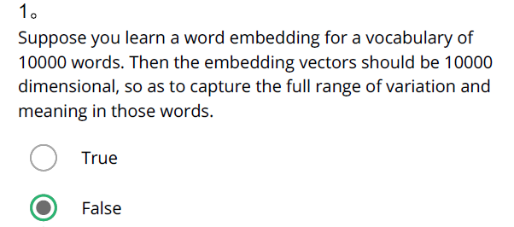

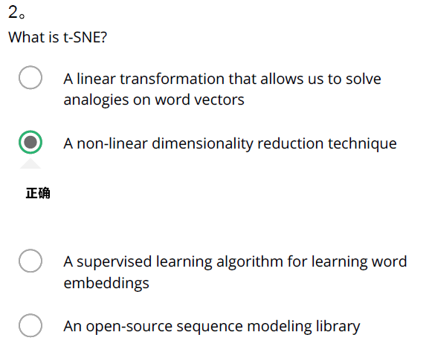

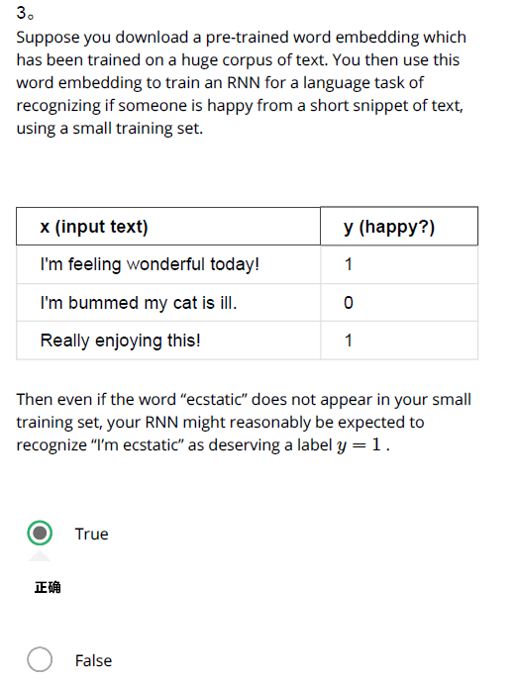

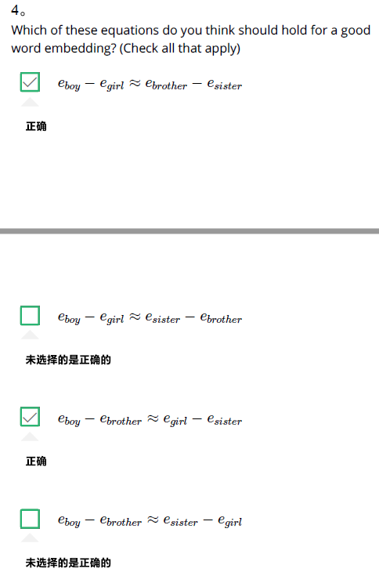

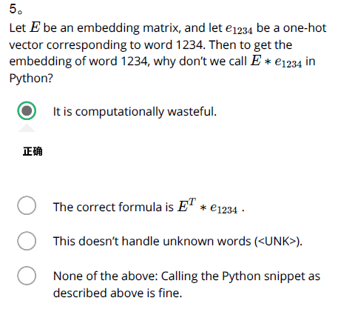

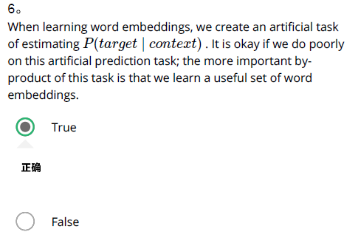

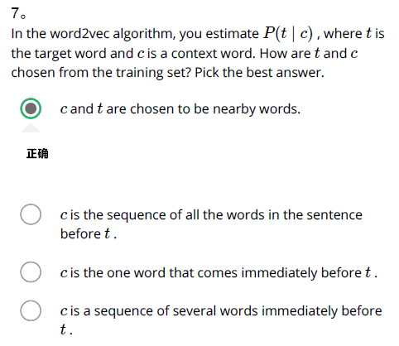

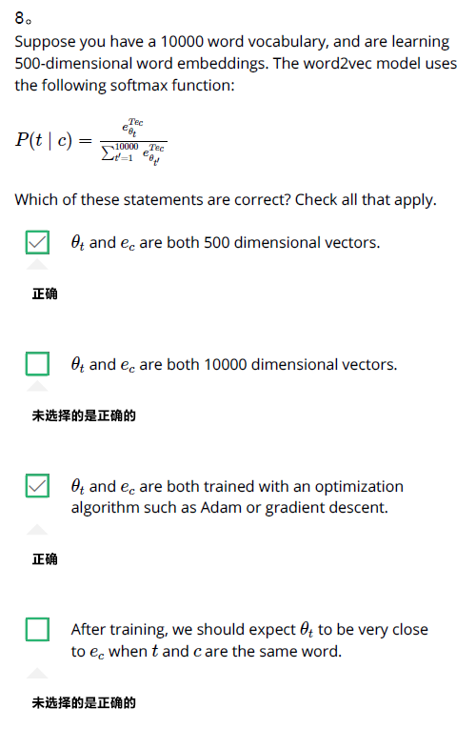

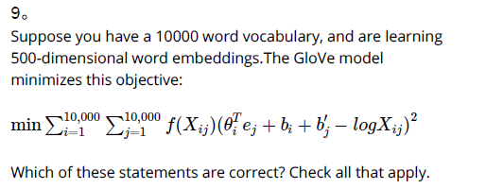

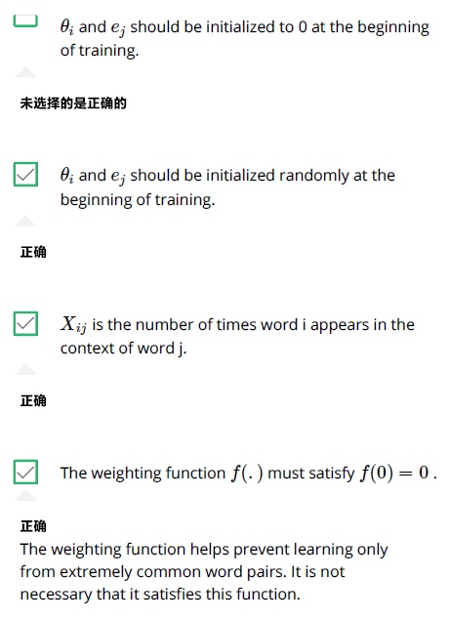

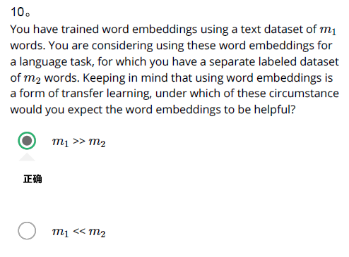

1. Suppose you learn a word embedding for a vocabulary of 10000 words. Then the embedding vectors should be 10000 dimensional, so as to capture the full range of variation and meaning in those words.

Ans: False

1. What is t-SNE?

Ans: A non-linear dimensionality reduction technique

1. Suppose you download a pre-trained word embedding which has been trained on a huge corpus of text. You then use this word embedding to train an RNN for a language task of recognizing if someone is happy from a short snippet of text, using a small training set.

x (input text) y (happy?)

I'm feeling wonderful today! 1

I'm bummed my cat is ill. 0

Really enjoying this! 1

Then even if the word “ecstatic” does not appear in your small training set, your RNN might reasonably be expected to recognize “I’m ecstatic” as deserving a label y = 1y=1.

Ans: True

1. Which of these equations do you think should hold for a good word embedding? (Check all that apply)

Ans: e_{boy} - e_{girl} ≈ e_{brother} - e_{sister}

e_{boy} - e_{brother} ≈ e_{girl} - e_{sister}

1. Let E be an embedding matrix, and let o1234 be a one-hot vector corresponding to word 1234. Then to get the embedding of word 1234, why don’t we call E∗o1234 in Python?

Ans: It is computationally wasteful.

1. When learning word embeddings, we create an artificial task of estimating P(target \mid context)P(target∣context). It is okay if we do poorly on this artificial prediction task; the more important by-product of this task is that we learn a useful set of word embeddings.

Ans: False

1. In the word2vec algorithm, you estimate P(t \mid c)P(t∣c), where t is the target word and c is a context word. How are t and c chosen from the training set? Pick the best answer.

Ans: c and t are chosen to be nearby words.

1. Suppose you have a 10000 word vocabulary, and are learning 500-dimensional word embeddings. The word2vec model uses the following softmax function:

P(t∣c)=eθTtec∑10000t′=1eθTt′ec

Which of these statements are correct? Check all that apply.

Ans: θt and ec are both 500 dimensional vectors.

θt and ec are both trained with an optimization algorithm such as Adam or gradient descent.

9. Suppose you have a 10000 word vocabulary, and are learning 500-dimensional word embeddings.The GloVe model minimizes this objective:

min∑10,000i=1∑10,000j=1f(Xij)(θTiej+bi+b′j−logXij)2

Which of these statements are correct? Check all that apply.

θi and ej hould be initialized to 0 at the beginning of training.

Xij is the number of times word i appears in the context of word j.

The weighting function f(.)f(.) must satisfy f(0) = 0f(0)=0.

10. You have trained word embeddings using a text dataset of m1 words. You are considering using these word embeddings for a language task, for which you have a separate labeled dataset of m2 words. Keeping in mind that using word embeddings is a form of transfer learning, under which of these circumstance would you expect the word embeddings to be helpful?

m1 >> m2

## 第三周 序列模型和注意力机制

### 3.1 基础模型

### 3.2 选择最可能的句子

### 3.3 定向搜索

### 3.4 改进定向搜索

### 3.5 定向搜索的误差分析

### 3.6 Bleu得分（选修）

### 3.7 注意力模型直观理解

### 3.8 注意力模型

### 3.9 语音辨识

### 3.10 触发字检测

### 3.11 结论和致谢

### C5W3 Quiz - Sequence models & Attention mechanism

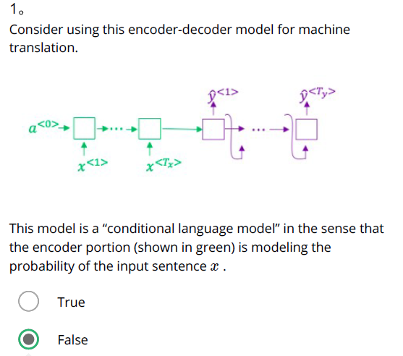

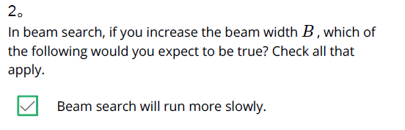

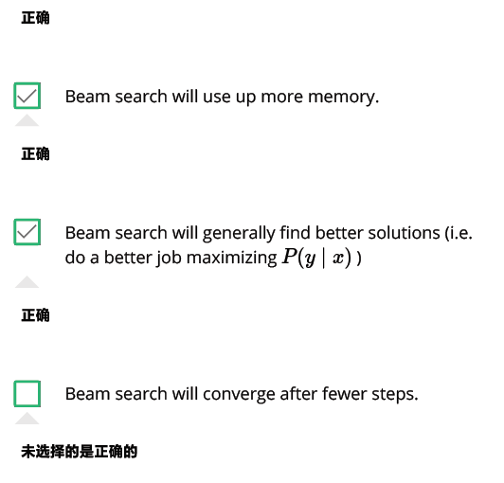

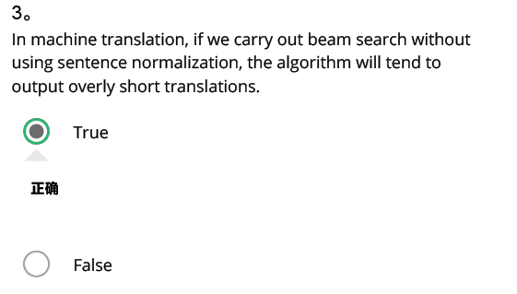

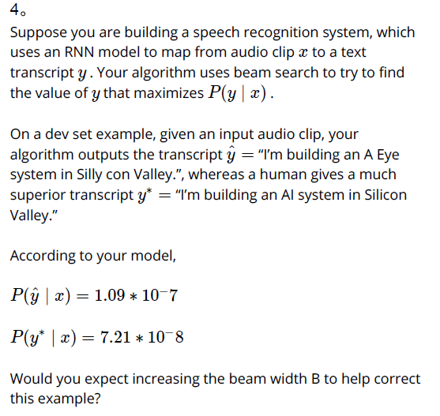

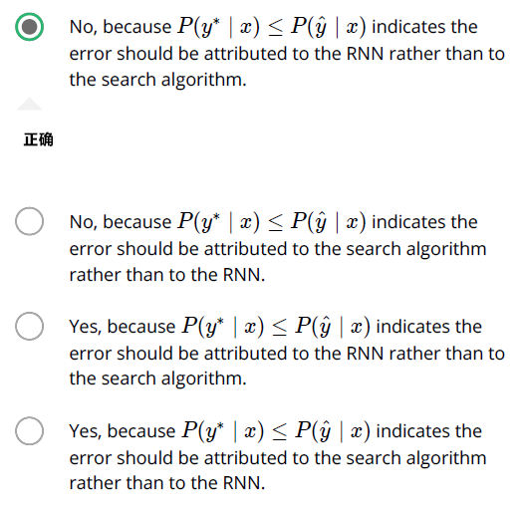

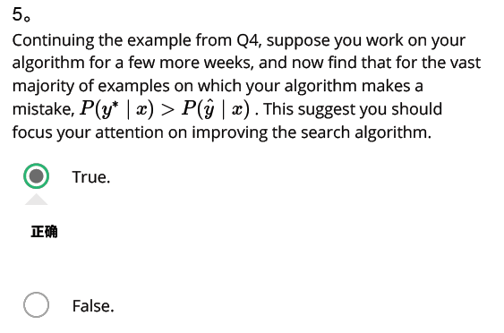

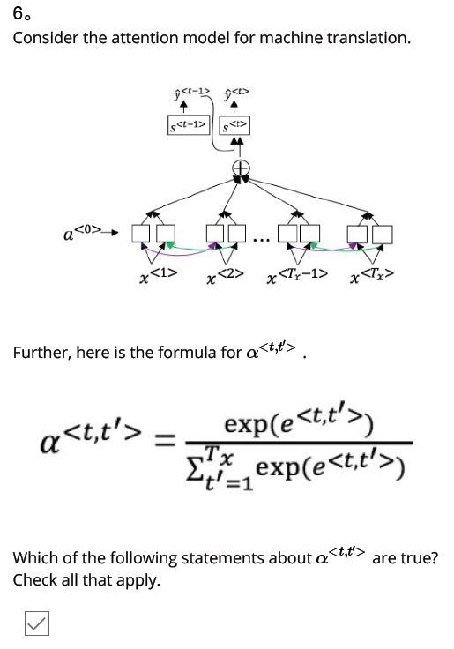

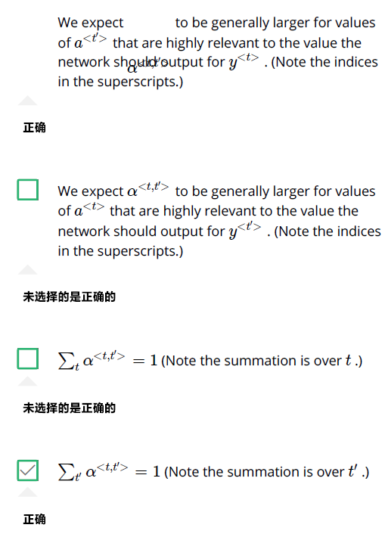

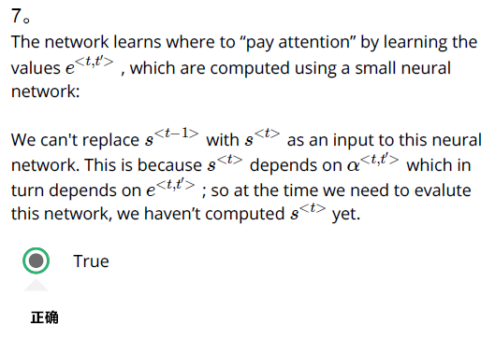

False

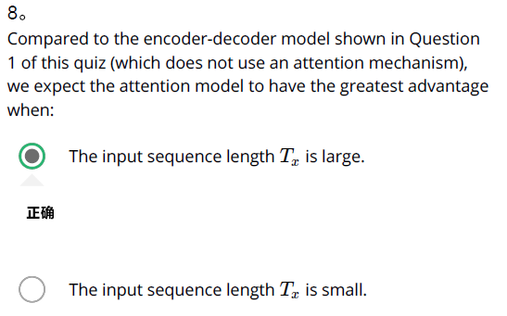

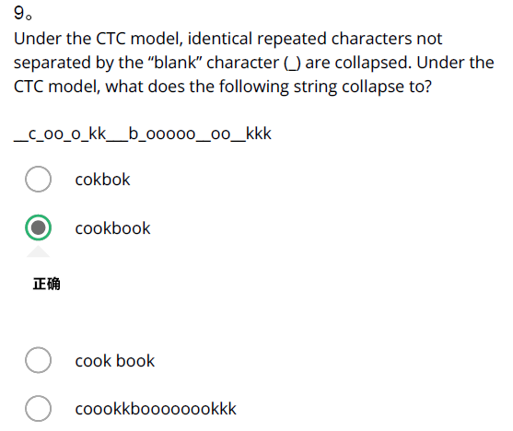

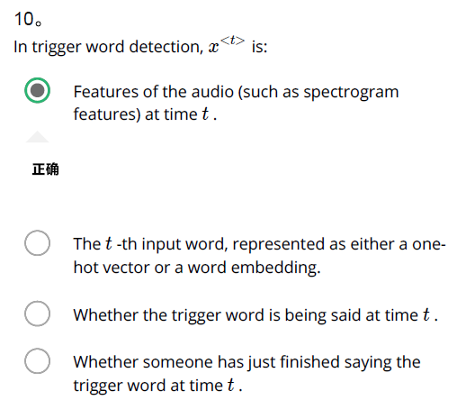

1. Consider using this encoder-decoder model for machine translation.

This model is a “conditional language model” in the sense that the encoder portion (shown in green) is modeling the probability of the input sentence xx.

Ans: True

1. In beam search, if you increase the beam width BB, which of the following would you expect to be true? Check all that apply.

Ans: Beam search will run more slowly.

Beam search will use up more memory.

Beam search will generally find better solutions (i.e. do a better job maximizing P(y \mid x)P(y∣x))

1. In machine translation, if we carry out beam search without using sentence normalization, the algorithm will tend to output overly short translations.

Ans: True

1. Suppose you are building a speech recognition system, which uses an RNN model to map from audio clip x to a text transcript y. Your algorithm uses beam search to try to find the value of y that maximizes P(y∣x).

On a dev set example, given an input audio clip, your algorithm outputs the transcript y^ = “I’m building an A Eye system in Silly con Valley.”, whereas a human gives a much superior transcript y* = “I’m building an AI system in Silicon Valley.”

According to your model,

P(y^|x) = 1.09*10^-7

P(y∗∣x) = 7.21∗10^−8

Would you expect increasing the beam width B to help correct this example?

Ans: No, because P(y∗∣x) ≤ P(y^∣x) indicates the error should be attributed to the RNN rather than to the search algorithm.

1. Continuing the example from Q4, suppose you work on your algorithm for a few more weeks, and now find that for the vast majority of examples on which your algorithm makes a mistake, P(y∗∣x) > P(y^∣x). This suggest you should focus your attention on improving the search algorithm.

Ans: True.

1. Consider the attention model for machine translation. Further, here is the formula for α<t,t′>. Which of the following statements about α<t,t′> are true? Check all that apply.

We expect α<t,t′> to be generally larger for values of a<t′> that are highly relevant to the value the network should output for y^{<t>}. (Note the indices in the superscripts.)

∑tα<t,t′> = 1 (Note the summation is over tt.)

7. The network learns where to “pay attention” by learning the values e<t,t′>, which are computed using a small neural network:

We can't replace s^{<t-1>} with s^{<t>} as an input to this neural network. This is because s^{<t>} depends on α<t,t′> which in turn depends on e<t,t′>; so at the time we need to evalute this network, we haven’t computed s^{<t>} yet.

True

8. Compared to the encoder-decoder model shown in Question 1 of this quiz (which does not use an attention mechanism), we expect the attention model to have the greatest advantage when:

The input sequence length Tx is large.

9. Under the CTC model, identical repeated characters not separated by the “blank” character (_) are collapsed. Under the CTC model, what does the following string collapse to? __c_oo_o_kk___b_ooooo__oo__kkk

coookkboooooookkk

10. In trigger word detection, x^{<t>) is:

Features of the audio (such as spectrogram features) at time t.